Table of Contents

What is Containerization ? 2

Which applications are the best candidates for containerization? 2

What is Kubernetes ? 2

Features of Kubernetes 3

Kubernetes Architecture: 4

Master node 5

API server 6

**Scheduler** 6

**Controller manager** 6

**What is the ETCD?** 7

Worker Node (formerly minions) 7

**Container runtime** 8

**Kubelet** 8

**Kube-proxy** 8

**Pods** 8

Difference between Docker Swarm and Kubernetes 9

Basic building blocks 9

Pods 9

Why do we need Pods? 10

How containers communicate with each other inside same pod? 10

Pods states: 11

Controllers 11

Services 12

Creating Kubernetes Cluster 20

Kubernetes Clusters 20

Namespace 21

Control Plane 21

Nodes 21

Deploy an App 23

Kubernetes Deployments 23

Explore an App 25

Kubernetes Pods 25

Kubernetes Nodes 26

Expose an App 27

Kubernetes Services 27

Annexure I 28

[PODs]: Commands & Outputs 28

[ReplicaSets]: Commands & Outputs 31

[Deployment]: Commands & Outputs 36

Annexure II 36

<https://kubernetes.io/docs/tutorials/kubernetes-basics/_print/>

# What is Containerization ?

- It involves encapsulating or packaging up software code and all its dependencies so that it can run uniformly and consistently on any infrastructure

- Container is an image with an execution environment and having set of instructions

- Containerization allows developers to create and deploy applications faster and more securely

- Containers are often referred to as “lightweight,” meaning they share the machine’s operating system kernel and do not require the overhead of associating an operating system within each application.

- Containers are inherently smaller in capacity than a VM and require less start-up time, allowing far more containers to run on the same compute capacity as a single VM.

- Class --> Image and object --> container

- Docker engine: runtime packaging tool on Docker hosts

- Docker hub --> hub where images are stored

- Benefits: portable and packaged in standard way

- This approach enables the decoupling of application from underlying infrastructure and thus improves business agility, application security and operating environments.

## Which applications are the best candidates for containerization?

Applications that are **stateless** (i.e., pass all information needed to process with the request) and **un-clustered** (i.e., designed to run on a single machine rather than requiring a server cluster to operate) such as network daemons and web server components.

Containers are designed to run only a single process per container (unless the

process itself spawns child processes). If you run multiple unrelated processes in a

single container, it is your responsibility to keep all those processes running, manage

their logs, and so on.

For example, you’d have to include a mechanism for automatically

restarting individual processes if they crash. Also, all those processes would

log to the same standard output, so you’d have a hard time figuring out what process

logged what.

Therefore, you need to run each process in its own container. That’s how Docker

and Kubernetes are meant to be used.

# What is Kubernetes ?

Kubernetes in an open source container management(orchestration) tool hosted by Cloud Native Computing Foundation (CNCF).

It’s container management responsibilities includes:

* container deployment,
* scaling & descaling of containers &
* container load balancing.
* Kubernetes always run processes in containers and each container is much like an isolated machine

Note: *Kubernetes is not a containerization platform. It is a multi-container management solution.*

- Kubernetes is a platform to schedule and run containers on cluster of VMs, bare metal, cloud

- Kubernetes can be used with Docker, where Docker can be used to develop and build applications and then Kubernetes can be used to run these applications on infrastructure

# Features of Kubernetes

- multi-host container scheduling

- done by kube-scheduler

- assigns pods to nodes at runtime

- check resources, quality of services etc before scheduling

- Scalability & Availability

- masters can be deployed in highly available configurations

- multi-region deployments available

- supports 5000 nodes clusters

- 150000 total pods

- pods can be horizontally scaled

- Plug and play architecture, which allows to extend architecture whenever needed

- Registration

- nodes can be registered to Kubernetes master

- Service Discovery

- Services can be automatically detected via DNS

- persistent storage

- much requested and important feature for containers

- Pods can use persistent volume to store data

- Data retained across pod restarts and crashes

- Application Upgrade and Downgrade

- Based on need the applications can be upgraded or downgraded

- Logging

- application monitoring

- health check

- inbuilt logging framework

# Kubernetes Architecture:

Kubernetes implements a cluster computing background, everything works from inside a ***Kubernetes Cluster***. This cluster is hosted by one node acting as the ‘master’ of the cluster, and other nodes as ‘nodes’ which do the actual ‘containerization‘

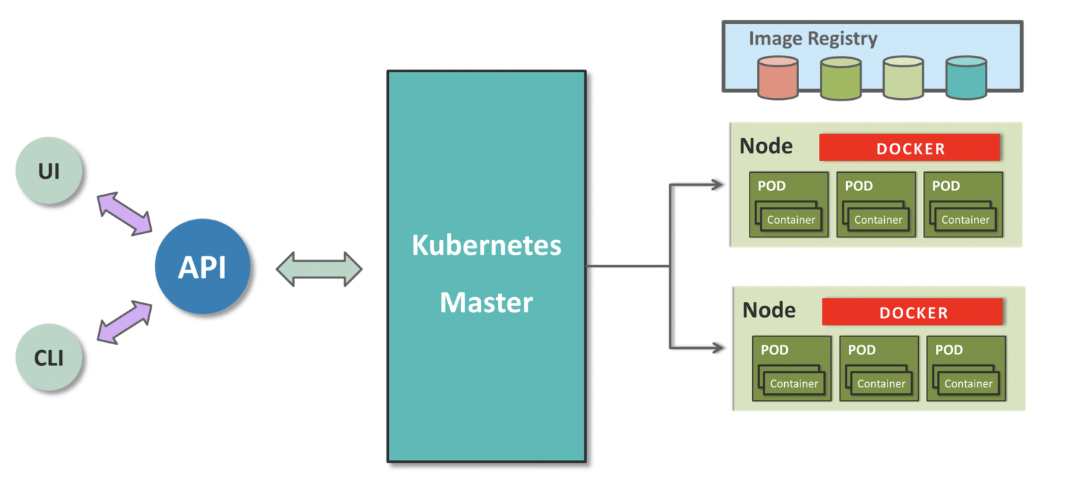

Master controls the cluster, and the nodes in it. It ensures the execution only happens in nodes and coordinates the act.

Nodes host the containers; in-fact these Containers are grouped logically to form Pods. Each node can run multiple such Pods, which are a group of containers, that interact with each other, for a deployment.

Replication Controller is Master’s resource to ensure that the requested no. of pods are always running on nodes.

Service is an object on Master that provides load balancing across a replicated group of Pods.

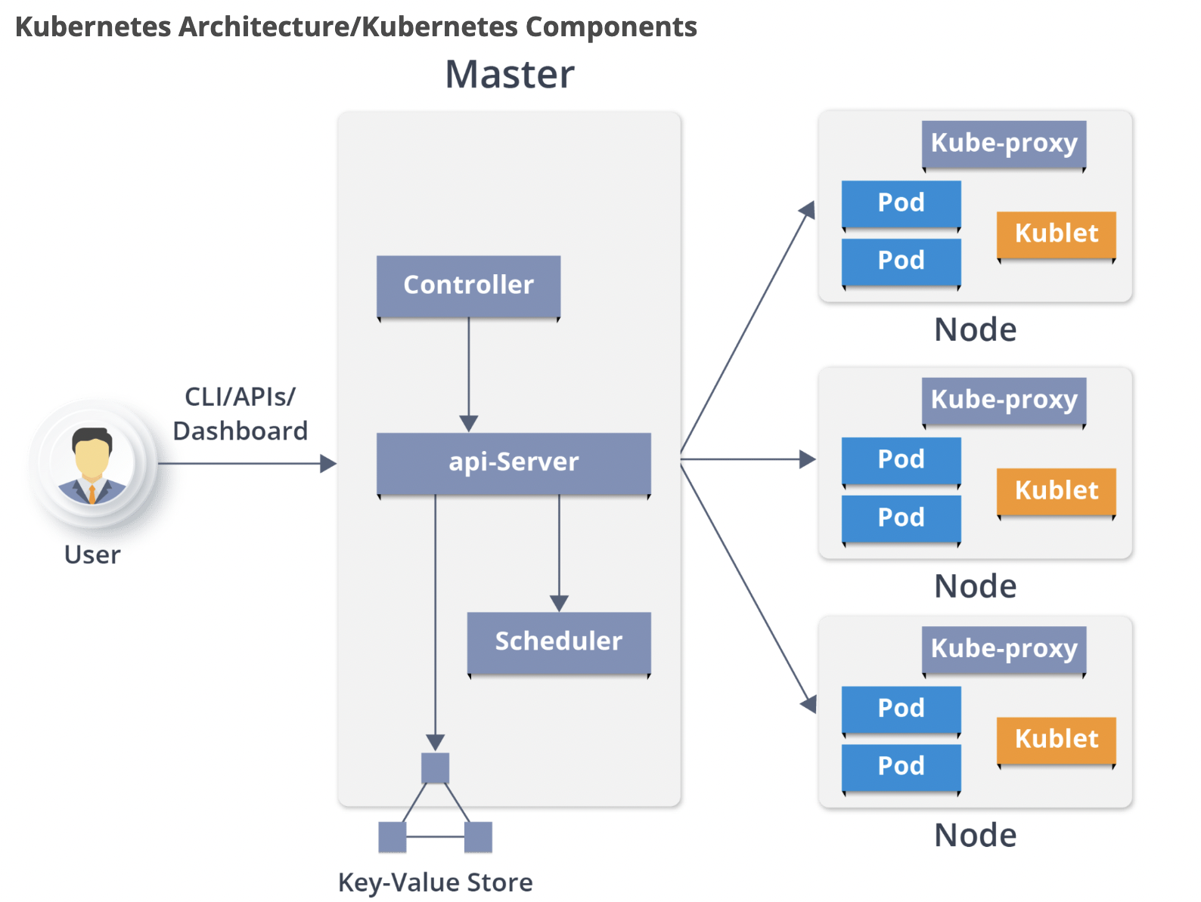

Kubernetes Architecture has the following main components:

* Master nodes
* Worker/Slave nodes
* Distributed key-value store(etcd.)

## Master node

It is the entry point for all administrative tasks which is responsible for managing the Kubernetes cluster. There can be more than one master node in the cluster to check for fault tolerance. More than one master node puts the system in a High Availability mode, in which one of them will be the main node which we perform all the tasks.

For managing the cluster state, it uses**etcd** in which all the master nodes connect to it.

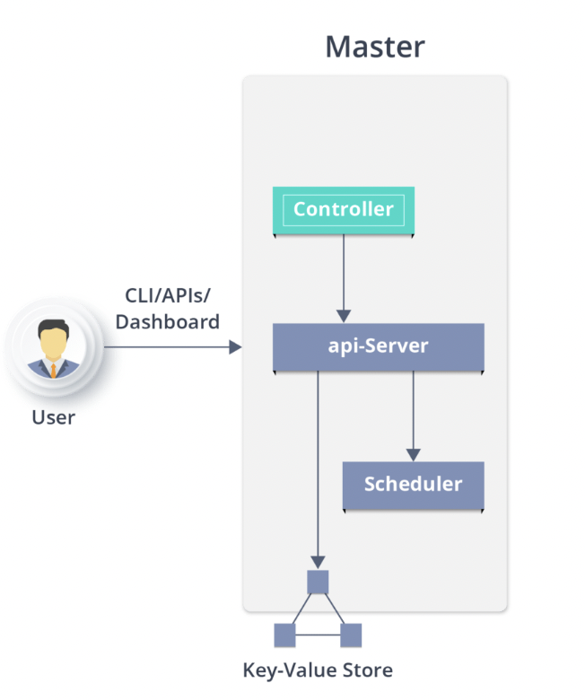

### **API server**

* Performs all the administrative tasks through the API server within the master node.
* In this REST commands (runs over HTTP/HTTPs over JSON) are sent to the API server which validates and processes the requests.
* After requesting, the resulting state of the cluster is stored in the distributed key-value store.

### **Scheduler**

* The scheduler schedules the tasks to slave nodes. It stores the resource usage information for each slave node.
* It schedules the work in the form of Pods and Services.
* Before scheduling the task, the scheduler also takes into account the quality of the service requirements, data locality, affinity, anti-affinity, etc.

### **Controller manager**

* Also known as **controllers**.
* It is a daemon which regulates the Kubernetes cluster which manages the different non-terminating control loops.
* It also performs lifecycle functions such as namespace creation and lifecycle, event garbage collection, terminated-pod garbage collection, cascading-deletion garbage collection, node garbage collection, etc.
* Basically, a controller watches the desired state of the objects it manages and watches their current state through the API server. If the current state of the objects it manages does not meet the desired state, then the control loop takes corrective steps to make sure that the current state is the same as the desired state.

### **What is the ETCD?**

* etcd is a distributed key-value store which stores the cluster state.
* It can be part of the Kubernetes Master, or, it can be configured externally.
* etcd is written in the Go programming language. In Kubernetes, besides storing the cluster state (based on the **Raft Consensus Algorithm**) it is also used to store configuration details such as subnets, ConfigMaps, Secrets, etc.
* A raft is a consensus algorithm designed as an alternative to Paxos. The Consensus problem involves multiple servers agreeing on values; a common problem that arises in the context of replicated state machines. Raft defines three different roles (Leader, Follower, and Candidate) and achieves consensus via an elected leader

## **Worker Node (formerly minions)**

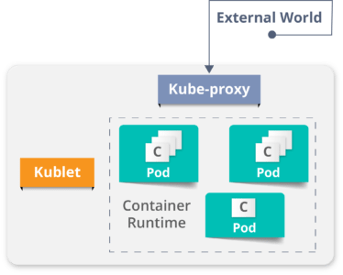

It is a physical server or you can say a VM which runs the applications using Pods (**a pod scheduling unit**) which is controlled by the master node. On a physical server (worker/slave node), pods are scheduled. For accessing the applications from the external world, we connect to nodes.

### **Container runtime**

* To run and manage a container’s lifecycle, we need a **container runtime**on the worker node.
* Sometimes, Docker is also referred to as a container runtime, but to be precise, Docker is a platform which uses **containers**as a container runtime.

### **Kubelet**

* It is an agent which communicates with the Master node and executes on nodes or the worker nodes. It gets the Pod specifications through the API server and executes the containers associated with the Pod and ensures that the containers described in those Pod are running and healthy.

### **Kube-proxy**

* Kube-proxy runs on each node to deal with individual host sub-netting and ensure that the services are available to external parties.
* It serves as a network proxy and a load balancer for a service on a single worker node and manages the network routing for TCP and UDP packets.
* It is the network proxy which runs on each worker node and listens to the API server for each Service endpoint creation/deletion.
* For each Service endpoint, kube-proxy sets up the routes so that it can reach to it.

### **Pods**

A pod is one or more containers that logically go together. Pods run on nodes. Pods run together as a logical unit. So they have the same shared content. They all share the same IP address but can reach other Pods via localhost, as well as shared storage. Pods don’t need to all run on the same machine as containers can span more than one machine. One node can run multiple pods.

# Difference between Docker Swarm and Kubernetes

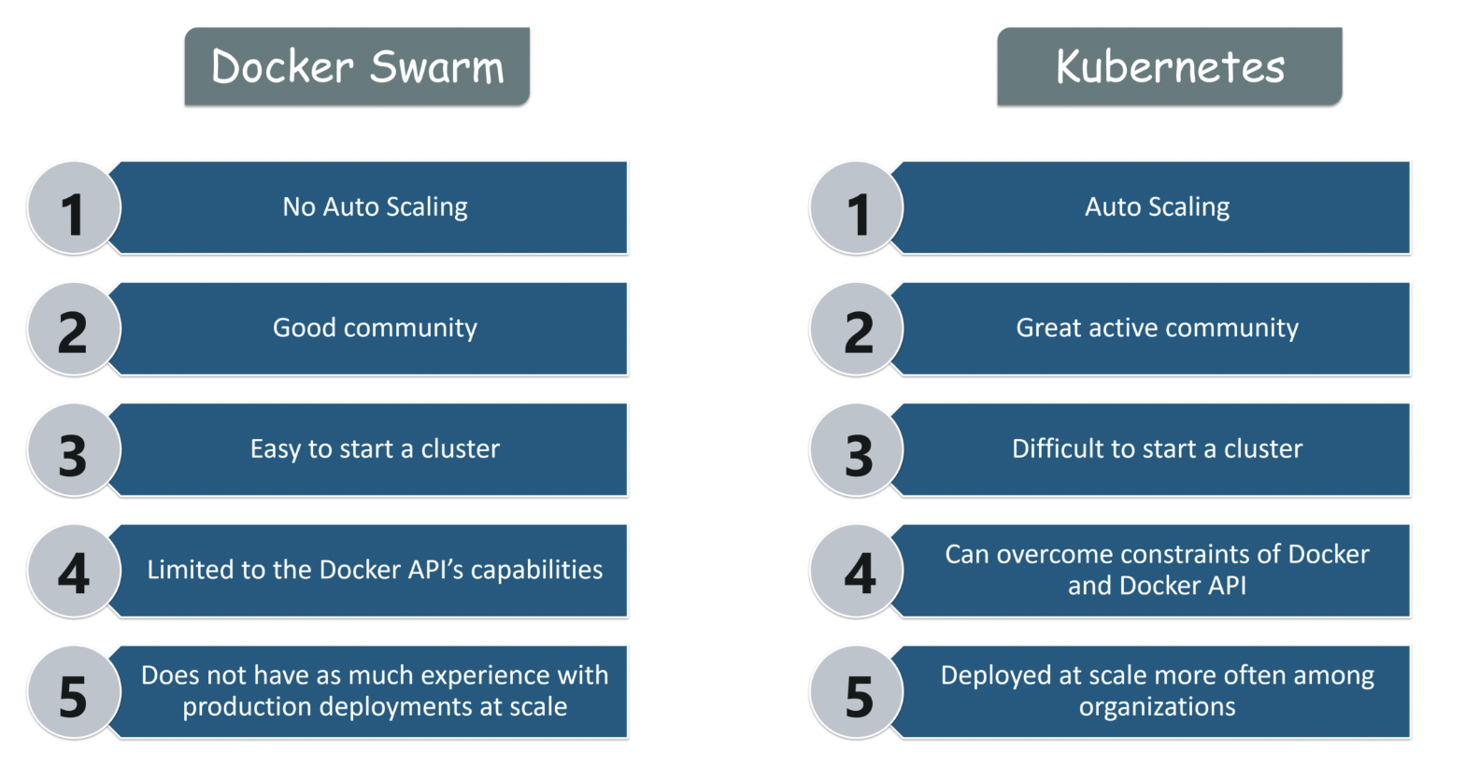

# Basic building blocks

- Requirements

- Each node must have a kubelet running, which is an agent to for managing the node and communicating with control plane

- Container tooling like docker

- kube-proxy process running

- Supervisord process running that restart components

- in production we should use 3 node clusters at least to run Kubernetes

|  |
| --- |
| ainani@ainani-a01 demo % kubectl get nodes  NAME STATUS ROLES AGE VERSION  minikube Ready control-plane,master 6d2h v1.23.3  ainani@ainani-a01 demo % |

- Minikube

- lightweight Kubernetes implementation that creates a VM on local m/c and deploys a simple cluster containing only one node

## Pods

* Pod is a collection of single or multiple containers in same node
* Containers inside pods can communicate with each other using pod’s IP
* Note that it’s pod not containers who will be assigned with IP
* This pod’s IP is used by containers to communicate each other’s.
* Pod is a simplest unit that can be interacted with
* For simplicity, we can understand that pod will act as VM and containers inside that pod will act as processes. Which are sharing the same network and resources of pod (acting as VM here)

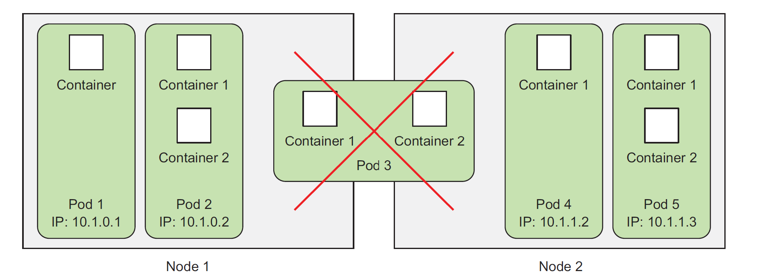

## Why do we need Pods?

As we are not supposed to group multiple processes into a single container, it’s

obvious you need another higher-level construct that will allow you to bind containers

together and manage them as a single unit. This is the reasoning behind pods.

A pod of containers allows you to run closely related processes together and provide

them with (almost) the same environment as if they were all running in a single

container, while keeping them somewhat isolated. This way, you get the best of both

worlds. You can take advantage of all the features containers provide, while at the

same time giving the processes the illusion of running together.

As we know that containers are completely isolated from

each other, then how they will interact with each other in same pod.

Kubernetes achieves this by configuring Docker to have all containers of a pod share the same set of Linux namespaces instead of each container having its own set.

Because all containers of a pod run under the same Network and UTS namespaces

(we’re talking about Linux namespaces here), they all share the same hostname and

network interfaces. Similarly, all containers of a pod run under the same IPC namespace

and can communicate through IPC.

## How containers communicate with each other inside same pod?

Containers in a pod run in the same Network namespace, they share the same IP address and port space. This means processes running in containers of the same pod need to take care not to bind to the same port numbers or they’ll run into port conflicts. But this only concerns containers in the same pod. Containers of different pods can never run into port conflicts, because each pod has a separate port space.   
All the containers in a pod also have the same loopback network interface, so a container can communicate with other containers in the same pod through localhost.

|  |
| --- |
| ainani@ainani-a01 demo % kubectl run sise --image=quay.io/openshiftlabs/simpleservice:0.5.0 --port=9876  pod/sise created  ainani@ainani-a01 demo %  ainani@ainani-a01 demo % kubectl get pods  NAME READY STATUS RESTARTS AGE  sise 1/1 Running 0 4m3s  ainani@ainani-a01 demo %  # image sise correspond to curl command  ainani@ainani-a01 demo % kubectl exec sise -t -- curl -s localhost:9876/info  {"host": "localhost:9876", "version": "0.5.0", "from": "127.0.0.1"}**%** ainani@ainani-a01 demo % |

- Requirements:

- docker application container

- Storage resources

- Unique n/w ip

- options that governs how the container(s) should run- Pods are ephemeral and disposable

- Never self-heal and not restarted by scheduler it self

- Never create pods by just themselves

- use higher-level constructs

- Pods are started by some controllers

### Pods states:

- **Pending** - pod had been accepted by Kubernetes system but a container had not been created yet

- **Running** - pod had been scheduled over node, all it's containers are created and at least one of it's container is in running state

- **Succeeded** - all the containers in pods are exited with exist status 0

- **Failed** - all the containers in pod are executed and at least one container is failed with non zero exit status

- **CrashLoopBackOff** - Container is failed to start due to some region and Kubernetes tried over and over to start the pod

- Kubernetes Probes the Pods to check health of Pods – Means checking that application inside pod is running or not.

- Pods are Ephemeral – Means Pod can’t be redeployed. Once a pod died, it can’t be redeployed. Kubernetes had to create new pod

## Controllers

- Controllers creates Pods for system

- Controllers keep systems in desired state (mainly Pods)

- application reliability - multiple instances of applications running prevent problems if one or more instance of application fails

- Scaling - if pod experience larger volume data Kubernetes allows the pod to scale

- Load balancing - when multiple pods are running, traffic can be distributed to other

pods doesn't overload one single pod

- Kinds of controllers

- ReplicaSets

- Deployments

- DaemonSets

- Jobs

- Services

- ReplicaSet

- Ensure that a specified no. of replicas for a pod are running at all times

- if a pod crashed then replicaSet will ensure to start a new pod to ensure the no. of replica pod should be same as declared

- ReplicaSet cannot be declared by itself and should be used in deployment set

- Deployments

- Deployment controller provides declarative updates for pods and ReplicaSets

- This mean you can defined a desired state of deployment in a YAML file and deployment controller will align the actual state to match

- Deployment sets can be defined to create new replicaSet or replace the existing once

- Deployment manages ReplicaSet, which manages pods

- Pod management - running a replica-set allows us to deploy a number of pods and check their status as a single unit

- Scaling of ReplicaSet : scales out the pods and allows for the deployment to handle more traffic

- Pause a deployment make changes and resume the deployment set

- A new replicaSet will be started every-time after pause-resume

- Pausing a deployment means only updates are paused but traffic is still running

- Status : easy way to check health of pods

- DaemonSets:

- Ensures that all nodes run a copy of a specific pod

- As nodes are added or removed from the cluster, a DaemonSet will add or remove the required pods

- Deleting a DaemonSet will also cleanup the all the pods it's created

- a typical use case of DaemonSet is to run a single log aggregator or a monitoring agent on a node

- Jobs:

- Supervisor process for pods carrying out batch jobs

- Run individual processes that run once and complete successfully

- Jobs are run in cronjob to run a specific process at specific time

## Services

- Communication b/w one set of deployments with another

- When a service is created it's assigned with unique IP address which will never change throughout out the lifetime of service

- Pods are then configured to talk to services and rely on service IP for any communication

- Services are really important because they allow one set of pods to communicate with other set of pods

- in simple form, it's best practice to use a service when you allow one deployment to talk to another deployment

- If frontend pods needs to talk to backend pods then it should communicate via Service IP, because backend pods IP may changes anytime

- Internal Service : IP is only reachable within cluster, also known as cluster IP in K8s

- External Service : Endpoint available through node ip:port (called NodePort)

- LoadBalancer : Exposes application to internet with a load balancer

### Labels, selectors and namespaces

Labels:

- Labels are key/value pairs that are attached to objects like pods, services and deployments.

- Labels are for users of Kubernetes to identify attributes for objects

- Label keys are unique for objects

- Labels are generally used with selectors

Selectors:

- Equality selectors : Equals and not equals

- Set based selectors : In, NOTIN and EXISTS

- labels and selectors are used with kubectl to lister or filter objects

Namespaces:

- Great for large enterprises

### Kubelet and KubeProxy:

# Kubelet

- Kubelet is "Kubernetes node agent" that runs on each node

- communicate with API server to see if pods have been assigned to nodes

- Executes pods containers via a container engine

- mounts and runs pod volumes and secrets

- Execute health check to identify pod/node status

- Podspec: YAML file that describe a pod

- Kubelet takes set of Prodspecs and ensures that the containers in those Prodspec are running and healthy

- Kubelet only manages the containers createdby API server - not any other one

# KubeProxy : N/w Proxy

- process run on all worker nodes

- Reflects services as defined on each node and can to simple n/w stream or round robin forwarding across a set of backends

3 modes:

- User space mode - most common

- IPtables mode

- IPVs mode

- Services are defnied against the API server, kube-proxy watches the API server for the addition and removal of services

- For each new service, kube-proxy opens a randomly choosen port on the local node

- connections mage to the choosen port are proxied to one of the corresponding back-end pods

### Install

- Docker and Hypervisor should be installed already for Kubernetes

- Install Docker desktop for Mac/windows

- Install hypervisor

### Hello World

- minikube start

😄 minikube v1.25.2 on Darwin 12.2.1 (arm64)

✨ Using the docker driver based on existing profile

👍 Starting control plane node minikube in cluster minikube

🚜 Pulling base image ...

🏃 Updating the running docker "minikube" container ...

🐳 Preparing Kubernetes v1.23.3 on Docker 20.10.12 ...

▪ kubelet.housekeeping-interval=5m

🔎 Verifying Kubernetes components...

▪ Using image gcr.io/k8s-minikube/storage-provisioner:v5

🌟 Enabled addons: storage-provisioner, default-storageclass

🏄 Done! kubectl is now configured to use "minikube" cluster and "default" namespace by default

- kubectl get nodes

NAME STATUS ROLES AGE VERSION

minikube Ready control-plane,master 13m v1.23.3

- kubectl create -f /Users/ainani/Downloads/Ex_Files_Learning_Kubernetes_Upd/Exercis_Files/03_04/helloworld.yaml

deployment.apps/helloworld created

- kubectl get deployments

NAME READY UP-TO-DATE AVAILABLE AGE

helloworld 1/1 1 1 22m

- kubectl get rs

NAME DESIRED CURRENT READY AGE

helloworld-d7c6dd56 1 1 1 22m

- kubectl get pods

NAME READY STATUS RESTARTS AGE

helloworld-d7c6dd56-4s5ds 1/1 Running 0 22m

- kubectl get all

NAME READY STATUS RESTARTS AGE

pod/helloworld-d7c6dd56-4s5ds 1/1 Running 0 31m

NAME TYPE CLUSTER-IP EXTERNAL-IP PORT(S) AGE

service/kubernetes ClusterIP 10.96.0.1 <none> 443/TCP 63m

NAME READY UP-TO-DATE AVAILABLE AGE

deployment.apps/helloworld 1/1 1 1 31m

NAME DESIRED CURRENT READY AGE

replicaset.apps/helloworld-d7c6dd56 1 1 1 31m

- kubectl expose deployment helloworld --type=NodePort

service/helloworld exposed

- kubectl get all

NAME READY STATUS RESTARTS AGE

pod/helloworld-d7c6dd56-4s5ds 1/1 Running 0 44m

NAME TYPE CLUSTER-IP EXTERNAL-IP PORT(S) AGE

service/helloworld NodePort 10.100.70.103 <none> 80:32673/TCP 28s

service/kubernetes ClusterIP 10.96.0.1 <none> 443/TCP 77m

NAME READY UP-TO-DATE AVAILABLE AGE

deployment.apps/helloworld 1/1 1 1 44m

NAME DESIRED CURRENT READY AGE

replicaset.apps/helloworld-d7c6dd56 1 1 1 44m

- kubectl get services

NAME TYPE CLUSTER-IP EXTERNAL-IP PORT(S) AGE

kubernetes ClusterIP 10.96.0.1 <none> 443/TCP 57m

- minikube service <service name> --> see application up and running

-

### Breaking hello World

-kubectl get deployment

NAME READY UP-TO-DATE AVAILABLE AGE

helloworld 1/1 1 1 135m

- kubectl get deployment/helloworld -o yaml

apiVersion: apps/v1

kind: Deployment

metadata:

annotations:

deployment.kubernetes.io/revision: "1"

creationTimestamp: "2022-06-16T06:02:17Z"

generation: 1

name: helloworld

namespace: default

resourceVersion: "1862"

uid: 02040503-08f0-4a68-ab84-dde4179b93cb

spec:

progressDeadlineSeconds: 600

replicas: 1

revisionHistoryLimit: 10

selector:

matchLabels:

app: helloworld

strategy:

rollingUpdate:

maxSurge: 25%

maxUnavailable: 25%

type: RollingUpdate

template:

metadata:

creationTimestamp: null

labels:

app: helloworld

spec:

containers:

- image: karthequian/helloworld:latest

imagePullPolicy: Always

name: helloworld

ports:

- containerPort: 80

protocol: TCP

resources: {}

terminationMessagePath: /dev/termination-log

terminationMessagePolicy: File

dnsPolicy: ClusterFirst

restartPolicy: Always

schedulerName: default-scheduler

securityContext: {}

terminationGracePeriodSeconds: 30

status:

availableReplicas: 1

conditions:

- lastTransitionTime: "2022-06-16T06:02:32Z"

lastUpdateTime: "2022-06-16T06:02:32Z"

message: Deployment has minimum availability.

reason: MinimumReplicasAvailable

status: "True"

type: Available

- lastTransitionTime: "2022-06-16T06:02:17Z"

lastUpdateTime: "2022-06-16T06:02:32Z"

message: ReplicaSet "helloworld-d7c6dd56" has successfully progressed.

reason: NewReplicaSetAvailable

status: "True"

type: Progressing

observedGeneration: 1

readyReplicas: 1

replicas: 1

updatedReplicas: 1

- kubectl get service/helloworld -o yaml

apiVersion: v1

kind: Service

metadata:

creationTimestamp: "2022-06-16T06:46:47Z"

name: helloworld

namespace: default

resourceVersion: "3516"

uid: d6f61616-a9c4-4262-a9d1-3b17d9094d0b

spec:

clusterIP: 10.100.70.103

clusterIPs:

- 10.100.70.103

externalTrafficPolicy: Cluster

internalTrafficPolicy: Cluster

ipFamilies:

- IPv4

ipFamilyPolicy: SingleStack

ports:

- nodePort: 32673

port: 80

protocol: TCP

targetPort: 80

selector:

app: helloworld

sessionAffinity: None

type: NodePort

status:

loadBalancer: {}

### Scaling Hello world

- kubectl scale --replicas=3 deploy/<name>

- kubectl get deploy/<name>

### Add, Change and Delete labels

- kubectl get pods --show-labels

- kubectl label pod/<name> app=<new label name> --overwrite

- kubectl label pod/<name> app- => remove label

### Working with labels

- kubectl get pods --selector env=production

- kubectl get pods --selector dev-lead=name,env=staging

- kubectl get pods --selector dev-lead!=name,env=staging --> NOT EQUAL

- kubectl get pods -l release-version in (1.0.2.0)'

- kubectl get pods -l release-version notin (1.0.2.0)'

- kubectl delete pods -l dev-lead=<name>

- kubectl get pods --show-labels

### Application health checks

- kubectl describe po/<pod name>

### Upgrades

- kubectl create -f <name> --record

--> record roll out history

- kubectl set image deploymnet/<name> helloworld=<new name of image>

- kubectl rollout undo deployment/<name>

### Troubleshooting

- kubectl describe deployment <deploy name>

- kebectl describe pod <pod name>

- kubectl logs <pod name>

- kubectl exec -it <pod name> /bin/bash

- kubectl exec -it <pod name> -c <pod2 name>/bin/bash --> in case multiple pods

### Dashboard

- Allow to visualize and monitor cluster for operational purpose

- minikube addons list

- minikube dashboard

- minikube addons enable heapster

### Configurations

- kubectl create configmap logger --from-literal=log_level=debug

- kubectl get configmaps

- kubectl get configmap/logger -o yaml

- kubectl logs <pod name>

### Secret data

- kubectl create secret generic apikey --from-literal=api_key=1234567

- kubectl get secret apikey -o yaml

### Running jobs

- kubectl get jobs

- kubectl get cronjobs

### Running stateful applications

- kubectl get daemonset

- stateful sets manages the deployment and scaling for set of pods

- provides guarantees and ordering of pods

- kubectl get statefulsets

### Kubernetes in Production

- using kubeadm tool

### Monitoring and Logging

- kubectl logs

- Stdout

- cAdvisor

- Heapster

- Prometheus

### Authentication & Authorization

- normal users - intereact with systems

- service accounts - account managed by K8s API

- username, UID, group, extra fields

- Authenticate checks that a user have access to system or not

- Authorization checks that user can perform an action in the system or not

Methods:

- client cert

- Token file

- OpenID connect

- Webhook Tokens

### kind

- brew install kind

- kind version

- kind create cluster --name test1

Creating cluster "test1" ...

✓ Ensuring node image (kindest/node:v1.24.0) 🖼

✓ Preparing nodes 📦

✓ Writing configuration 📜

✓ Starting control-plane 🕹️

✓ Installing CNI 🔌

✓ Installing StorageClass 💾

Set kubectl context to "kind-test1"

You can now use your cluster with:

kubectl cluster-info --context kind-test1

Have a nice day! 👋

- kubectl get namespaces

NAME STATUS AGE

default Active 4m31s

kube-node-lease Active 4m33s

kube-public Active 4m33s

kube-system Active 4m33s

local-path-storage Active 4m27s

- kubectl get pods --namespace kube-system

NAME READY STATUS RESTARTS AGE

coredns-6d4b75cb6d-m2dfw 1/1 Running 0 4m35s

coredns-6d4b75cb6d-t4zc9 1/1 Running 0 4m35s

etcd-test1-control-plane 1/1 Running 0 4m47s

kindnet-p496k 1/1 Running 0 4m35s

kube-apiserver-test1-control-plane 1/1 Running 0 4m47s

kube-controller-manager-test1-control-plane 1/1 Running 0 4m47s

kube-proxy-x6g8r 1/1 Running 0 4m35s

kube-scheduler-test1-control-plane 1/1 Running 0 4m47s

# Creating Kubernetes Cluster

## Kubernetes Clusters

**A Kubernetes cluster is a set of nodes that run containerized applications. Containerizing applications packages an app with its dependences and some necessary services. They are more lightweight and flexible than virtual machines.**

* Kubernetes clusters allow containers to run across multiple machines and environments: virtual, physical, cloud-based, and on-premises.
* Kubernetes containers are not restricted to a specific operating system, unlike virtual machines. Instead, they are able to share operating systems and run anywhere
* Kubernetes clusters are comprised of one master node and a number of worker nodes. These nodes can either be physical computers or virtual machines, depending on the cluster
* There must be a minimum of one master node and one worker node for a Kubernetes cluster to be operational.
* For production and staging, the cluster is distributed across multiple worker nodes.
* For testing, the components can all run on the same physical or virtual node.
* Kubernetes automates the distribution and scheduling of application containers across a cluster in a more efficient way.
* Kubernetes is an open-source platform and is production-ready.

### Namespace

A **namespace** is a way for a Kubernetes user to organize many different clusters within just one physical cluster. Namespaces enable users to divide cluster resources within the physical cluster among different teams via resource quotas. For this reason, they are ideal in situations involving complex projects or multiple teams.

A Kubernetes cluster consists of two types of resources:

* The Control Plane coordinates the cluster
* Nodes are the workers that run applications

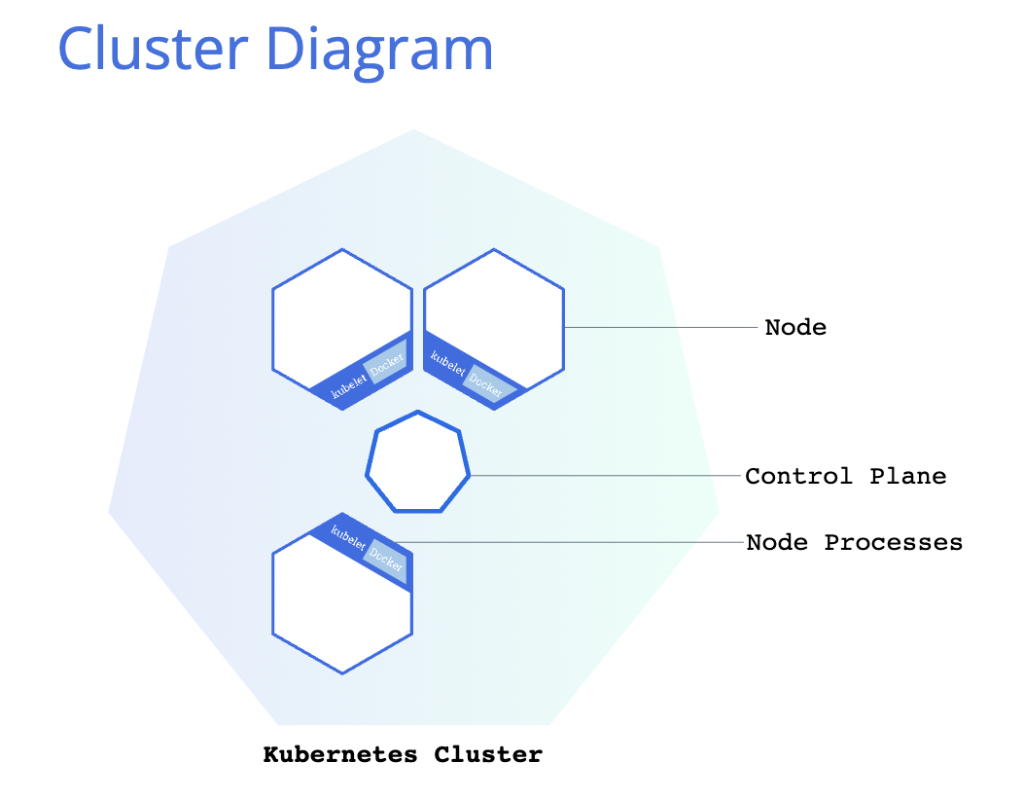

### Control Plane

- Responsible to manage the cluster and nodes that are used to host the running apps

- co-ordinates all activities in a cluster like scheduling apps, scaling apps and rolling out new updates etc

### Nodes

* **A node is a VM or a physical computer that serves as a worker machine in a Kubernetes cluster.**
* Each node has a Kubelet, which is an agent for managing the node and communicating with the Kubernetes control plane.
* The node should also have tools for handling container operations, such as containerd or Docker.
* A Kubernetes cluster that handles production traffic should have a minimum of three nodes because if one node goes down, both an etcd member and a control plane instance are lost, and redundancy is compromised. You can mitigate this risk by adding more control plane nodes.
* **The nodes communicate with the control plane using the**[**Kubernetes API**](https://kubernetes.io/docs/concepts/overview/kubernetes-api/), which the control plane exposes.
* End users can also use the Kubernetes API directly to interact with the cluster.

When you deploy applications on Kubernetes, you tell the control plane to start the application containers.

The control plane schedules the containers to run on the cluster's nodes.

* A Kubernetes cluster can be deployed on either physical or virtual machines. To get started with Kubernetes development, you can use Minikube. Minikube is a lightweight Kubernetes implementation that creates a VM on your local machine and deploys a simple cluster containing only one node. Minikube is available for Linux, macOS, and Windows systems. The Minikube CLI provides basic bootstrapping operations for working with your cluster, including start, stop, status, and delete.

|  |
| --- |
| ainani@ainani-a01 demo % minikube version  minikube version: v1.25.2  commit: 362d5fdc0a3dbee389b3d3f1034e8023e72bd3a7  ainani@ainani-a01 demo % minikube start  😄 minikube v1.25.2 on Darwin 12.2.1 (arm64)  🎉 minikube 1.26.0 is available! Download it: https://github.com/kubernetes/minikube/releases/tag/v1.26.0  💡 To disable this notice, run: 'minikube config set WantUpdateNotification false'  ✨ Using the docker driver based on existing profile  👍 Starting control plane node minikube in cluster minikube  🚜 Pulling base image ...  🏃 Updating the running docker "minikube" container ...  🐳 Preparing Kubernetes v1.23.3 on Docker 20.10.12 ...  ▪ kubelet.housekeeping-interval=5m  🔎 Verifying Kubernetes components...  ▪ Using image quay.io/rhdevelopers/core-dns-patcher  ▪ Using image gcr.io/k8s-minikube/storage-provisioner:v5  ▪ Using image alpine:3.11  ▪ Using image gcr.io/google_containers/pause:3.1  ╭──────────────────────────────────────────────────────────────────────────────────────────────────────╮  │ │  │ Registry addon with docker driver uses port 52417 please use that instead of default port 5000 │  │ │  ╰──────────────────────────────────────────────────────────────────────────────────────────────────────╯  📘 For more information see: https://minikube.sigs.k8s.io/docs/drivers/docker  ▪ Using image registry:2.7.1  ▪ Using image gcr.io/google_containers/kube-registry-proxy:0.4  🔎 Verifying registry addon...  🌟 Enabled addons: storage-provisioner, registry-aliases, default-storageclass, registry  🏄 Done! kubectl is now configured to use "minikube" cluster and "default" namespace by default  ainani@ainani-a01 demo % kubectl version  WARNING: This version information is deprecated and will be replaced with the output from kubectl version --short. Use --output=yaml|json to get the full version.  Client Version: version.Info{Major:"1", Minor:"24", GitVersion:"v1.24.2", GitCommit:"f66044f4361b9f1f96f0053dd46cb7dce5e990a8", GitTreeState:"clean", BuildDate:"2022-06-15T14:14:10Z", GoVersion:"go1.18.3", Compiler:"gc", Platform:"darwin/arm64"}  Kustomize Version: v4.5.4  Server Version: version.Info{Major:"1", Minor:"23", GitVersion:"v1.23.3", GitCommit:"816c97ab8cff8a1c72eccca1026f7820e93e0d25", GitTreeState:"clean", BuildDate:"2022-01-25T21:19:12Z", GoVersion:"go1.17.6", Compiler:"gc", Platform:"linux/arm64"}  ainani@ainani-a01 demo % kubectl cluster-info  Kubernetes control plane is running at https://127.0.0.1:52418  CoreDNS is running at https://127.0.0.1:52418/api/v1/namespaces/kube-system/services/kube-dns:dns/proxy  To further debug and diagnose cluster problems, use 'kubectl cluster-info dump'.  ainani@ainani-a01 demo % kubectl get nodes  NAME STATUS ROLES AGE VERSION  minikube Ready control-plane,master 6d22h v1.23.3  ainani@ainani-a01 demo % |

# Deploy an App

## Kubernetes Deployments

* Containerized apps are deployed over Kubernetes cluster
* To do so, user creates Deployment configuration
* The Deployment instructs Kubernetes how to create and update instances of your application.
* Once you've created a Deployment, the Kubernetes control plane schedules the application instances included in that Deployment to run on individual Nodes in the cluster.
* Once the application instances are created, a Kubernetes Deployment Controller continuously monitors those instances.
* If the Node hosting an instance goes down or is deleted, the Deployment controller replaces the instance with an instance on another Node in the cluster.
* **This provides a self-healing mechanism to address machine failure or maintenance.**

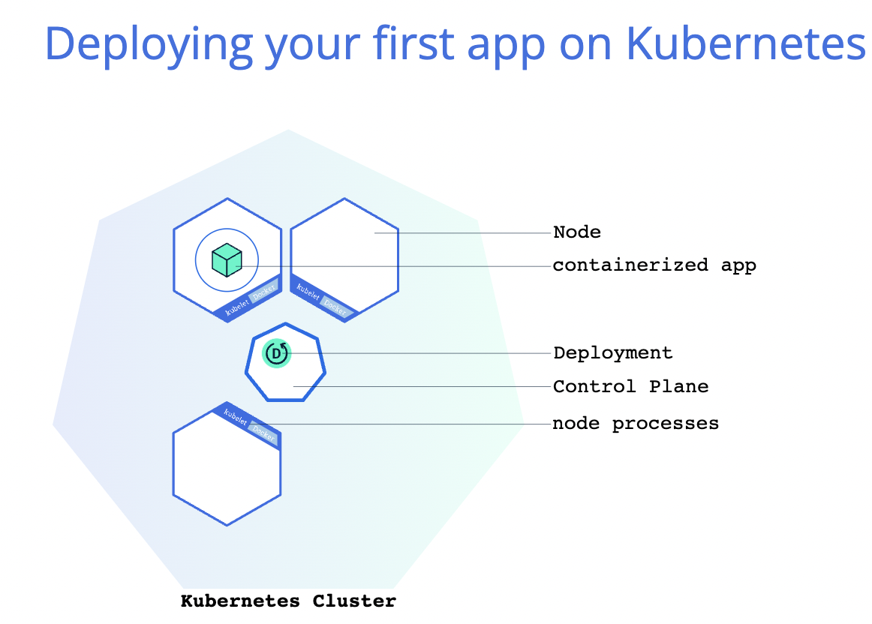

You can create and manage a Deployment by using the Kubernetes command line interface, **Kubectl**.

Kubectl uses the Kubernetes API to interact with the cluster.

When you create a Deployment, you'll need to specify the container image for your application and the number of replicas that you want to run. You can change that information later by updating your Deployment

|  |
| --- |
| ainani@ainani-a01 demo % kubectl version  WARNING: This version information is deprecated and will be replaced with the output from kubectl version --short. Use --output=yaml|json to get the full version.  Client Version: version.Info{Major:"1", Minor:"24", GitVersion:"v1.24.2", GitCommit:"f66044f4361b9f1f96f0053dd46cb7dce5e990a8", GitTreeState:"clean", BuildDate:"2022-06-15T14:14:10Z", GoVersion:"go1.18.3", Compiler:"gc", Platform:"darwin/arm64"}  Kustomize Version: v4.5.4  Server Version: version.Info{Major:"1", Minor:"23", GitVersion:"v1.23.3", GitCommit:"816c97ab8cff8a1c72eccca1026f7820e93e0d25", GitTreeState:"clean", BuildDate:"2022-01-25T21:19:12Z", GoVersion:"go1.17.6", Compiler:"gc", Platform:"linux/arm64"}  ainani@ainani-a01 demo % kubectl get nodes  NAME STATUS ROLES AGE VERSION  minikube Ready control-plane,master 6d23h v1.23.3  ainani@ainani-a01 demo % kubectl create deployment kubernetes-bootcamp --image=gcr.io/google-samples/kubernetes-bootcamp:v1  deployment.apps/kubernetes-bootcamp created  ainani@ainani-a01 demo % kubectl get deployments  NAME READY UP-TO-DATE AVAILABLE AGE  kubernetes-bootcamp 1/1 1 1 50s  ainani@ainani-a01 demo % |

# Explore an App

## Kubernetes Pods

* Once user created a Deployment, Kubernetes created a **Pod** to host your application instance.
* A Pod is a Kubernetes abstraction that represents a group of one or more application containers (such as Docker), and some shared resources for those containers. Those resources include:
  + Shared storage, as Volumes
  + Networking, as a unique cluster IP address
  + Information about how to run each container, such as the container image version or specific ports to use
* A Pod models an application-specific "logical host" and can contain different application containers which are relatively tightly coupled.
* For example, a Pod might include both the container with your Node.js app as well as a different container that feeds the data to be published by the Node.js webserver.
* The containers in a Pod share an IP Address and port space, are always co-located and co-scheduled, and run in a shared context on the same Node.
* Pods are the atomic unit on the Kubernetes platform. When we create a Deployment on Kubernetes, that Deployment creates Pods with containers inside them (as opposed to creating containers directly).
* Each Pod is tied to the Node where it is scheduled, and remains there until termination (according to restart policy) or deletion. In case of a Node failure, identical Pods are scheduled on other available Nodes in the cluster.
* *A Pod is a group of one or more application containers (such as Docker) and includes shared storage (volumes), IP address and information about how to run them*

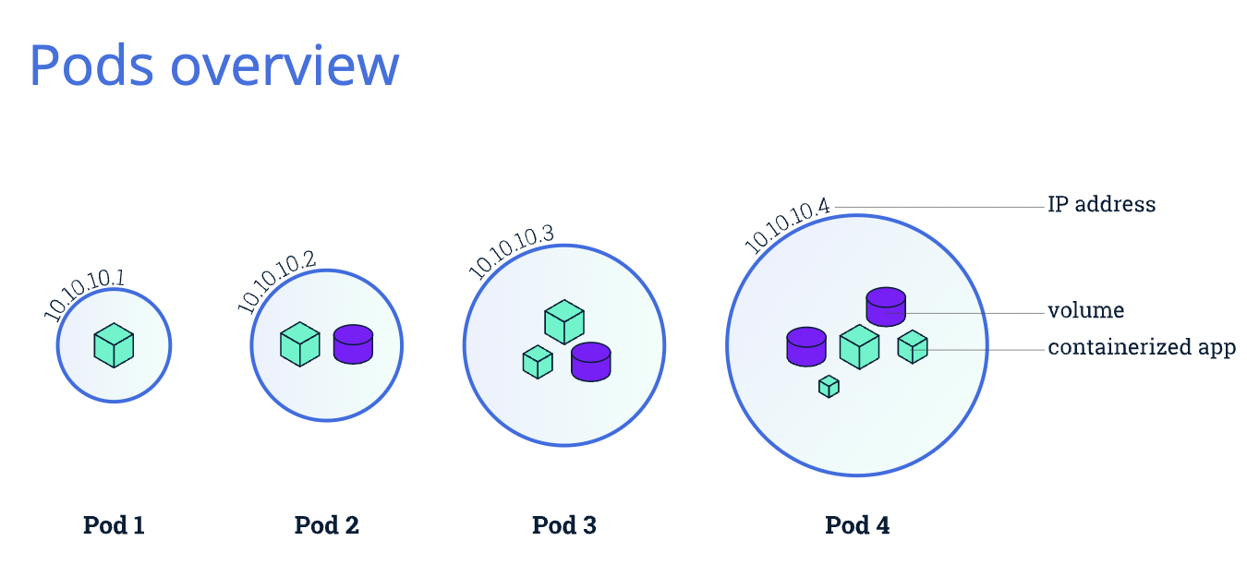

## Kubernetes Nodes

A Pod always runs on a **Node**. A Node is a worker machine in Kubernetes and may be either a virtual or a physical machine, depending on the cluster. Each Node is managed by the control plane. A Node can have multiple pods, and the Kubernetes control plane automatically handles scheduling the pods across the Nodes in the cluster. The control plane's automatic scheduling takes into account the available resources on each Node.

Every Kubernetes Node runs at least:

* Kubelet, a process responsible for communication between the Kubernetes control plane and the Node; it manages the Pods and the containers running on a machine.
* A container runtime (like Docker) responsible for pulling the container image from a registry, unpacking the container, and running the application.

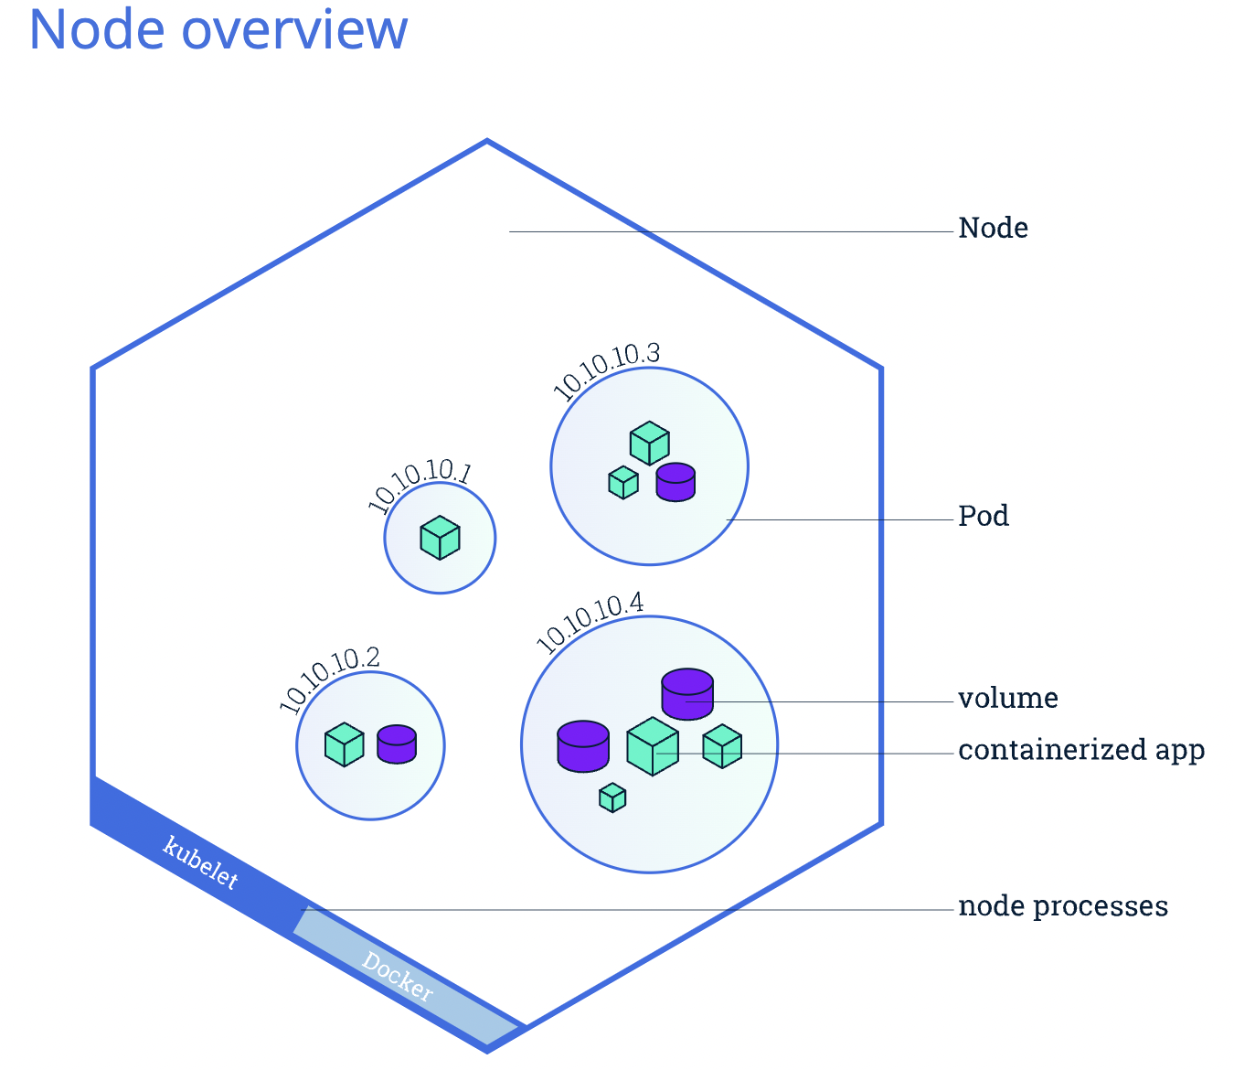

# Expose an App

## Kubernetes Services

* When a worker node dies, the Pods running on the Node are also lost.
* A [ReplicaSet](https://kubernetes.io/docs/concepts/workloads/controllers/replicaset/) might then dynamically drive the cluster back to desired state via creation of new Pods to keep your application running.
* A Service in Kubernetes is an abstraction which defines a logical set of Pods and a policy by which to access them.
* Services enable a loose coupling between dependent Pods. A Service is defined using YAML or JSON, like all Kubernetes objects.
* Although each Pod has a unique IP address, those IPs are not exposed outside the cluster without a Service.
* Services allow your applications to receive traffic.

# ConfigMaps

ConfigMaps are used to passed environments variable in pod-definitions’ yaml file.

1. Create ConfigMap
   1. Imperative Way: using Command line directly  
      Syntax:   
       kubectl create configmap <config-name> --from-literal=<key>=<value> --from-literal=<key>=<value>  
        
      Example:  
       kubectl create configmap app-config --from-literal=APP_COLOR=darkblue --from-literal=APP_OTHER=disregard  
      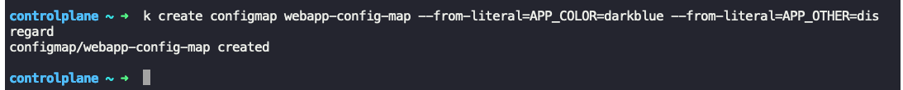  
        
      Note: This method become difficult when there are lot of --from-literal, so we generally use another method using file  
        
      Syntax:  
       kubectl create configmap <config-name> --from-file=<path-to-file>  
      Example:  
       kubectl create configmap app-config --from-file=app_config.properties
   2. Declarative Way: using an config-map.yaml file

|  |
| --- |
| apiVersion: v1 kind: ConfigMap  metadata:  name: app-config  data:  APP_COLOR: blue  APP_MODE: prod |

Syntax: kubectl create -f config-map.yaml

* 1. Create configmap without any configuration in a particular namespace  
     Syntax:   
      k create cm <configmap_name> -n <namespace>  
     Example: k create cm ingress-nginx-controller -n ingress-nginx

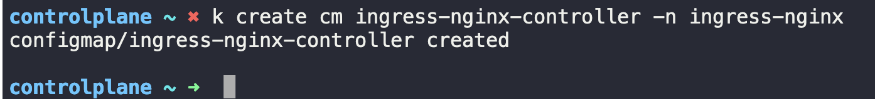

## Injecting ConfigMaps in pod-definition.yaml

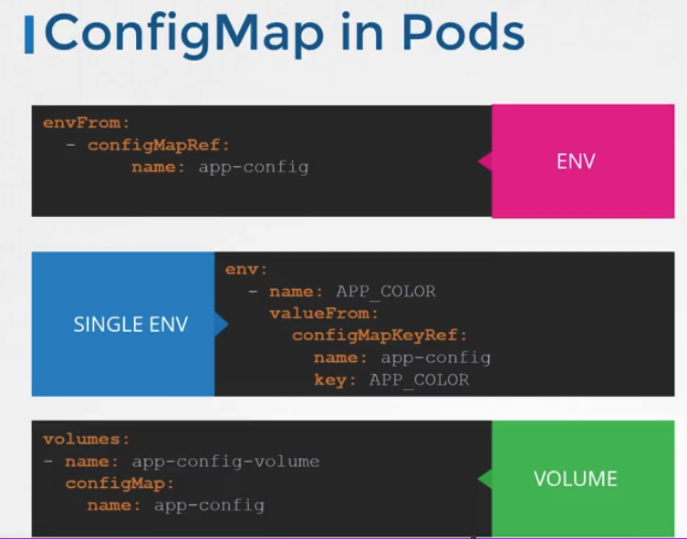

## Practice & Outputs

* Command to find the environments set in pod-definition.yaml  
  Syntax: k describe pod webapp-color  
  Example: k describe pod webapp-color 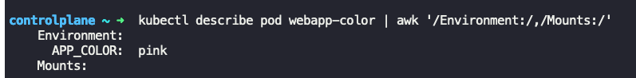
* Command to update the env variable
  + Take output of pod definition in .yaml
  + Edit the existing file  
    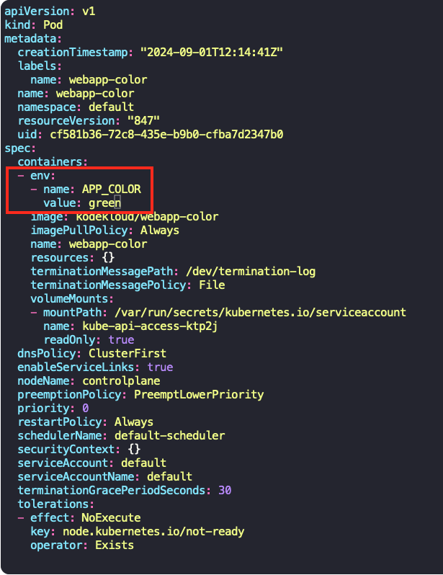
  + Delete the existing pod
  + Create new pod using edited file
* Command to get configMaps

Syntax:  
 k get configmaps

k get cm  
Example:  
 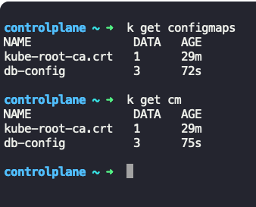

* Command to describe configMap  
  Syntax:   
   k get cm <configmap_name>

Example:  
 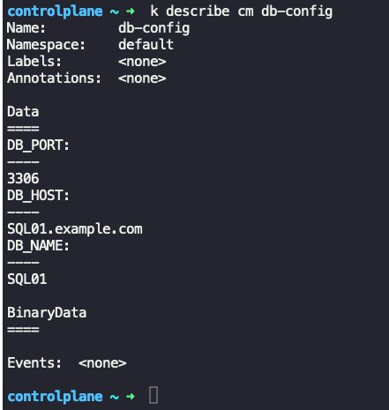

* Command to create new config map using yaml file

|  |
| --- |
| apiVersion: v1  kind: ConfigMap  metadata:  name: webapp-config-map  data:  APP_COLOR: darkblue  APP_OTHER: disregard |

Syntax:  
 k create -f new-cm.yaml  
Example:  
 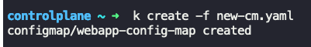

* Command to delete configmap  
  Syntax:  
     
  Example:  
   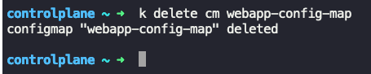
* To use the newly created configMap in pod file  
    
  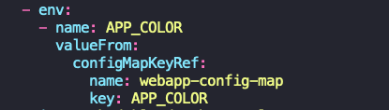

# Secrets

Secrets are same as ConfigMaps, only difference is Secrets are used to pass the environment variables in encoded form which is required for any app to connect (example: database)

1. Create Secret
   1. Imperative Way: using Command line directly  
      Syntax:   
       kubectl create secret <command> <secret-name> --from-literal=<key>=<value> --from-literal=<key>=<value>  
        
      Example:  
       kubectl create secret generic web-secret --from-literal=DB_HOST=localhost --from-literal=DB_USER=mysql --from-literal=DB_PASSWORD=mysql123  
      
   2. Declarative Way: using an secret.yaml file

|  |
| --- |
| apiVersion: v1 kind: Secret  metadata:  name: test-secret  data:  DB_HOST: localhost  DB_USER: mysql  DB_PASSWORD: mysql123 |

Syntax: kubectl create -f secret.yaml

## Injecting Secrets in pod-definition.yaml

Notes:

* Secrets are stored in encoded format not in encrypted format
* So anyone can decode it easily
* Kubernetes store these secrets in etcd as encoded format only.
* A secret is only sent to a node if a pod on that node requires it.
* Kubelet stores the secret into a tmpfs so that the secret is not written to disk storage.
* Once the Pod that depends on the secret is deleted, kubelet will delete its local copy of the secret data as well.

<https://www.youtube.com/watch?v=MTnQW9MxnRI>

## Practice & Outputs

* Command to get secrets  
  Syntax:  
   k get secrets  
  Example:  
   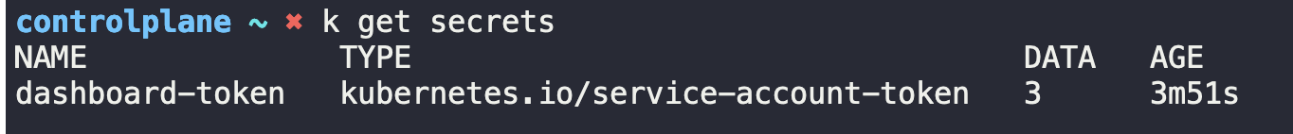
* Command to describe secret  
  Syntax:  
   k describe secret <secret_name>  
  Example:  
   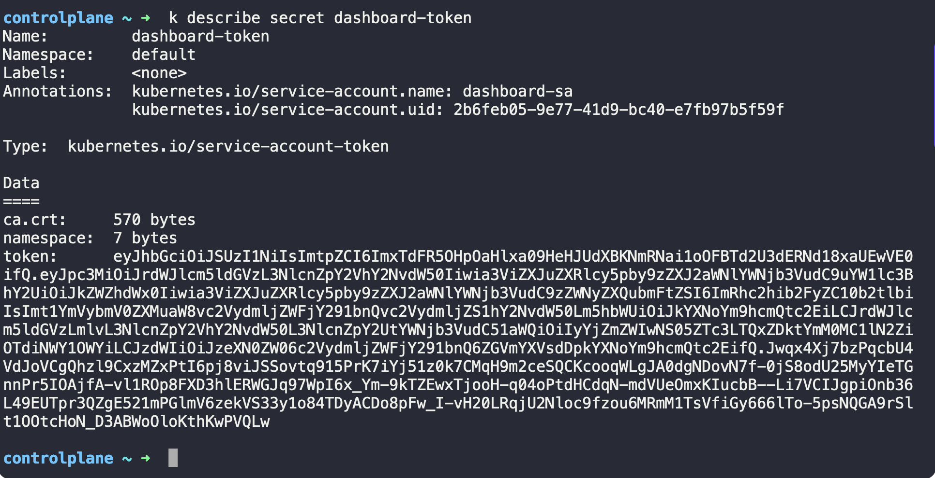
* Command to create secret  
  Syntax:  
   k create secret <command> --from-literal=<key>=<value> --from-literal=<key>=<calue>  
  Example:   
   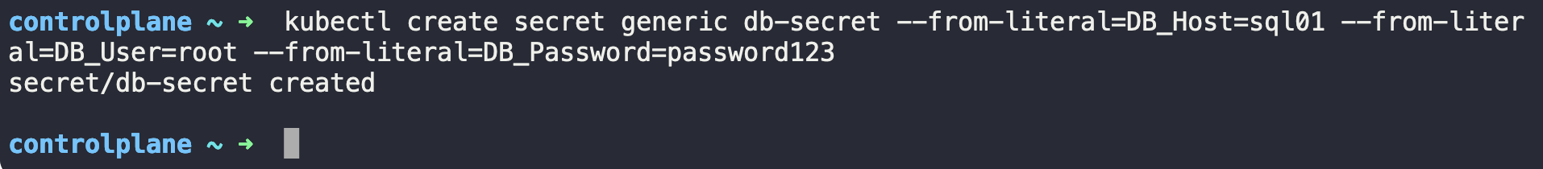
* Injecting already created secret in pod-defintion.yaml file  
  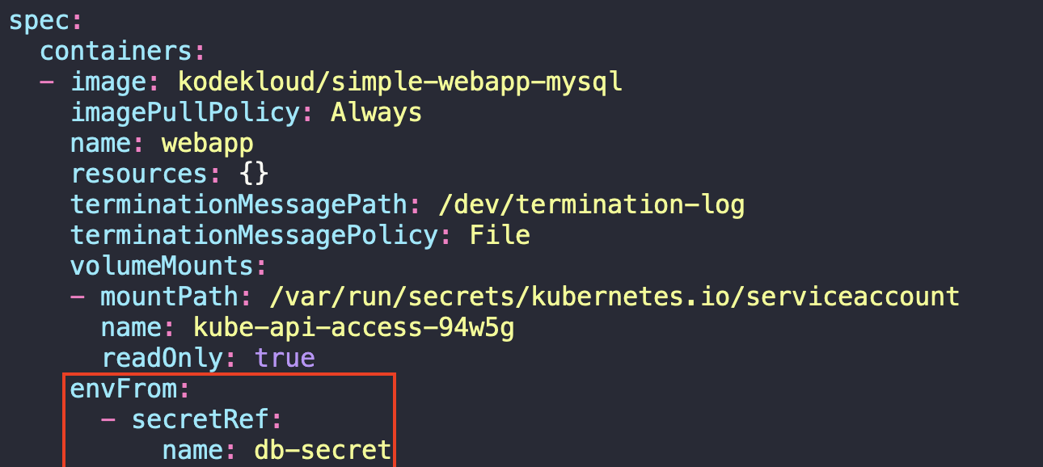

# Security Contexts:

* Command to see the pod is running by which Linux user  
  Synatx:  
   k exec <pod_name> -- whoami  
  Example:  
  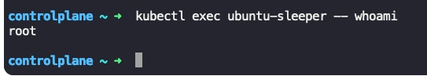
* Injecting SecurityContext  
  Syntax:  
   Update the existing yaml definition:  
   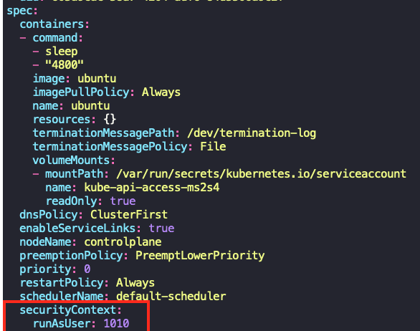  
  Example:  
   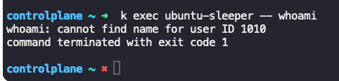
* Security context at container level and Pod level  
  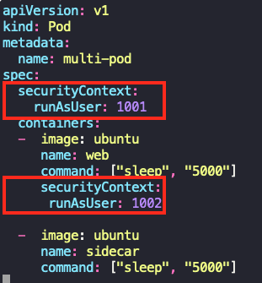  
    
  Note: Keep note that securitylevel at container level will always override the securitycontext at pod level  
  So, in above example user: 1002 will take preference over user: 1001. As user:1001 is defined at pod level, while user:1002 is defined at container level  
    
  SecurityContext defined at Pod level would be carried over to all containers in POD

SecurityContext at Pod level

SecurityContext at Container level

So, if any sidecar container(OR other containers) are running along with main container, it will have securitycontext of pod level.

* To add capabilities in container user can add securityContext as below:  
  Note: We can’t add capabilities under Pod level, the capabilities should be added in container level only.  
  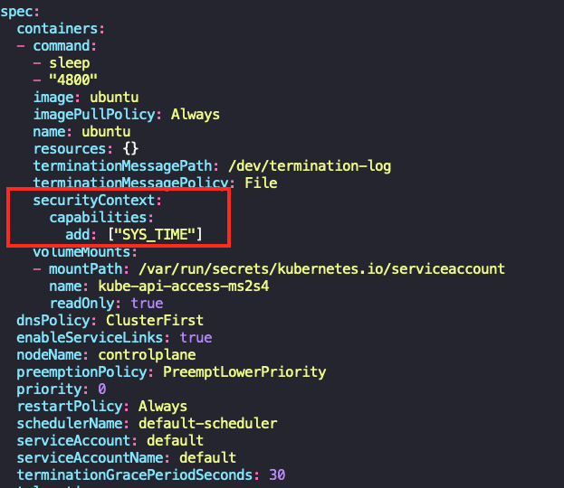

# Service Account

* Command to get Service accounts:  
  Syntax: k get sa  
   k get serviceaccounts  
   k get serviceaccount  
  Example:  
   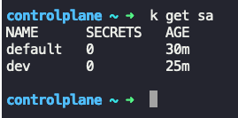
* Command to describe sa  
  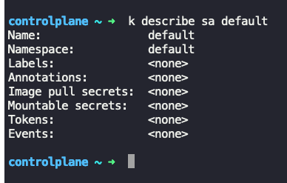
* Command to create sa  
  Syntax:  
   k create sa <sa_name>  
  Example: k create sa ingress-nginx  
  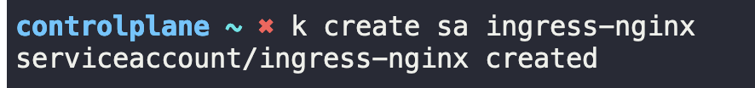
* Command to create sa in a particular namespace  
  Syntax:  
   k create sa <sa_name> -n <namespace>  
  Example: k create sa ingress-nginx -n ingress-nginx  
  

# Section 5 [Observability]

## Readiness & Liveness Probes:

### Readiness Probes

Readiness probes are configured to check that container is actually ready/running and ready to accept the requests from services. Because Kubernetes will change the status of pod as “Running” as soon as it found that container in that pod is started running. But actually, there are few processes/apps (like Jenkins) which may take time to come up and serve. As Kubernetes had already set the pod state as Running, services will start sending the requests to these pods which will fail actually as processes in these containers are yet to be ready to accept the requests. For this we configure readiness probes that will check the status of process, that it’s ready to accept the request or not.

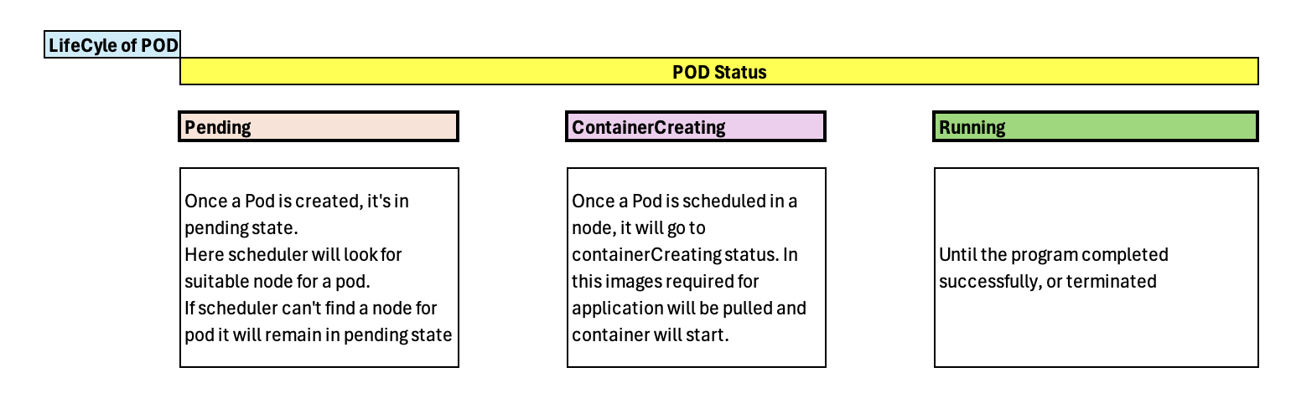

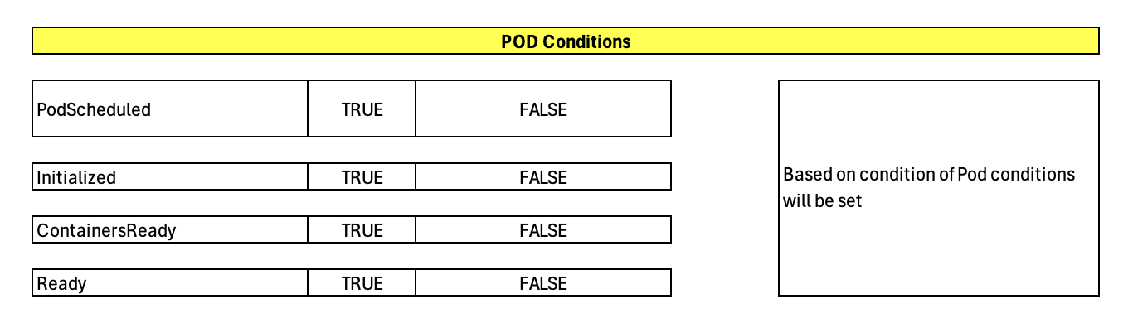

### Liveness Probes

Liveness probes are configured to check that container is healthy and working fine, this is useful in case of deadlocks. Deadlocks may occur when an application is stuck running in infinite loop, where for Kubernetes it’s still understand that app/container is running. But in actual this running app is not serving any purpose, because it’s stuck and no longer serving any request.

Http ready script to check readinessProbe for a webapp

|  |
| --- |
| cat curl-test.sh  for i in {1..20}; do  kubectl exec --namespace=kube-public curl -- sh -c 'test=`wget -qO- -T 2 http://webapp-service.default.svc.cluster.local:8080/ready 2>&1` && echo "$test OK" || echo "Failed"';  echo ""  done |

Freeze API

|  |
| --- |
| nohup kubectl exec --namespace=kube-public curl -- wget -qO- http://webapp-service.default.svc.cluster.local:8080/freeze & |

Crash API

|  |
| --- |
| kubectl exec --namespace=kube-public curl -- wget -qO- http://webapp-service.default.svc.cluster.local:8080/crash |

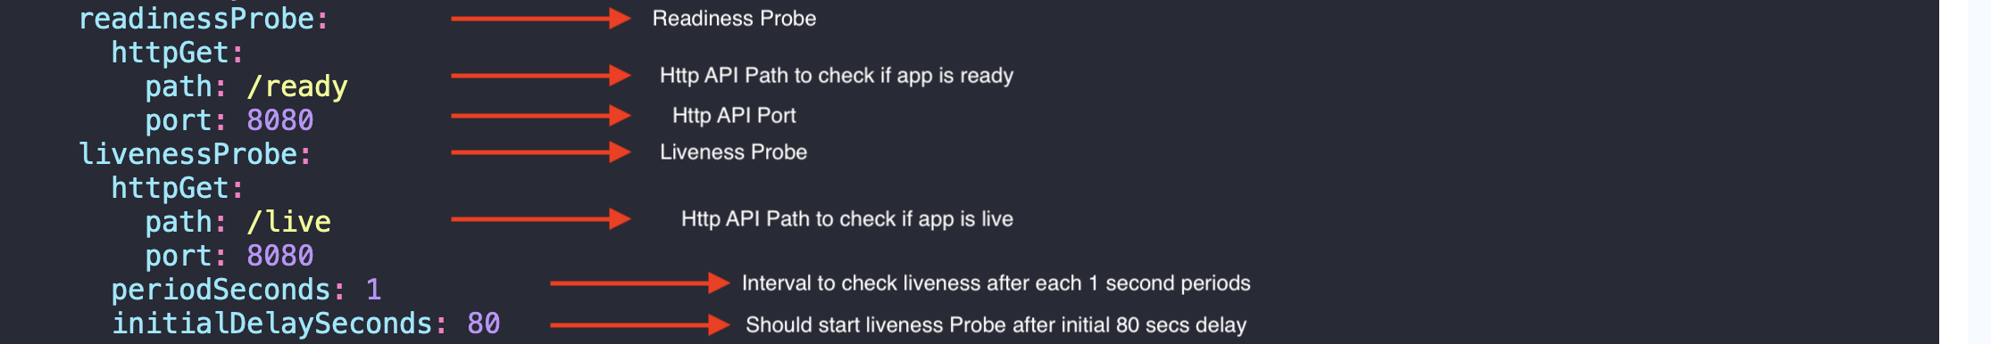

## Container Logging

To check the logs of containers running in pod, use below command

|  |
| --- |
| kubectl logs -f <pod_name> <container_name> |

Here, -f is used to get live logs  
  
Note: If there is only single container running in a pod, then <container_name> is not required, but in case multiple containers are running in a pod (like helper containers) then specifying the container_name is must otherwise it will give error.

Remove -f option to see logs for finished containers.

## Monitoring

Kubernetes monitoring happens using Metrics Server (earlier Heapster), metrics server stores metrics of pods as IN-MEMORY instead of disk, so we will not able to get historic metrics (until we use other tools). Metrics is collected using CAdvisor (Container Advisor) which is sub component of Kubelet. It collects the metrics and share the metrics using Kubelet to Metrics server.

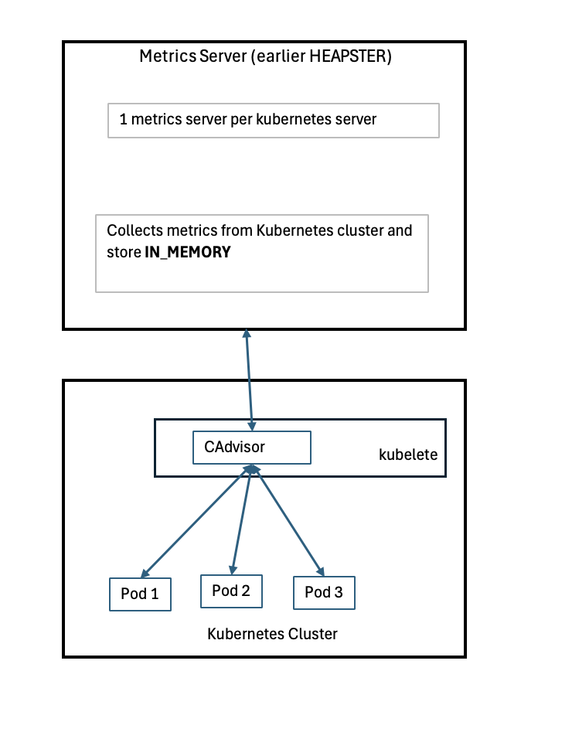

Deploying metrics server

* 1. Clone the repo

|  |
| --- |
| git clone https://github.com/kodekloudhub/kubernetes-metrics-server.git  Cloning into 'kubernetes-metrics-server'...  remote: Enumerating objects: 31, done.  remote: Counting objects: 100% (19/19), done.  remote: Compressing objects: 100% (19/19), done.  remote: Total 31 (delta 8), reused 0 (delta 0), pack-reused 12 (from 1)  Receiving objects: 100% (31/31), 8.08 KiB | 4.04 MiB/s, done.  Resolving deltas: 100% (10/10), done. |

* 1. Go inside cloned repo  
     cd kubernetes-metrics-server
  2. Deploy:

|  |
| --- |
| k create -f .  clusterrole.rbac.authorization.k8s.io/system:aggregated-metrics-reader created  clusterrolebinding.rbac.authorization.k8s.io/metrics-server:system:auth-delegator created  rolebinding.rbac.authorization.k8s.io/metrics-server-auth-reader created  apiservice.apiregistration.k8s.io/v1beta1.metrics.k8s.io created  serviceaccount/metrics-server created  deployment.apps/metrics-server created  service/metrics-server created  clusterrole.rbac.authorization.k8s.io/system:metrics-server created  clusterrolebinding.rbac.authorization.k8s.io/system:metrics-server created |

* 1. Getting output

|  |
| --- |
| k top node  NAME CPU(cores) CPU% MEMORY(bytes) MEMORY%  controlplane 226m 0% 934Mi 0%  node01 27m 0% 280Mi 0%   k top pods  NAME CPU(cores) MEMORY(bytes)  elephant 14m 32Mi  lion 1m 18Mi  rabbit 99m 77Mi |

# Section 6 [POD Design]

## Labels, Selectors and Annotations:

Labels in Kubernetes are used to differentiate Kubernetes objects like (deployments, services, pods etc)

Labels are mentioned in metadata section of pod-definition.yaml file e.g. app=App1

Selectors are used to select that particular label, created using pod-definition.yaml file.

“**k get pods --selectors app=App1**”

While Labels and Selectors are used to group and select objects.

Annotations are used to record other details for informatorily purpose.  
like: Name, version & BuildVersion

Command to list pods using selector:

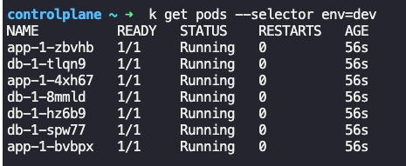

k get pods all --selector env=prod

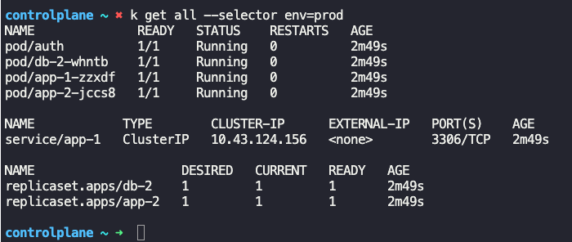

Multiple selectors can be used as comma separated

k get pod --selector env=prod,bu=finance,tier=frontend  
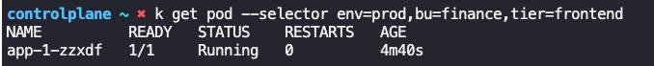

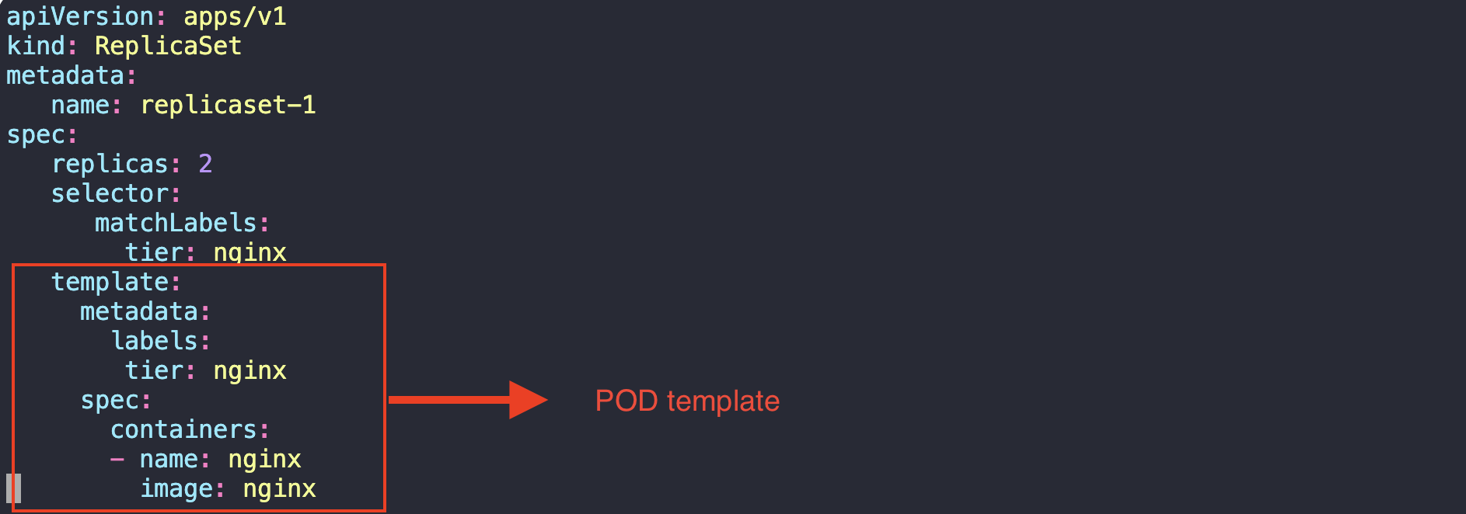

## Rolling Updates & Rollback in Deployments

There are 2 types of strategies for update:

* Recreate 🡪 all pods will be bringdown and then new pods will be created. This is having downtime and it’s not default strategy.
* Rolling update 🡪 Pods will be bring down one by one and simultaneously bring up one by one. This will avoid any downtime as not all pods went down.

Note: Rolling update is the default deployment strategy.

How Upgrades works ?

When a new deployment set is asked to be deployed using k create -d deploy.yaml file, it will automatically create a Replica-set and then deploy the pods in that replica-set.

During upgrade, it will create another replica-set and start deploying the pods one by one simultaneously deleting the pods in replica-set1 one by one.

Rollbacks:

Rollback works in similar fashion, by destroying the pods in new replica-set and bring up the pods in older replicate set again.

Command to get rollout status:

Syntax: **k rollout status <name_of_k8_object>**

Example: k rollout status deployment/frontend

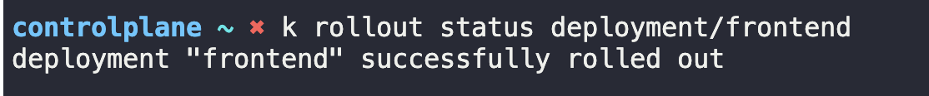

Command to get rollout history:

Syntax: **k rollout history <name_of_k8_object>**

Example: k rollout history deployment/frontend  
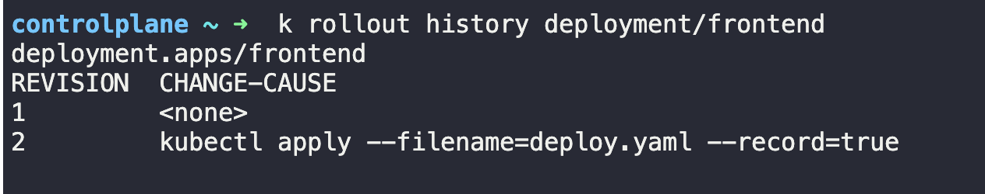

RollingUpdate Strategy

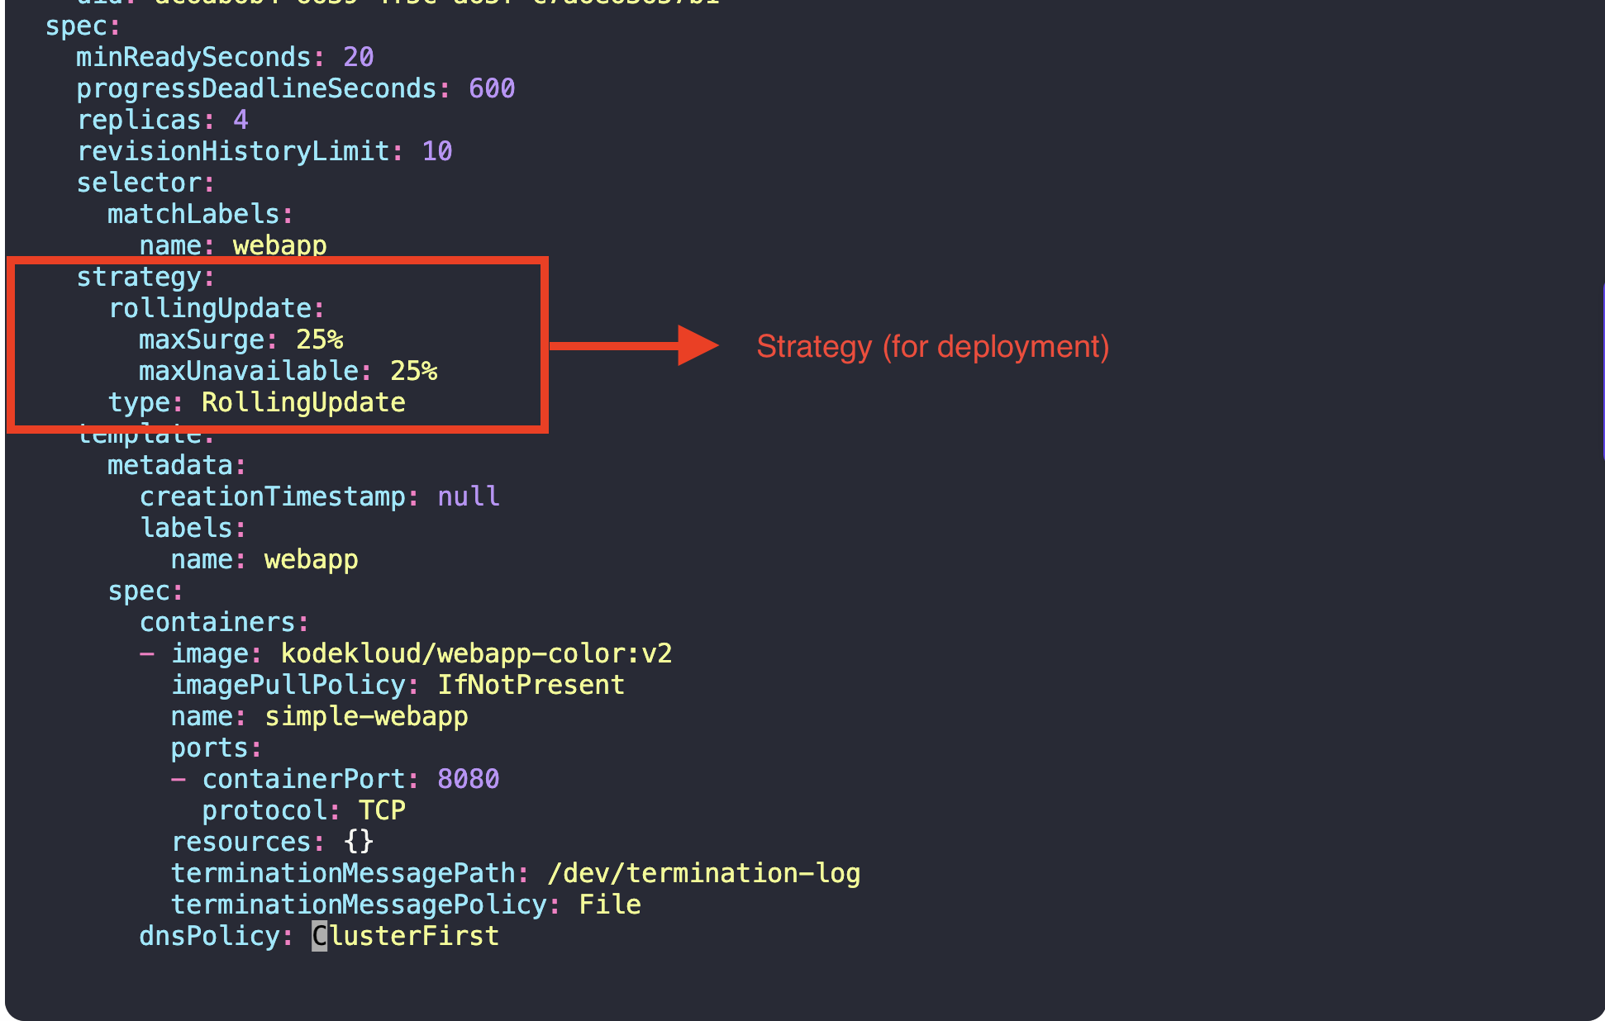

Recreate Strategy :

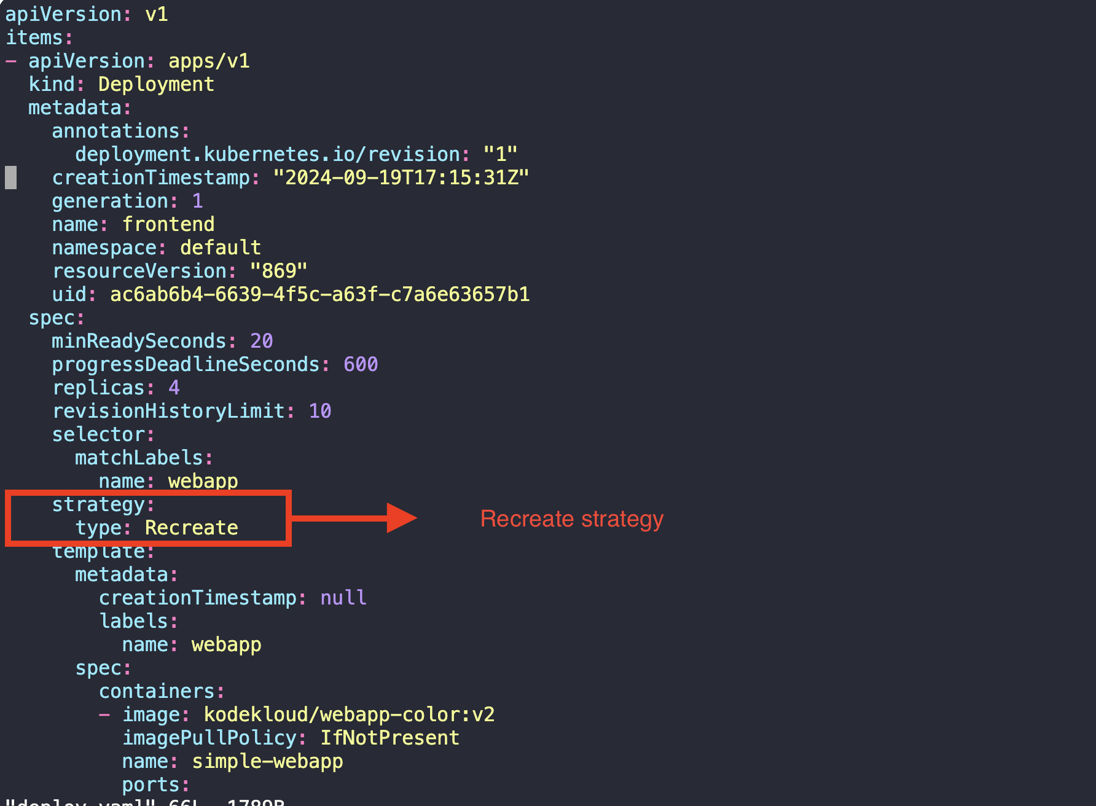

Command to roll back the existing upgrade:

Syntax: **k rollout undo <name_of_k8_object>**

Example: k rollout undo deployment/frontend

## Blue-Green Strategy

In Blue-Green strategy there are 2 deployments exists at a time. Blue deployment with older version while Green deployment with newer version. Service send the requests to Blue deployments and once the tests completed, change the request to Green deployment.

## Canary Strategy

In Canary deployment strategy, we only redirect small percentage of traffic to newly deployed deployment with upgraded version of pods. Rest all traffic will still continue to older deployment running at older version.  
The reason behind this is to avoid any kind to requests failures if there is any issue with new version of pods. So here we shift the traffic from old to new pods spontaneously.

To achieve this we have 2 steps:

* 1. Route traffic to both versions:

To do this we can create new deployment with equal no. of pods having new labels app=version2 and let service use both labels to transfer the requests in load balanced way. But that would be 50-50 % of requests in both side.

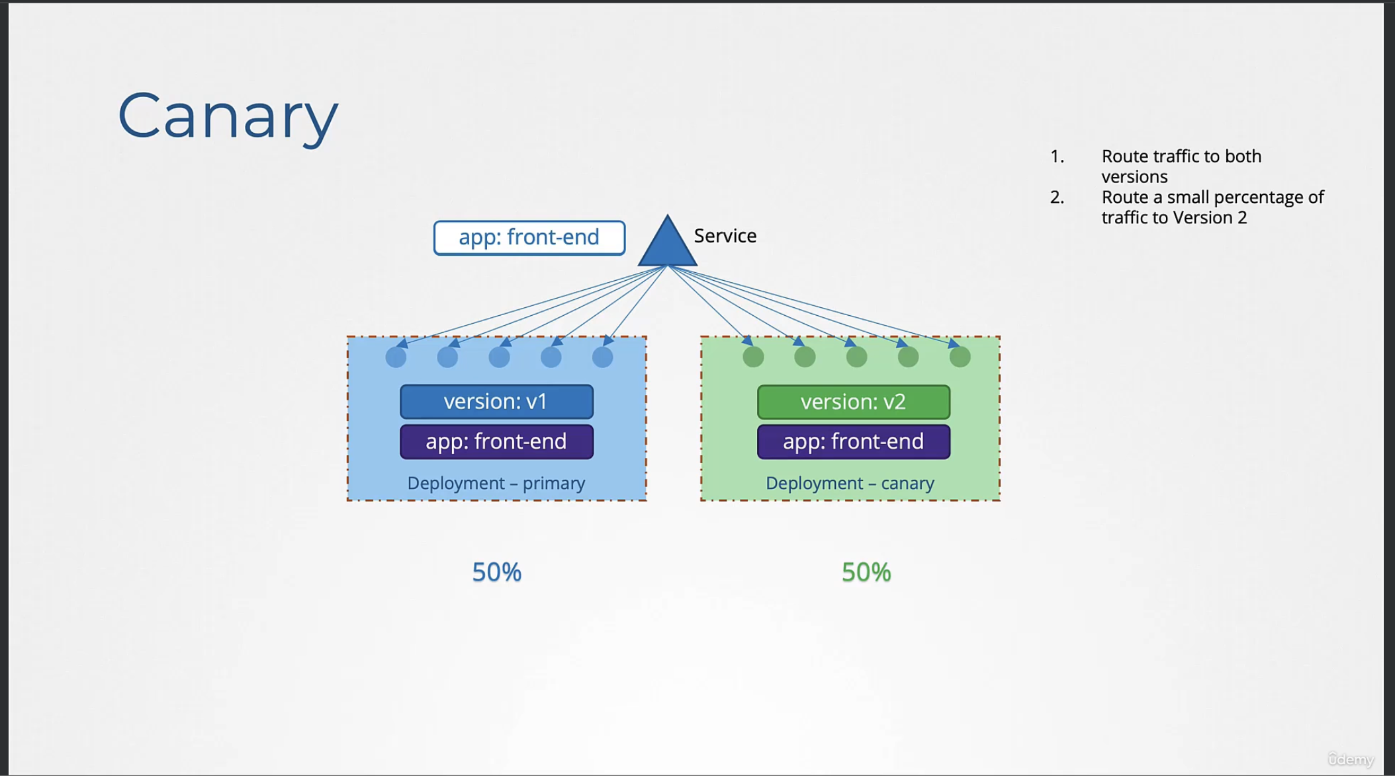

* 1. Route a small percentage of traffic to version 2  
     To do this we keep only one pod in new deployment and delete the other pods.

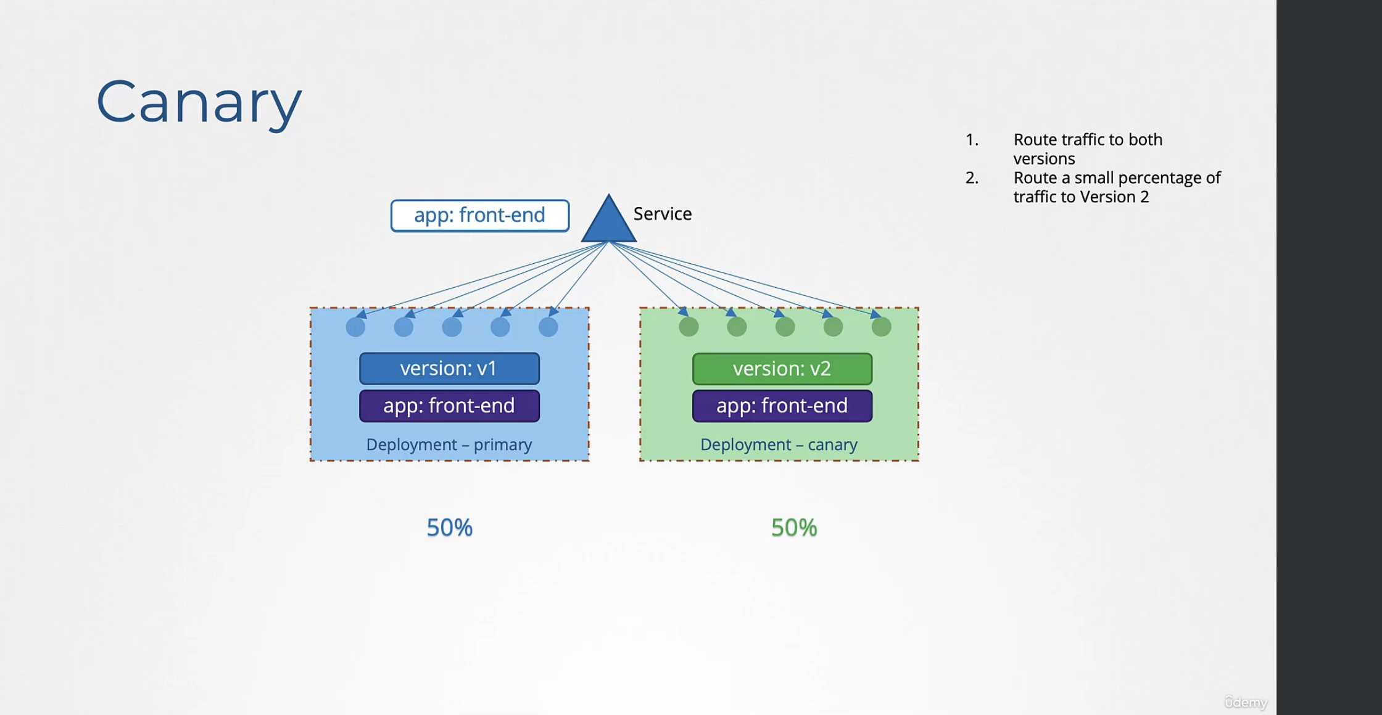

Later we can upgrade the 1st deployment using RollingUpdate strategy.

One limitation of using Canary deployment is we don’t have control over percentage of traffic to be redirected towards new deployment. This need to be done using service mesh.

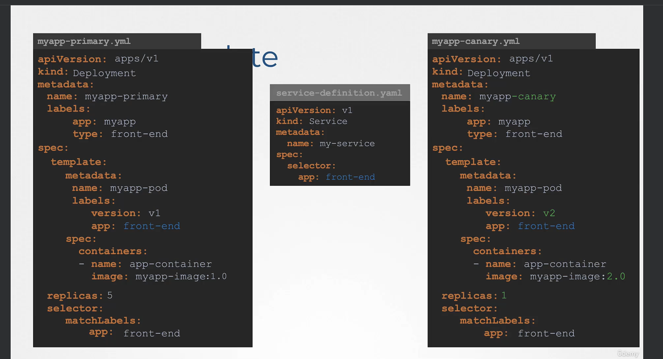

## Jobs

restartPolicy: Pods are designed to keep running themselves if they are failed or stopped by any mean. Because of this pods will try to keep alive them by restarting themselves multiple times. This can be stopped by setting restartPolicy: Never  
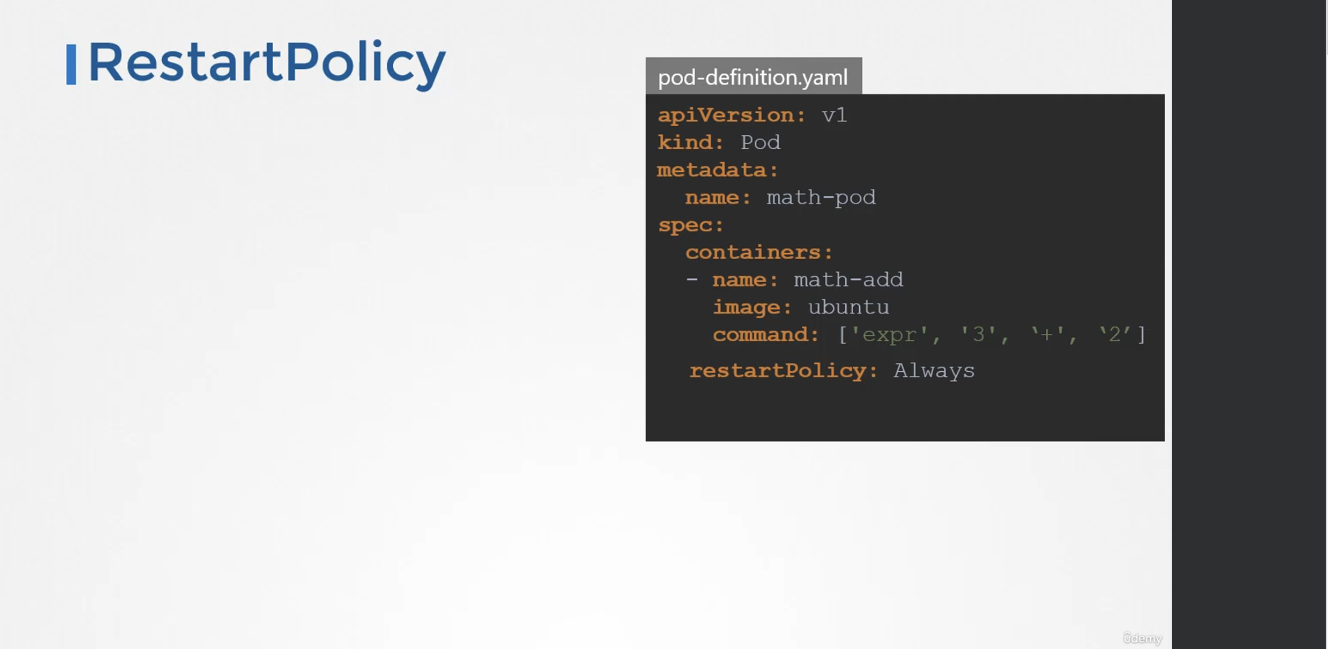

ReplicaSet ensures that Pod should be keep running, while Jobs ensures that Pod should be completed once assigned tasks are compelted.

Jobs in Kubernetes is another object. Jobs are used for specific tasks (like batch processing). Once those tasks are completed the pods associated with this job will be marked as completed and terminated.

We can achieve parallelism in jobs, if all tasks are independent of each other. So all pods in jobs would be spawned at same time till the desired state (completions) is not achieved.

In this process if any one of pod is not successfully completed, Kubernetes is intelligent enough to only start pending pod till the time it’s desired state is not achieved.  
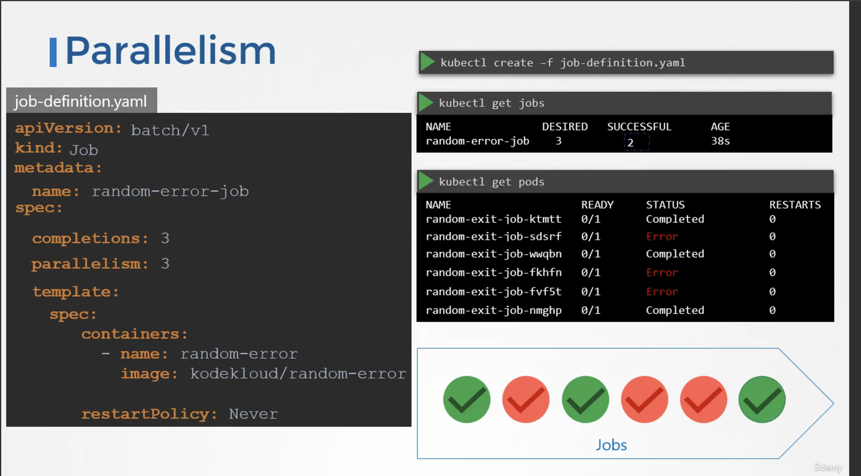

kubectl create job throw-dice-job --image=kodekloud/throw-dice --dry-run=client -o yaml > throw-dice-job.yaml

|  |
| --- |
| apiVersion: batch/v1  kind: Job  metadata:  name: throw-dice-job  spec:  backoffLimit: 15 # This is so the job does not quit before it succeeds.  template:  spec:  containers:  - name: throw-dice  image: kodekloud/throw-dice  restartPolicy: Never |

# Section 7 [Services & Networking]

## Services:

In Kubernetes Services are mainly responsible for internal and external connectivity. Two pods can communicate to each other using services internally, while the same services can be used to connect these pods to outside world like UI or Databases.  
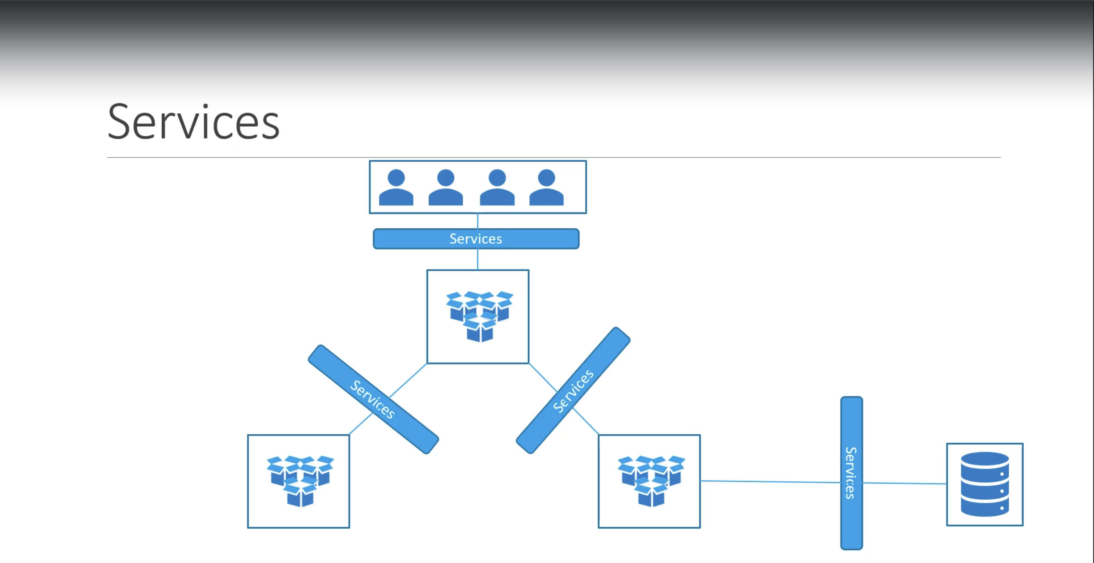

In below example to connect to a web app pod running inside Node, we need a NodePort Service. Which will be listening on a NodePort (here, 30008) and forward the request to Pod of same node.

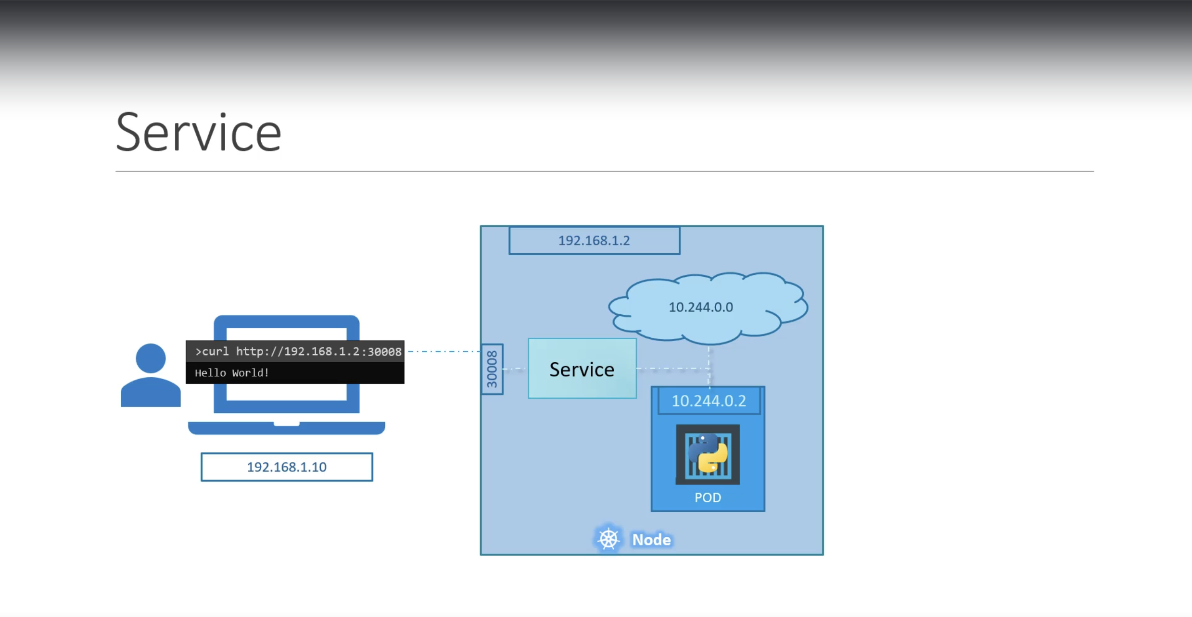

There are 3 types of services:

NodePort:  
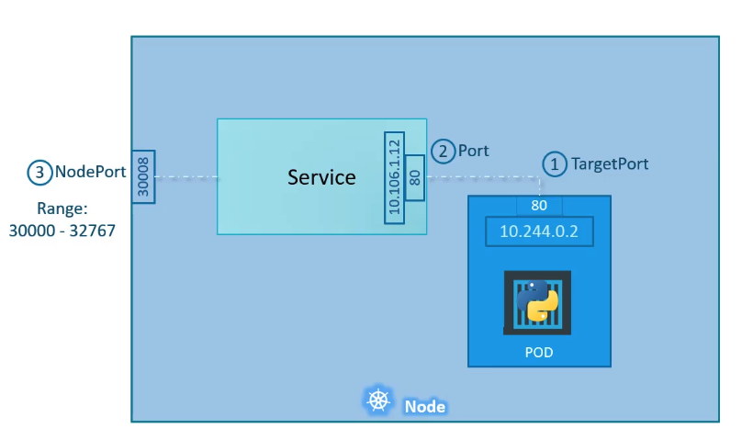

ClusterIP: This type of service mainly used to provide centralized connectivity in other clusters. Suppose a front end pods (say 5 pods) want to connects with backend pods (say 5 pods), all pods from frontend should connect to all pods of backend to send the request. This will create in total 5*5 = 25 connections which not looks good. Also, the Ips keep changing in case any one of pod is crashed, so we don’t know which IP to connect.   
To solve this problem, we create ClusterIP service which will sit in middle of frontend pods and backend pods and serve as a bridge to pass the requests and responses.

**ClusterIP is the default type of Service in Kubernetes**.

LoadBalancer

A simple webapp can be configured as below using service in Kubernetes cluster

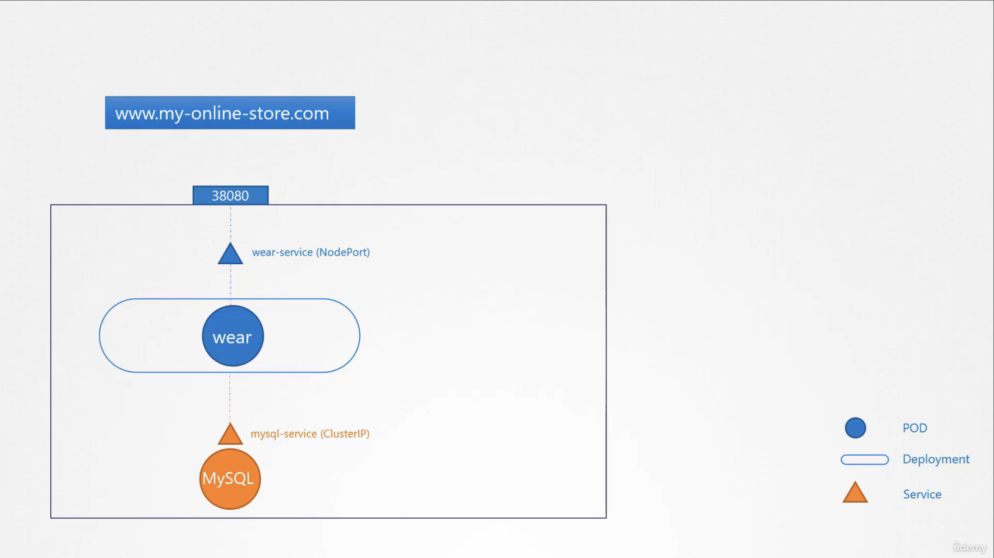

## Ingress:

Ingress Controller: Set of supported solution using Nginx, HaProxy or Trafeik by Kubernetes to create a load balancer that transfer the requests is known as ingress controller.

Ingress Resources: The set of configurations rules that carry the ingress controller request to further is known as Ingress resources.

## Network Policies:

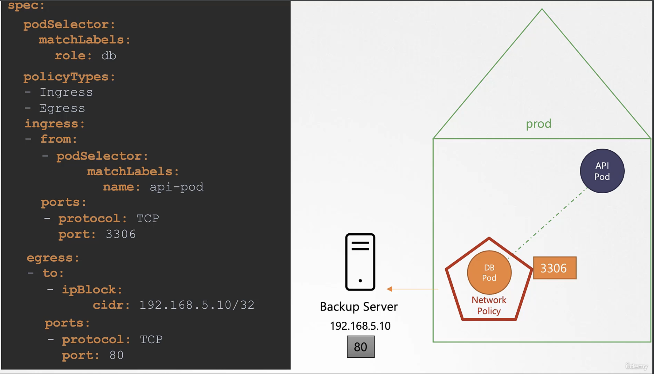

* Command to get network policies:

Syntax:   
 k get networkpolicies  
Example: k get netoworkpolicies  
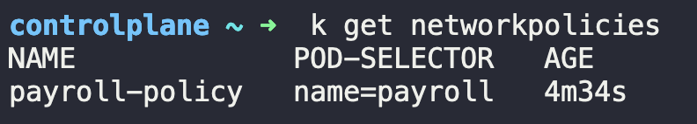

* Command to describe network policies:

Syntax:   
 k describe networkpolicies <network_policy_name>  
Example: k describe networkpolicies payroll-policy

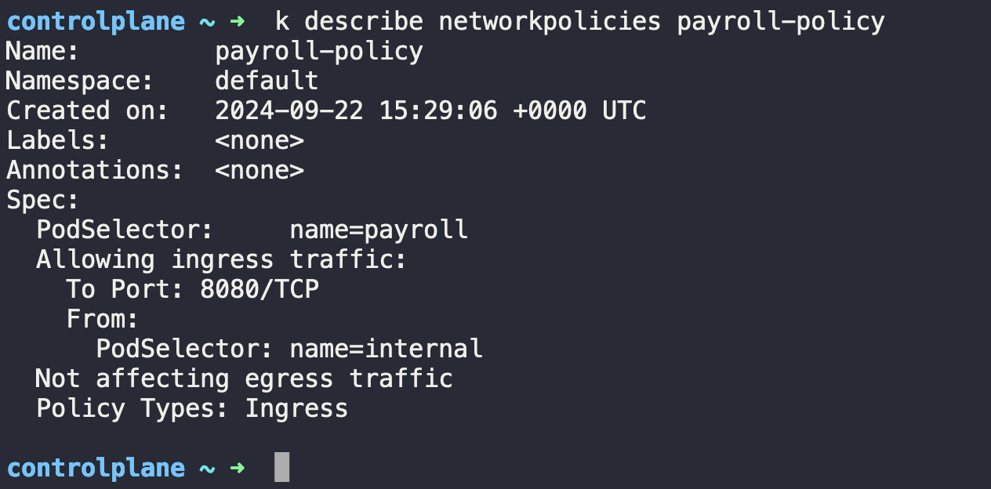

Netowrk policy YAML

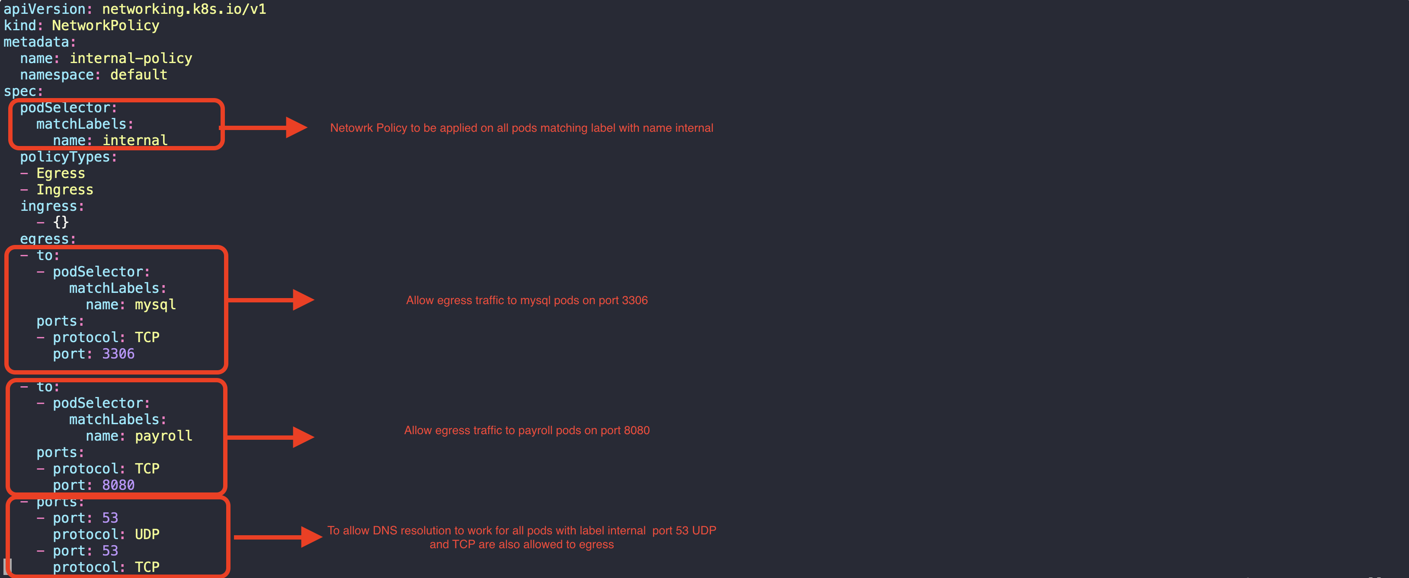

|  |
| --- |
| apiVersion: networking.k8s.io/v1  kind: NetworkPolicy  metadata:  name: internal-policy  namespace: default  spec:  podSelector:  matchLabels:  name: internal  policyTypes:  - Egress  - Ingress  ingress:  - {}  egress:  - to:  - podSelector:  matchLabels:  name: mysql  ports:  - protocol: TCP  port: 3306  - to:  - podSelector:  matchLabels:  name: payroll  ports:  - protocol: TCP  port: 8080  - ports:  - port: 53  protocol: UDP  - port: 53  protocol: TCP |

# Section 8 [State Persistence]

## Volumes:

To persist the data processed by container/pod we attach volumes to container/pod. So that even if container is destroyed the data stored in /data will be persisted.

## Persistent Volumes(PVs):

Persistent Volumes (PVs) are large storage blocks on some storage providers like AWS Elastic Block Store (EBS) etc created by administrators. Pods can store their data here in these PVs using PVC (Persistent Volume Claim)

## Persistent Volume Claims(PVC):

PVC are used by pods/users to store the data on PVs. Every PVC is bound to a single PV.

As there is one-to-one relation between PV and PVC, so a smaller PVC can be attached to a PV of larger capacity and rest of the space which is unused by PVC will be wasted as there is no other PVC can attach to same PV.

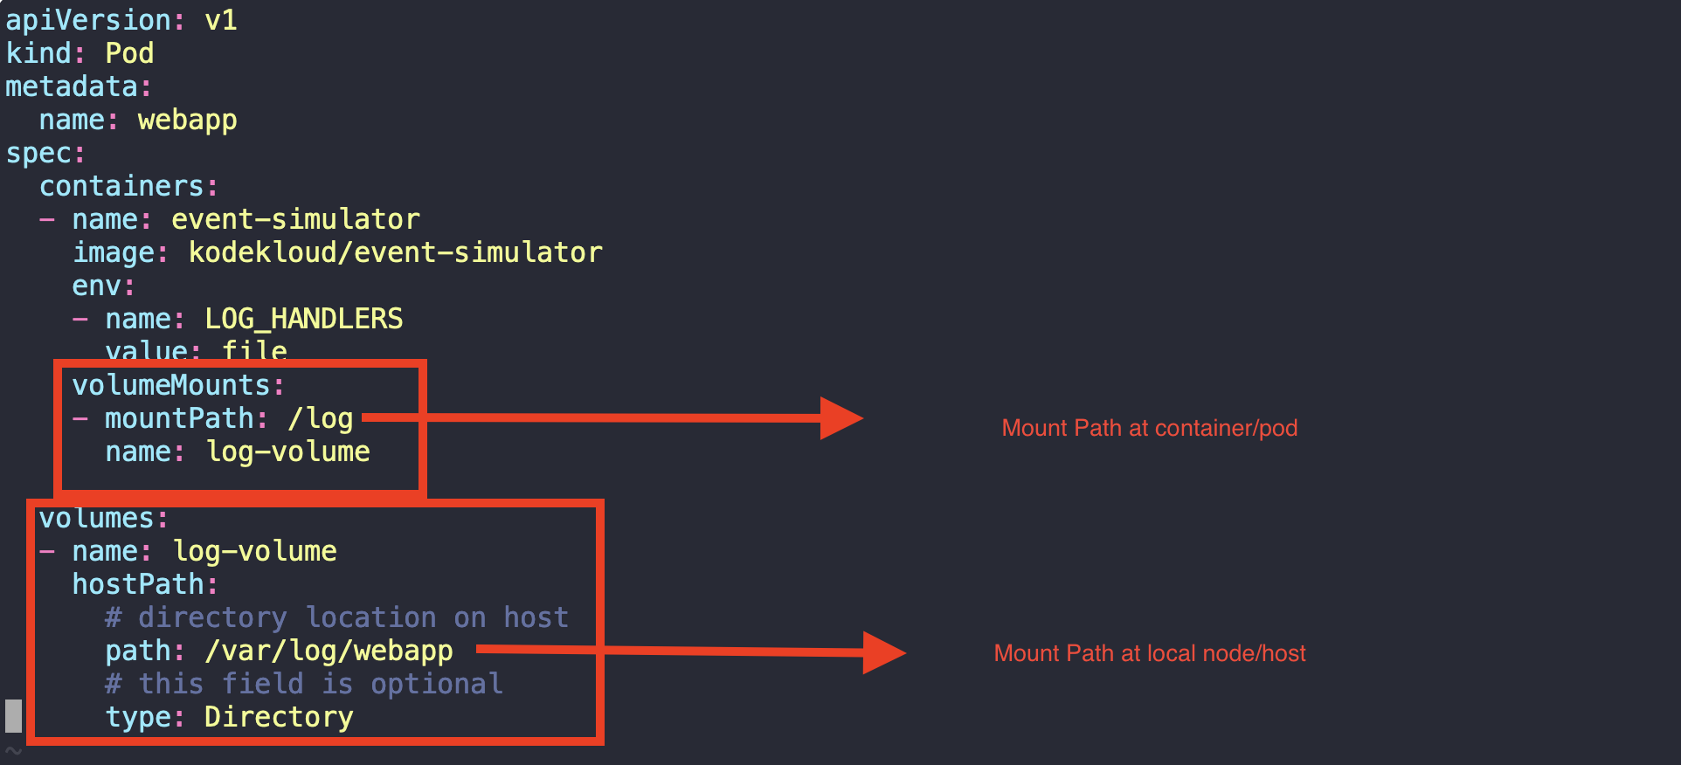

|  |
| --- |
| apiVersion: v1  kind: Pod  metadata:  name: webapp  spec:  containers:  - name: event-simulator  image: kodekloud/event-simulator  env:  - name: LOG_HANDLERS  value: file  volumeMounts:  - mountPath: /log  name: log-volume  volumes:  - name: log-volume  hostPath:  # directory location on host  path: /var/log/webapp  # this field is optional  type: Directory |

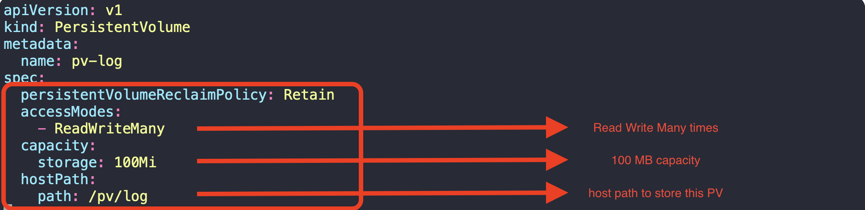

### PV File:

|  |
| --- |
| apiVersion: v1  kind: PersistentVolume  metadata:  name: pv-log  spec:  persistentVolumeReclaimPolicy: Retain  accessModes:  - ReadWriteMany  capacity:  storage: 100Mi  hostPath:  path: /pv/log |

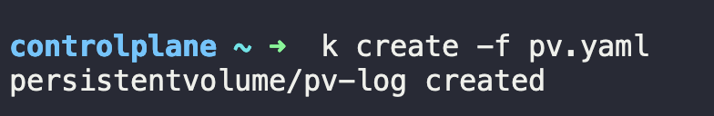



### PVC File:

|  |
| --- |
| kind: PersistentVolumeClaimapiVersion: v1metadata:name: claim-log-1spec:accessModes:- ReadWriteOnceresources:requests:storage: 50Mi |



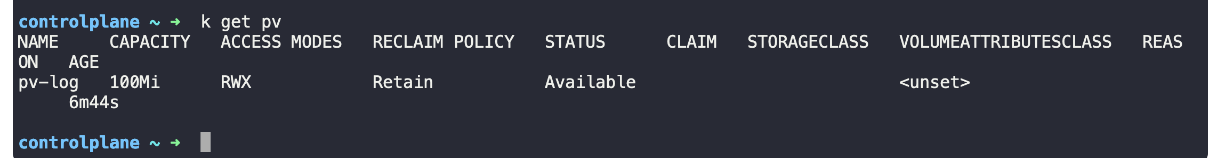

Attaching the PVC in pod

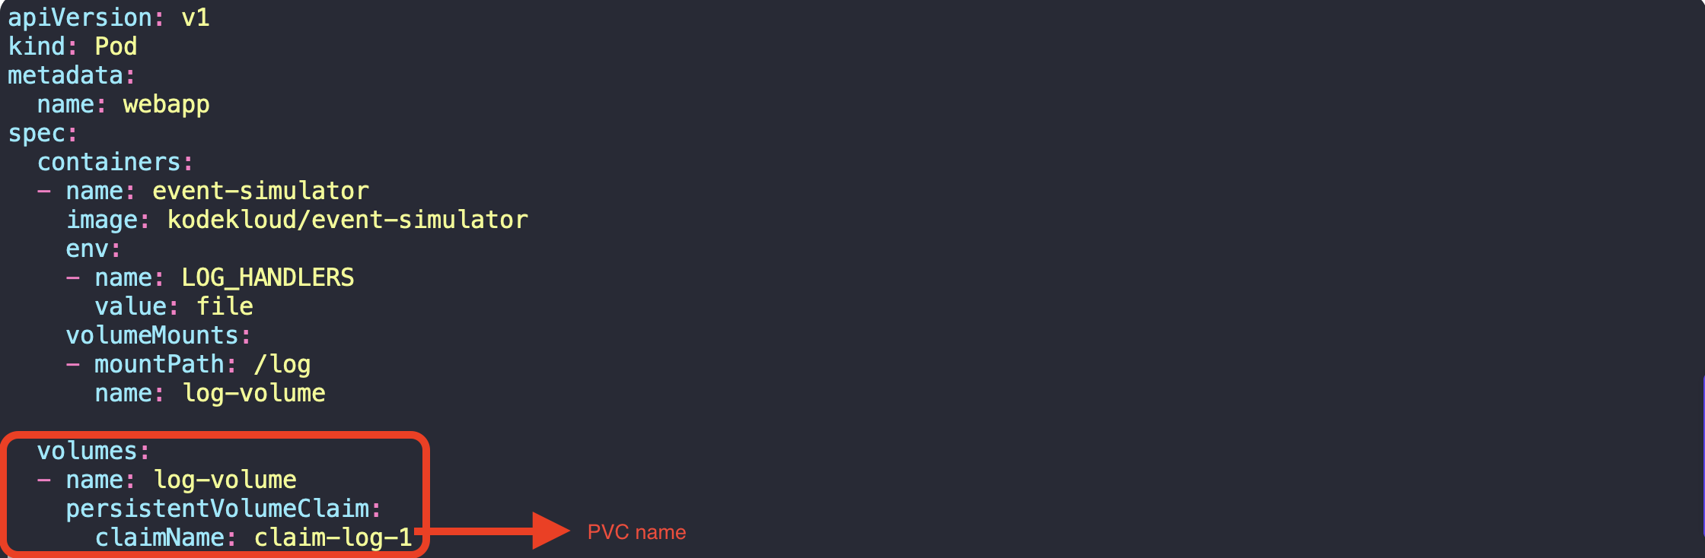

Deleting PVC:

If PVC is being used by in POD and we try to delete PVC, it will be stuck in Terminating state  
  
  


Delete pod first,

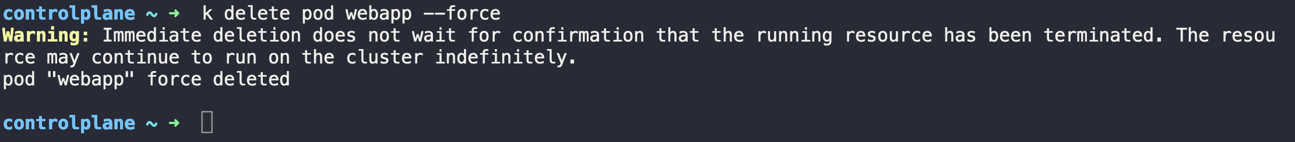

Now, PVC will be completed in another terminal  
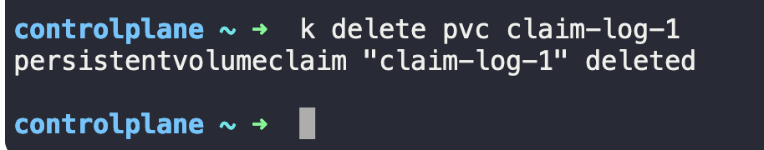

And, no PVC in system  
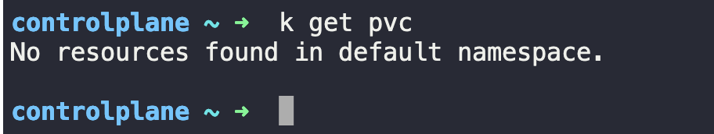

PV, now will be in RELEASED state



## Storage Class:

Example: k get sc  
 OR  
 k get storageclasses  
 OR  
 k get storageclass



|  |
| --- |
| ---  kind: PersistentVolumeClaim  apiVersion: v1  metadata:  name: local-pvc  spec:  accessModes:  - ReadWriteOnce  storageClassName: local-storage  resources:  requests:  storage: 500Mi |

# Section 9 [Security]

## Kubeconfig:

Kubeconfig file is default file stored at $HOME/.kube/config responsible to store configurations of Kubernetes cluster information’s and certificate information’s.

Command to get context from custom kubeconfig file  
k config get-contexts --kubeconfig=<path_of_custom_kubeconfig_file>

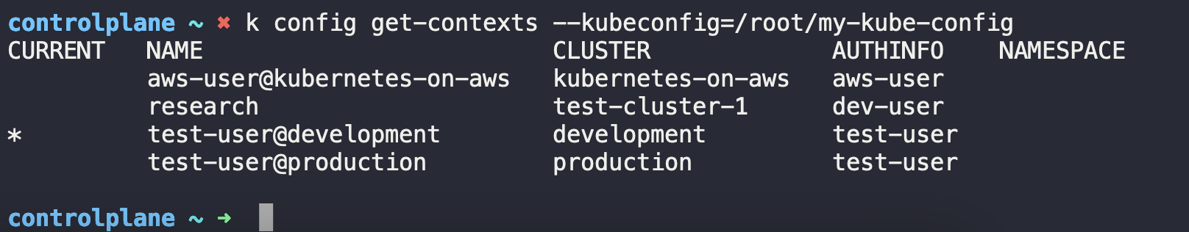

Command to get current-context  
k config current-context --kubeconfig==<path_of_custom_kubeconfig_file>

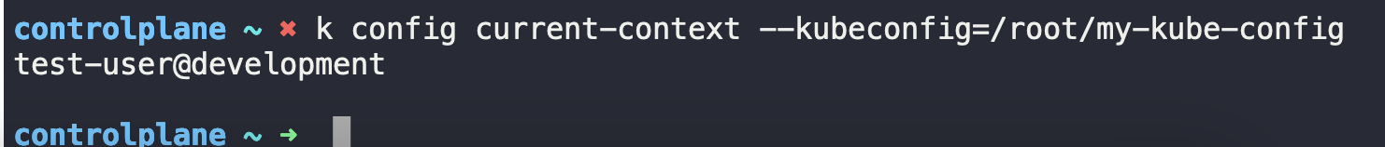

Switch context and check the current-context  
k config use-context <context_name> --kubeconfig==<path_of_custom_kubeconfig_file>

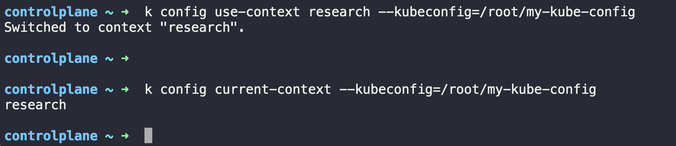

Sample kubeconfig file:

|  |
| --- |
| apiVersion: v1  current-context: research  kind: Config  preferences: {}  clusters:  - cluster:  certificate-authority: /etc/kubernetes/pki/ca.crt  server: https://controlplane:6443  name: development  - cluster:  certificate-authority: /etc/kubernetes/pki/ca.crt  server: https://controlplane:6443  name: kubernetes-on-aws  - cluster:  certificate-authority: /etc/kubernetes/pki/ca.crt  server: https://controlplane:6443  name: production  - cluster:  certificate-authority: /etc/kubernetes/pki/ca.crt  server: https://controlplane:6443  name: test-cluster-1  contexts:  - context:  cluster: kubernetes-on-aws  user: aws-user  name: aws-user@kubernetes-on-aws  - context:  cluster: test-cluster-1  user: dev-user  name: research  - context:  cluster: development  user: test-user  name: test-user@development  - context:  cluster: production  user: test-user  name: test-user@production  users:  - name: aws-user  user:  client-certificate: /etc/kubernetes/pki/users/aws-user/aws-user.crt  client-key: /etc/kubernetes/pki/users/aws-user/aws-user.key  - name: dev-user  user:  client-certificate: /etc/kubernetes/pki/users/dev-user/dev-user.crt  client-key: /etc/kubernetes/pki/users/dev-user/dev-user.key  - name: test-user  user:  client-certificate: /etc/kubernetes/pki/users/test-user/test-user.crt  client-key: /etc/kubernetes/pki/users/test-user/test-user.key |

## RBAC:

Role Based Access Control (RBAC)

Command to see the authorization mode:  
 k describe pod kube-apiserver-controlplane -n kube-system

|  |
| --- |
| Name: kube-apiserver-controlplane  Namespace: kube-system  Priority: 2000001000  Priority Class Name: system-node-critical  Node: controlplane/192.8.197.3  Start Time: Mon, 23 Sep 2024 04:51:45 +0000  Labels: component=kube-apiserver  tier=control-plane  Annotations: kubeadm.kubernetes.io/kube-apiserver.advertise-address.endpoint: 192.8.197.3:6443  kubernetes.io/config.hash: c6d5df26d2fd2ddafe3195411abecc39  kubernetes.io/config.mirror: c6d5df26d2fd2ddafe3195411abecc39  kubernetes.io/config.seen: 2024-09-23T04:51:35.639200517Z  kubernetes.io/config.source: file  Status: Running  SeccompProfile: RuntimeDefault  IP: 192.8.197.3  IPs:  IP: 192.8.197.3  Controlled By: Node/controlplane  Containers:  kube-apiserver:  Container ID: containerd://7fcc7ef50ff37924383b918b536a7b77356fb7d09475c636092f7ae7b5f56918  Image: registry.k8s.io/kube-apiserver:v1.30.0  Image ID: registry.k8s.io/kube-apiserver@sha256:6b8e197b2d39c321189a475ac755a77896e34b56729425590fbc99f3a96468a3  Port: <none>  Host Port: <none>  Command:  kube-apiserver  --advertise-address=192.8.197.3  --allow-privileged=true  --authorization-mode=Node,RBAC  --client-ca-file=/etc/kubernetes/pki/ca.crt  --enable-admission-plugins=NodeRestriction  --enable-bootstrap-token-auth=true  --etcd-cafile=/etc/kubernetes/pki/etcd/ca.crt  --etcd-certfile=/etc/kubernetes/pki/apiserver-etcd-client.crt  --etcd-keyfile=/etc/kubernetes/pki/apiserver-etcd-client.key  --etcd-servers=https://127.0.0.1:2379  --kubelet-client-certificate=/etc/kubernetes/pki/apiserver-kubelet-client.crt  --kubelet-client-key=/etc/kubernetes/pki/apiserver-kubelet-client.key  --kubelet-preferred-address-types=InternalIP,ExternalIP,Hostname  --proxy-client-cert-file=/etc/kubernetes/pki/front-proxy-client.crt  --proxy-client-key-file=/etc/kubernetes/pki/front-proxy-client.key  --requestheader-allowed-names=front-proxy-client  --requestheader-client-ca-file=/etc/kubernetes/pki/front-proxy-ca.crt  --requestheader-extra-headers-prefix=X-Remote-Extra-  --requestheader-group-headers=X-Remote-Group  --requestheader-username-headers=X-Remote-User  --secure-port=6443  --service-account-issuer=https://kubernetes.default.svc.cluster.local  --service-account-key-file=/etc/kubernetes/pki/sa.pub  --service-account-signing-key-file=/etc/kubernetes/pki/sa.key  --service-cluster-ip-range=10.96.0.0/12  --tls-cert-file=/etc/kubernetes/pki/apiserver.crt  --tls-private-key-file=/etc/kubernetes/pki/apiserver.key  State: Running  Started: Mon, 23 Sep 2024 04:51:37 +0000  Ready: True  Restart Count: 0  Requests:  cpu: 250m  Liveness: http-get https://192.8.197.3:6443/livez delay=10s timeout=15s period=10s #success=1 #failure=8  Readiness: http-get https://192.8.197.3:6443/readyz delay=0s timeout=15s period=1s #success=1 #failure=3  Startup: http-get https://192.8.197.3:6443/livez delay=10s timeout=15s period=10s #success=1 #failure=24  Environment: <none>  Mounts:  /etc/ca-certificates from etc-ca-certificates (ro)  /etc/kubernetes/pki from k8s-certs (ro)  /etc/ssl/certs from ca-certs (ro)  /usr/local/share/ca-certificates from usr-local-share-ca-certificates (ro)  /usr/share/ca-certificates from usr-share-ca-certificates (ro)  Conditions:  Type Status  PodReadyToStartContainers True  Initialized True  Ready True  ContainersReady True  PodScheduled True  Volumes:  ca-certs:  Type: HostPath (bare host directory volume)  Path: /etc/ssl/certs  HostPathType: DirectoryOrCreate  etc-ca-certificates:  Type: HostPath (bare host directory volume)  Path: /etc/ca-certificates  HostPathType: DirectoryOrCreate  k8s-certs:  Type: HostPath (bare host directory volume)  Path: /etc/kubernetes/pki  HostPathType: DirectoryOrCreate  usr-local-share-ca-certificates:  Type: HostPath (bare host directory volume)  Path: /usr/local/share/ca-certificates  HostPathType: DirectoryOrCreate  usr-share-ca-certificates:  Type: HostPath (bare host directory volume)  Path: /usr/share/ca-certificates  HostPathType: DirectoryOrCreate  QoS Class: Burstable  Node-Selectors: <none>  Tolerations: :NoExecute op=Exists  Events:  Type Reason Age From Message  ---- ------ ---- ---- -------  Normal Pulled 7m59s kubelet Container image "registry.k8s.io/kube-apiserver:v1.30.0" already present on machine  Normal Created 7m59s kubelet Created container kube-apiserver  Normal Started 7m59s kubelet Started container kube-apiserver |

* Command to get roles:

Syntax:   
 k get roles

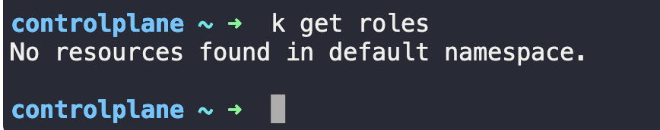

* Command to get all roles in all namespaces:

Syntax:   
 k get roles -A  
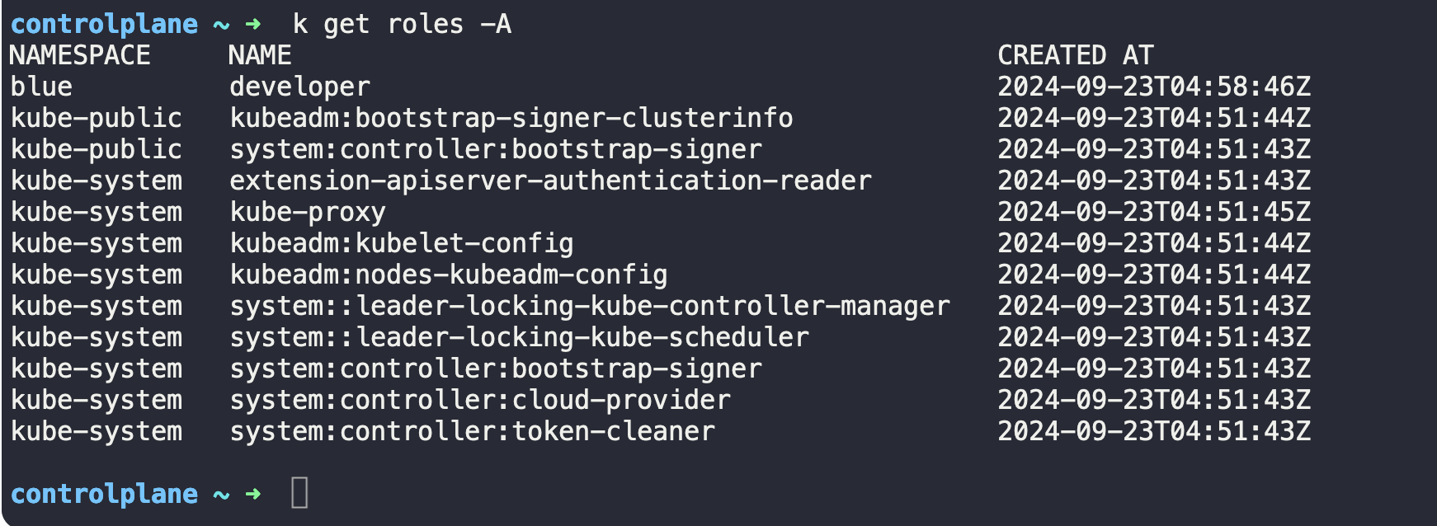

* Command to describe a particular role to check the assigned resources

Syntax:   
 k describe roles kube-proxy -n kube-system  
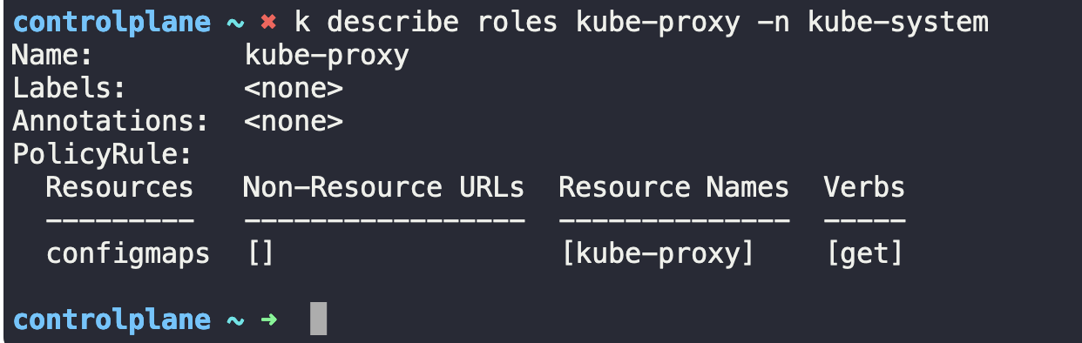

* Command to describe a particular rolebindings of a role

Syntax:   
 k describe rolebindings kube-proxy -n kube-system  
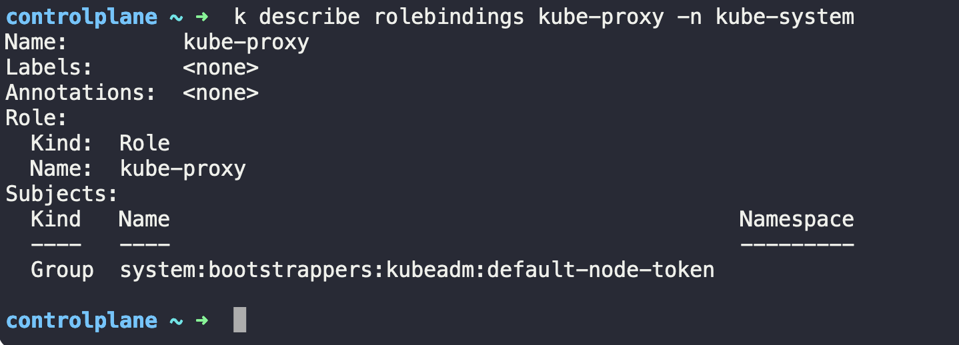

* Command to check the permission for a user using “--as”

Syntax:   
 k get pods --as dev-user

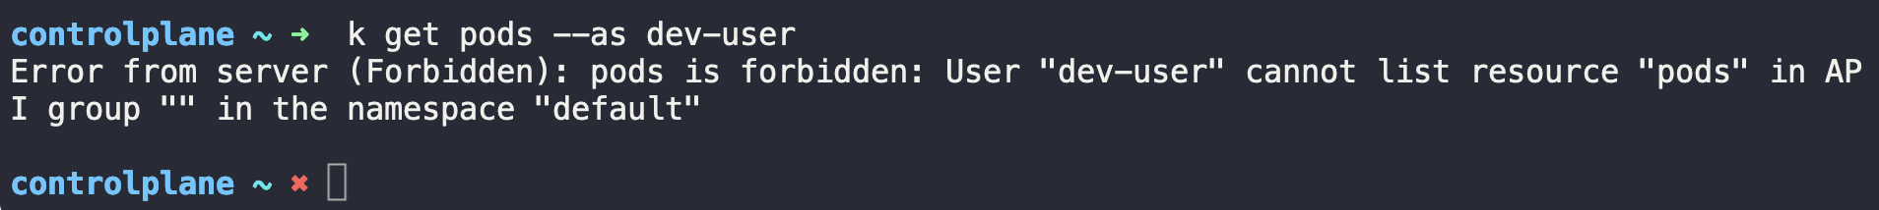

To create a Role:- kubectl create role developer --namespace=default --verb=list,create,delete --resource=pods   
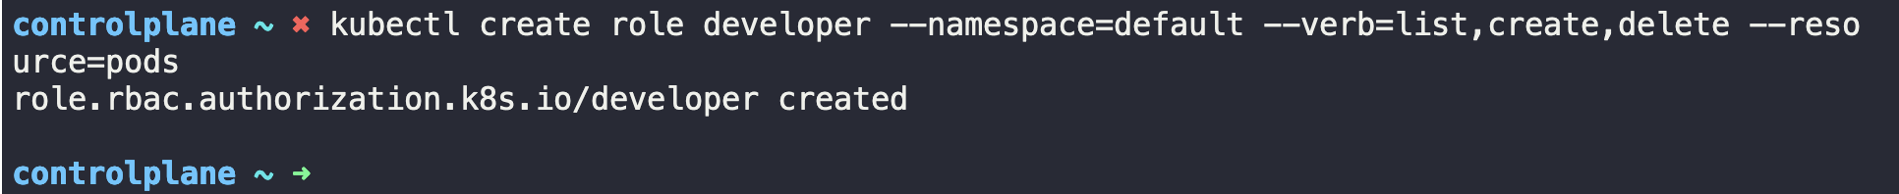

To create a RoleBinding:- kubectl create rolebinding dev-user-binding --namespace=default --role=developer --user=dev-user

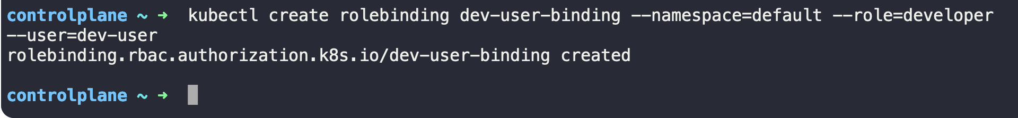

Note: Roles and RoleBinding can only be applied to namespaces. If no namespace is provided it will consider as default namespace

File:

|  |
| --- |
| kind: Role  apiVersion: rbac.authorization.k8s.io/v1  metadata:  namespace: default  name: developer  rules:  - apiGroups: [""]  resources: ["pods"]  verbs: ["list", "create","delete"]  ---  kind: RoleBinding  apiVersion: rbac.authorization.k8s.io/v1  metadata:  name: dev-user-binding  subjects:  - kind: User  name: dev-user  apiGroup: rbac.authorization.k8s.io  roleRef:  kind: Role  name: developer  apiGroup: rbac.authorization.k8s.io |

* Command to get existing clusterroles count

Syntax:   
 kubectl get clusterroles --no-headers | wc -l

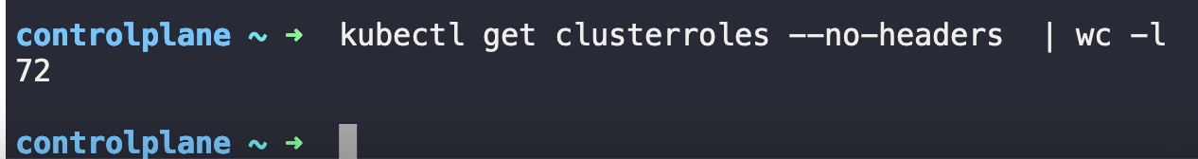

kubectl get clusterrolebindings --no-headers | wc -l

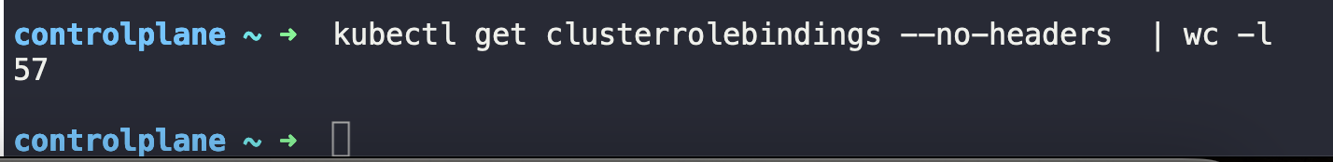

kubectl api-resources --namespaced=true

kubectl api-resources --namespaced=false

kubectl describe clusterrolebinding cluster-admin

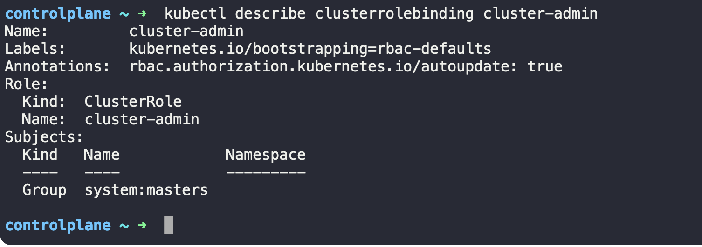

kubectl describe clusterrole cluster-admin

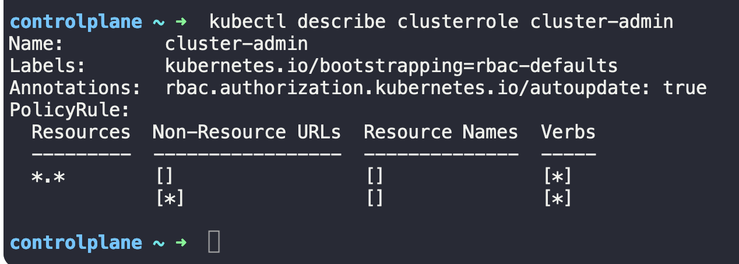

k create clusterrole new-role --verb=get,list,watch --resource=nodes

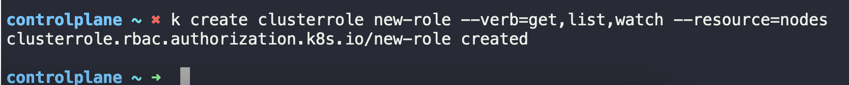

k create clusterrolebinding new-role-binding --clusterrole=new-role --user=michell

e

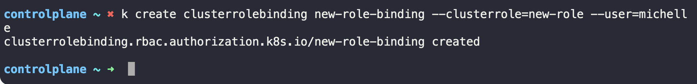

## Admission Controllers:

Note that the NamespaceExists and NamespaceAutoProvision admission controllers are deprecated and now replaced by NamespaceLifecycle admission controller.

The NamespaceLifecycle admission controller will make sure that requests  
to a non-existent namespace is rejected and that the default namespaces such as  
default, kube-system and kube-public cannot be deleted.

Command to create tls secret type in Kubernetes:

kubectl -n webhook-demo create secret tls webhook-server-tls \

--cert "/root/keys/webhook-server-tls.crt" \

--key "/root/keys/webhook-server-tls.key"

To check what is preferred version of an API use below 2 commands:

* kubectl proxy 8001&
* curl localhost:8001/apis/authorization.k8s.io  
  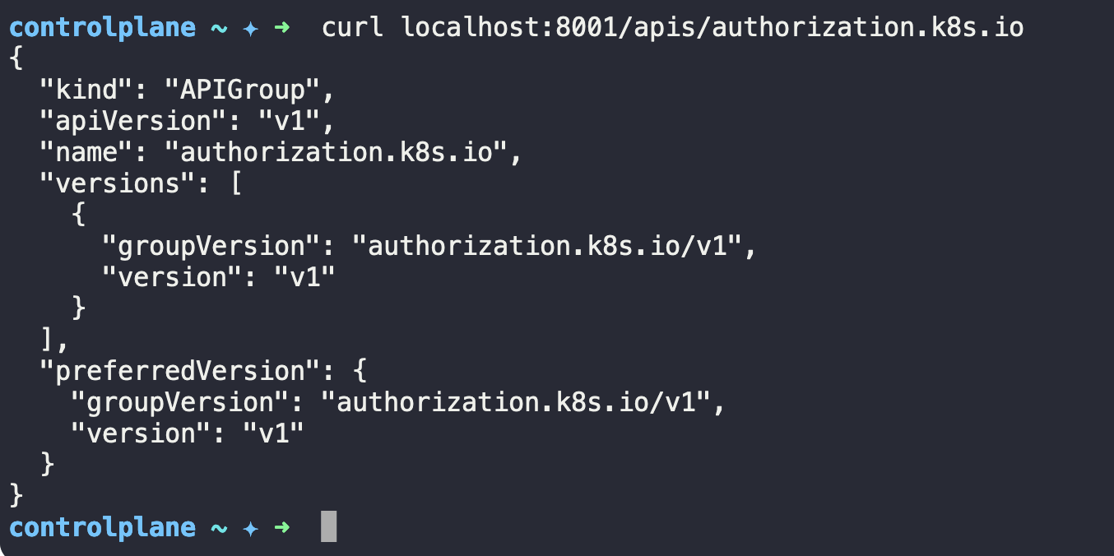

All Kubernetes manifests are present at:

/etc/Kubernetes/manifests  
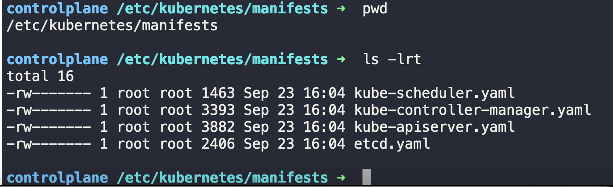

# Section 10 [Helm Fundamentals]

Helm is a package manager for Kubernetes, used to install to install k8 object in form of Helm Charts.

A helm chart is combination of templates in Yaml format and a values.yaml file used to fill these templates.

helm search hub wordpress

helm repo add bitnami https://charts.bitnami.com/bitnami

helm search repo Joomla  
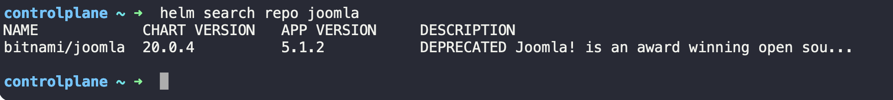

helm repo list

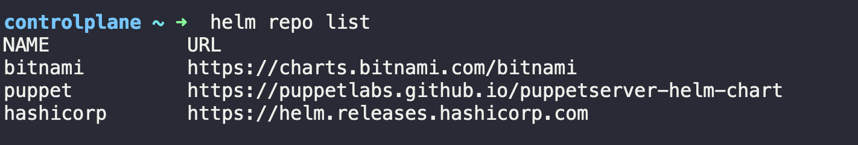

Command to install a package from repo

helm install bravo bitnami/drupal  
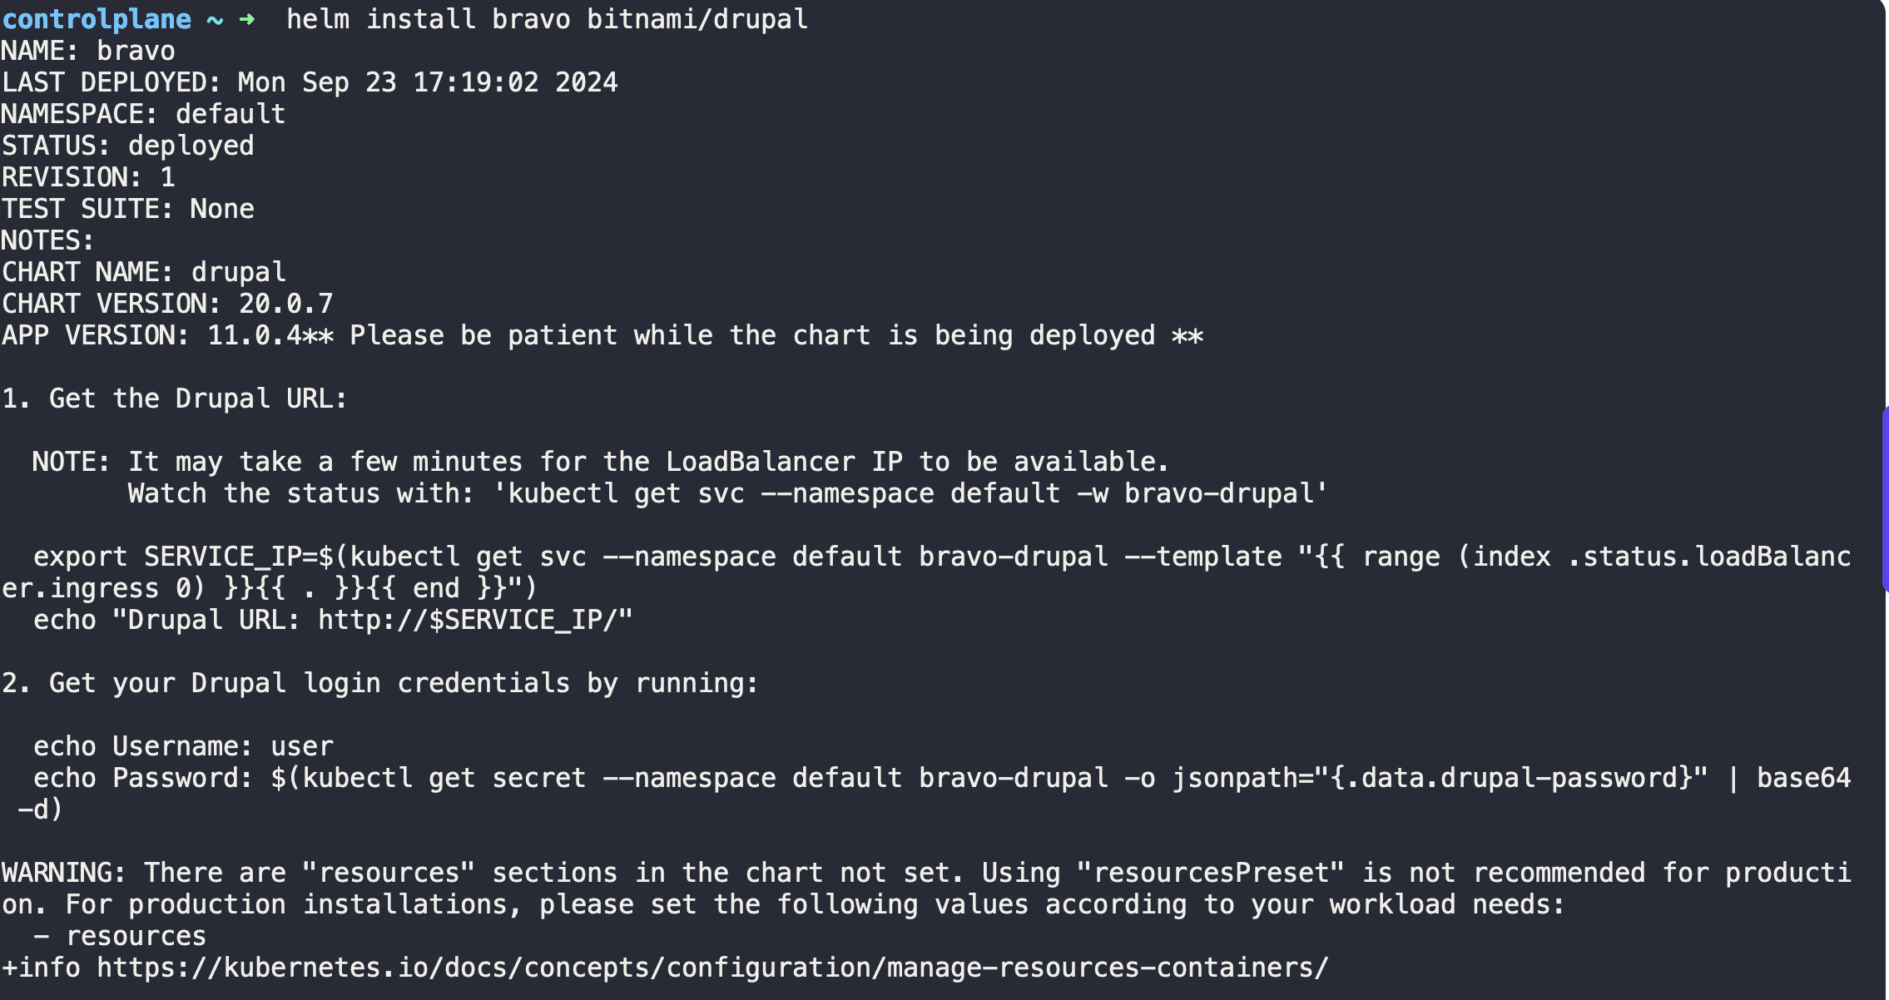

Command to list packages installed via Helm

helm list  


helm uninstall bravo

Command to download package and untar it, but don’t install it  
helm pull --untar bitnami/apache

# Annexure I

Create an alias of kubectl command first:

* This will save your time to write longer commands as **kubectl** is general cli command used everywhere

|  |
| --- |
| alias k=kubectl |

## [PODs]: Commands & Outputs

* Command to create a pod directly without using yaml file:

Syntax:   
 k run <pod_name> --image=<image_name>  
Example: k run nginx --image nginx

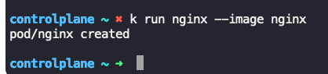

* Command to create a pod directly without using yaml file and passing some additional arguemnts  
  Syntax:

k run <pod_name> --image=<image_name> -- <cmd_args1> <cmd_args2>  
Example: k run webapp-green --image=kodekloud/webapp-color -- --color green  
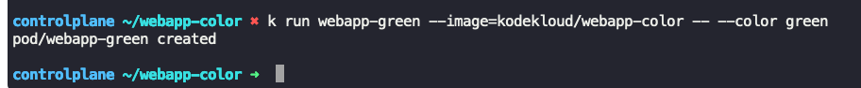

* Command to list(get) all pods  
  Syntax:   
   k get pods  
   k get po  
  Example:

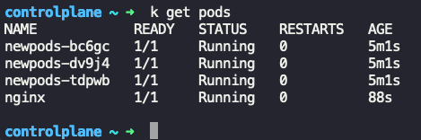

* Command to get detailed output of pods  
  Syntax:  
   k get pods -o wide  
  Example:

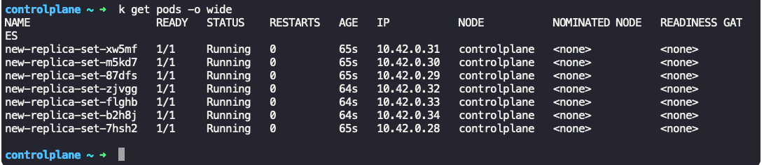

* Command to describe a pod  
  Syntax:  
   k describe pod <pod_name>  
  Example:  
  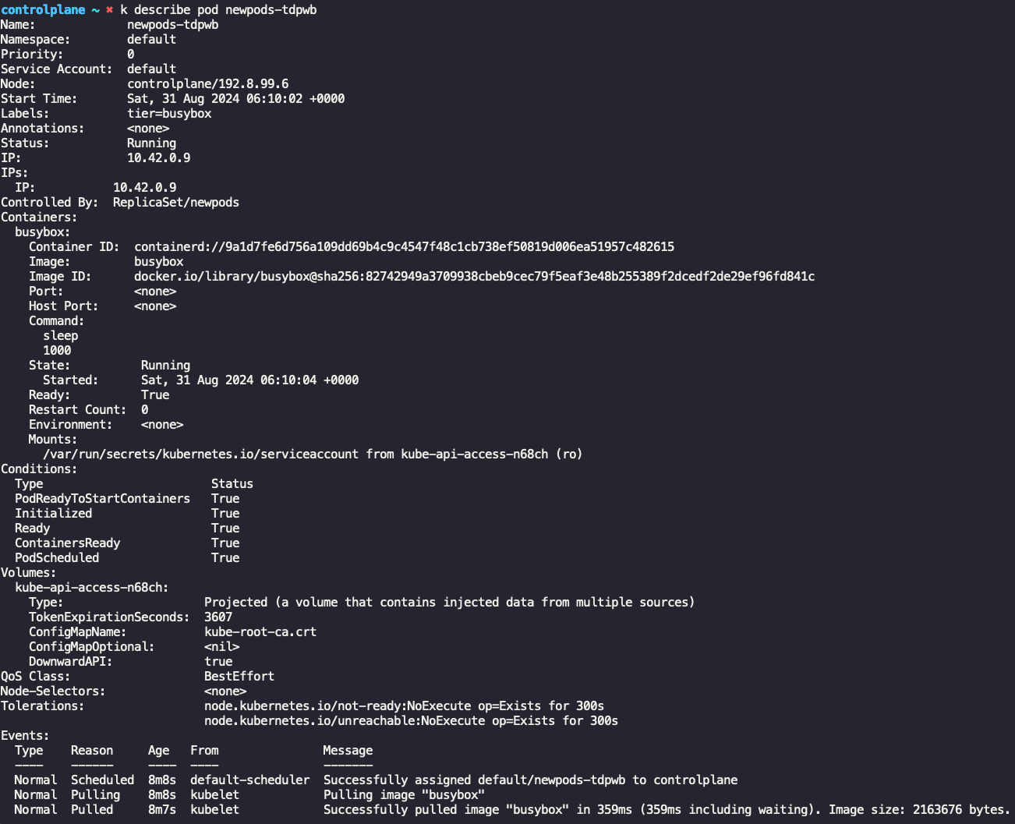

Note: To extract a specific fields use “grep”  
Example: To get image used in pod:  
 k describe pod <pod_name> | grep “Image: ”  
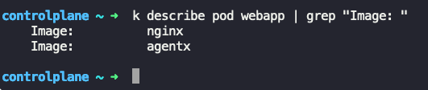

* Command to delete pod  
  Syntax:  
   k delete pod <pod_name>  
  Example:  
  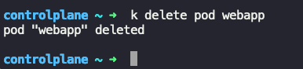
* An example YAML file to create a simple pod

|  |
| --- |
| apiVersion: v1  kind: Pod This is case sensitive, Pod and pod  metadata:  name: redis This name would be used as pod name while creating pod  spec:  containers:  - name: redis  image: redis  command: ["sleep", "5000"] |

|  |
| --- |
| command:   * “sleep” * “1200” Everything is in string in .yaml file even an integer also |

* Command to create a pod (K8 object)  
  Syntax:   
   k create -f <yaml_file>  
  Example:  
  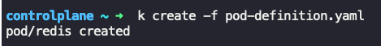
* Command to update the existing config in yaml and apply it  
  Syntax:   
   k apply -f <yaml_file>  
  Example:  
  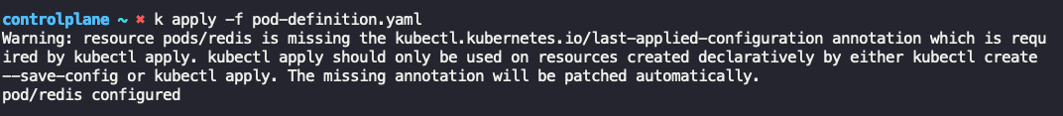

Extract the definition of pod to a file using the below command: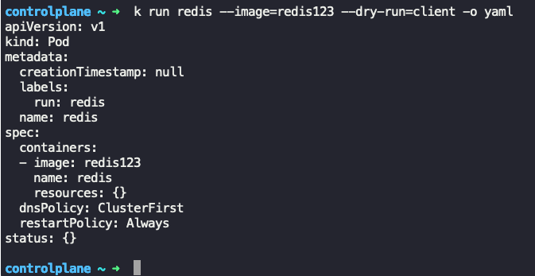

Extract the definition of a pod to a file using the below command:

kubectl get pod <pod-name> -o yaml > pod-definition.yaml

To modify the properties of the pod:

kubectl edit pod <pod-name>

|  |
| --- |
| Please note that only the properties listed below are editable.   * spec.containers[*].image * spec.initContainers[*].image * spec.activeDeadlineSeconds * spec.tolerations * spec.terminationGracePeriodSeconds |

## [NODEs]: Commands & Outputs

* Command to get nodes  
  Syntax:  
   k get nodes  
   k get no  
   k get node

Example:  
 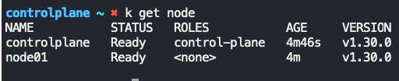

* Command to get taints on a node  
  Syntax:  
   k describe node <node_name> | grep -i taints  
  Example:  
   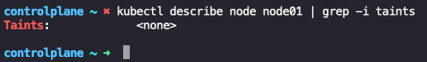
* Command to create taint on a node  
  Syntax:  
   k taint node <node_name> key=value:taint_effect  
  Example:  
   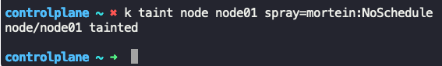
* Command to remove a taint  
  Syntax:  
   k taint nodes <node_name> node-role.kubernetes.io/<node-name>:effect-  
  Example:  
   
* Command to apply a label on a node  
  Syntax:  
   k label node <node_name> <key>=<value>  
  Example:  
   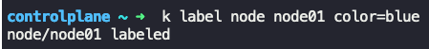

## [ReplicaSets]: Commands & Outputs

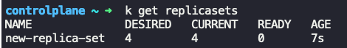  
  
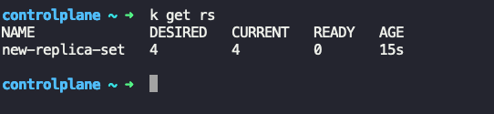

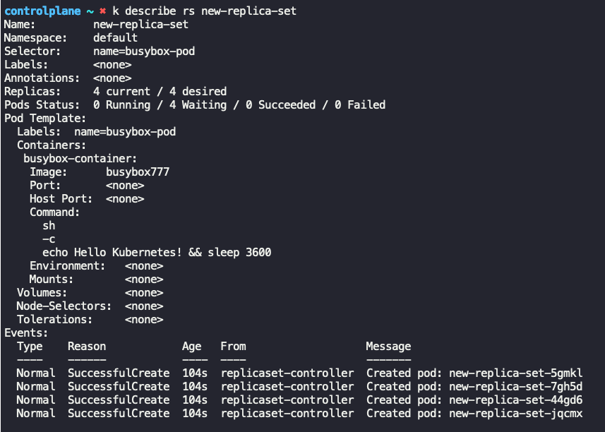

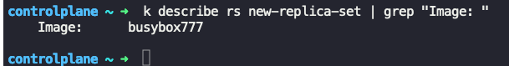

Get pods in replicaset

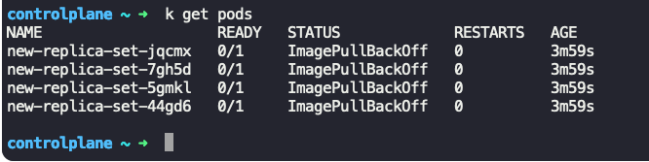

Delete a pod in



But no. of pods again become 4, because replicaset is configured to have atleast 4 pods

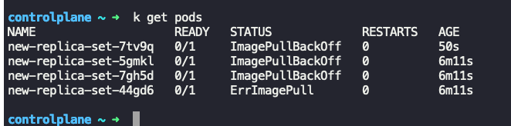

cat /root/replicaset-definition-1.yaml

|  |
| --- |
| apiVersion: apps/v1  kind: ReplicaSet  metadata:  name: replicaset-1  labels:  name: frontend  spec:  replicas: 2  selector:  matchLabels:  tier: frontend  template:  metadata:  labels:  tier: frontend  spec:  containers:  - name: nginx  image: nginx |

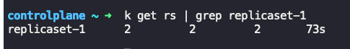

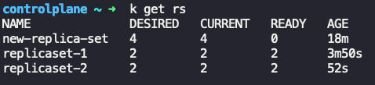

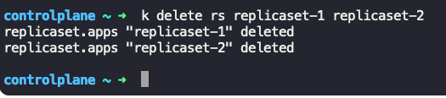

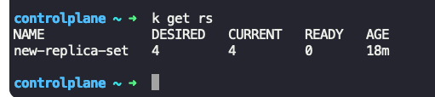

To edit the replicaSet,   
k edit rs new-replica-set

|  |
| --- |
| Open yaml in editor mode  Update the yaml  Save it |

Note: Updating yaml will not update the pods image here, user need to either delete the pods or replicasets to make the changes take effect.  
  
OR

It will create an updated .yaml file in /tmp/<name_of_updated_yml_file>, use that file with command  
k replace --force -f /tmp/<name_of_updated_yml_file>

k get rs -o yaml

|  |
| --- |
| apiVersion: v1  items:  - apiVersion: apps/v1  kind: ReplicaSet  metadata:  creationTimestamp: "2024-08-31T07:42:16Z"  generation: 1  name: new-replica-set  namespace: default  resourceVersion: "1140"  uid: 9aae427c-7146-4aa9-984a-618d8c53899b  spec:  replicas: 4  selector:  matchLabels:  name: busybox-pod  template:  metadata:  creationTimestamp: null  labels:  name: busybox-pod  spec:  containers:  - command:  - sh  - -c  - echo Hello Kubernetes! && sleep 3600  image: busybox777  imagePullPolicy: Always  name: busybox-container  resources: {}  terminationMessagePath: /dev/termination-log  terminationMessagePolicy: File  dnsPolicy: ClusterFirst  restartPolicy: Always  schedulerName: default-scheduler  securityContext: {}  terminationGracePeriodSeconds: 30  status:  fullyLabeledReplicas: 4  observedGeneration: 1  replicas: 4  kind: List  metadata:  resourceVersion: "" |

Do note that running create command on same object will give error

|  |
| --- |
|  |

Delete all pods matching same kind of name as wild card:

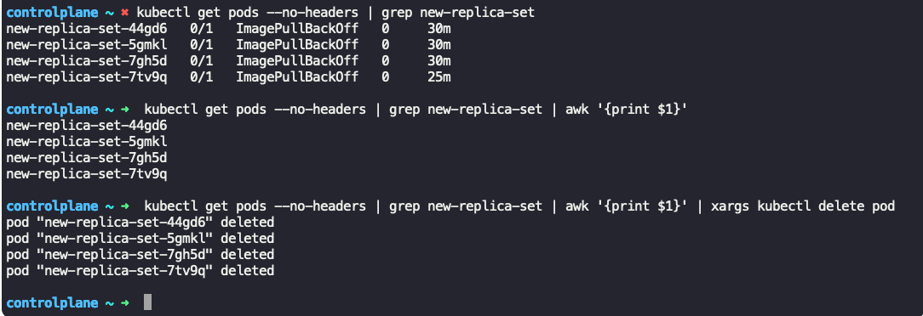

Another method:

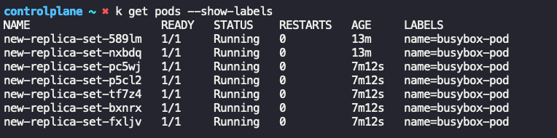

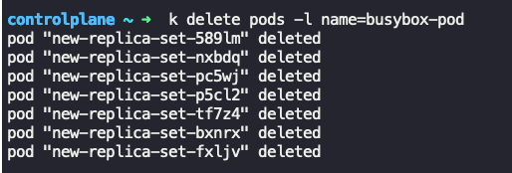

Scale Down the pods in replicaset:

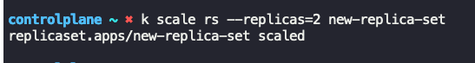

Pods in terminating state:  
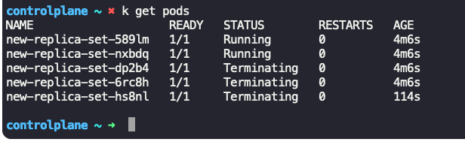

After sometime:

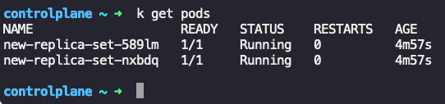

Scale Up the pods in replicaset

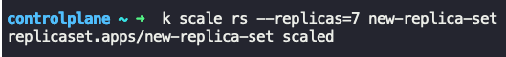

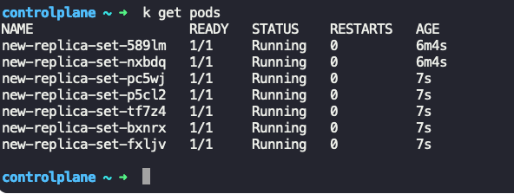

Note: Do note that scale command will update the definition of yaml file also

|  |
| --- |
|  |

## [Deployment]: Commands & Outputs

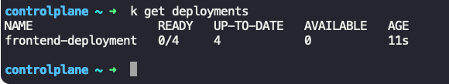

Master command:

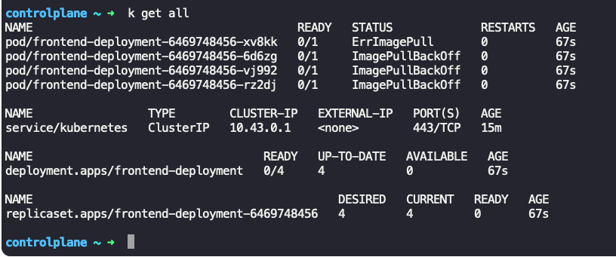

* Command to describe a deployment  
  Syntax:  
   k describe deployment <deployment_name>

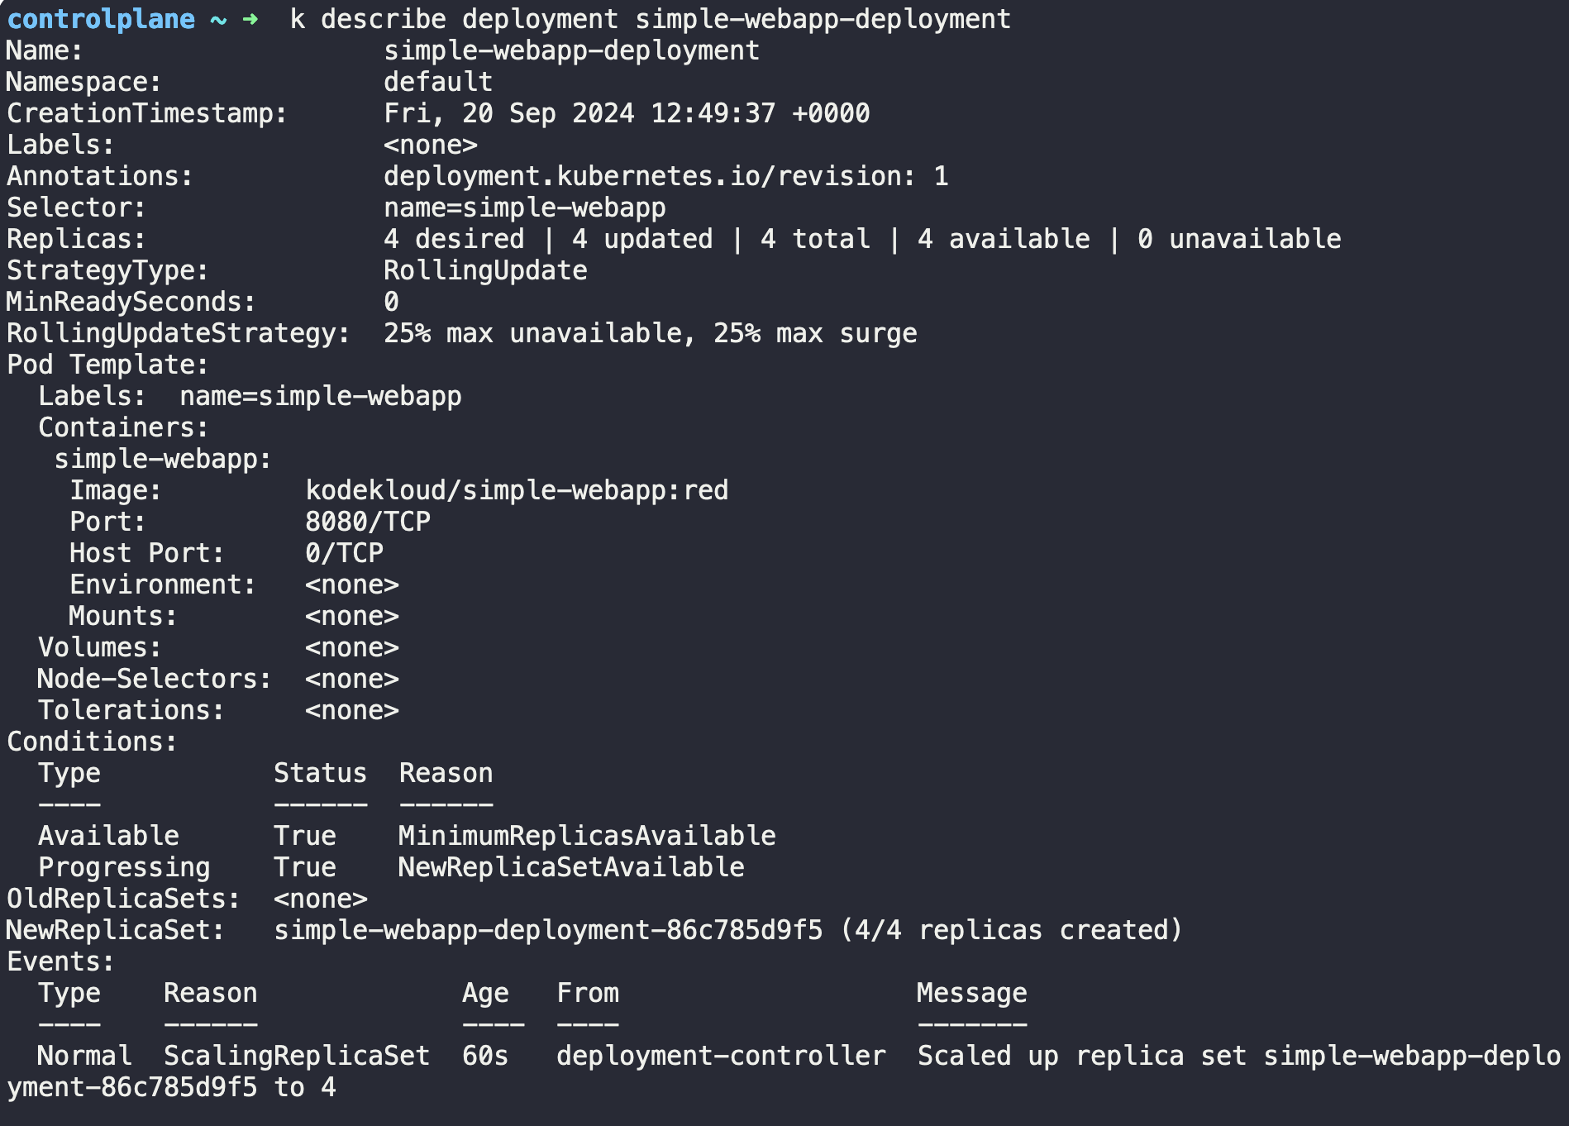

## [Namespaces]: Commands & Outputs

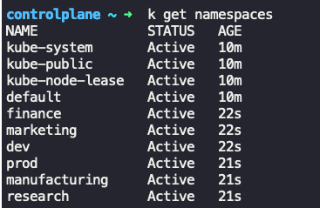

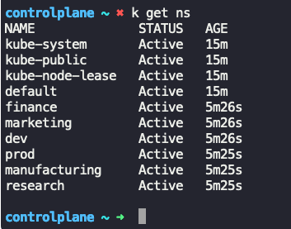

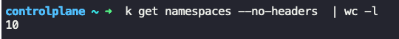

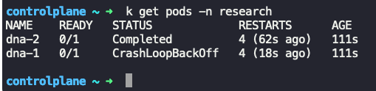

Create a pod in namespace=finance

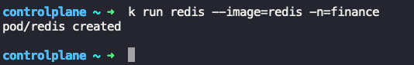

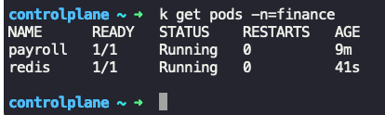

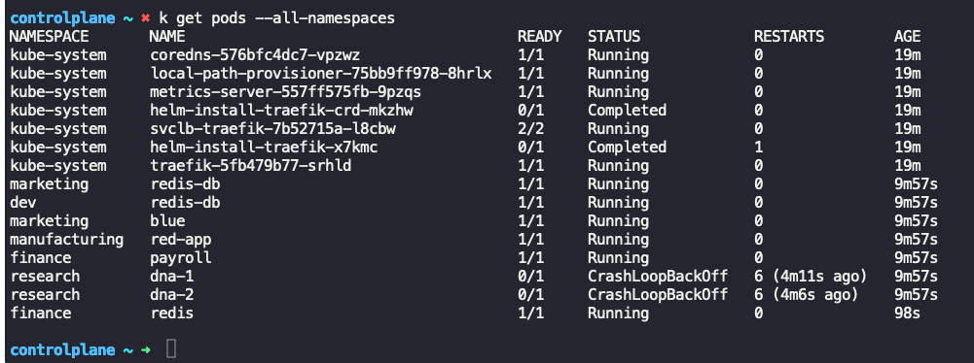

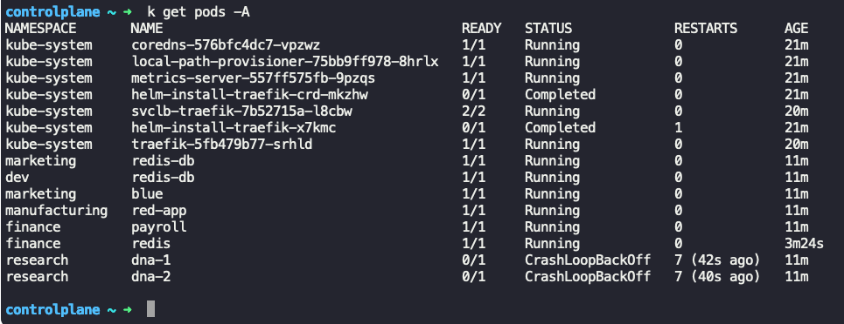

* Command to create a namespace   
  Syntax:  
   k create ns <namespace_name>

Example: k create ns ingress-nginx  
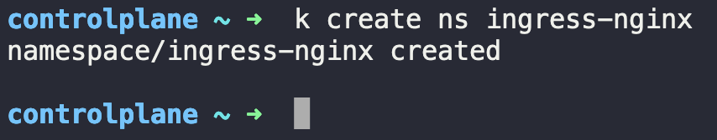

## [Services]: Commands & Outputs

* Command to get services:

Syntax:   
 k get services  
 OR  
 k get svc  
Example: k get svc  
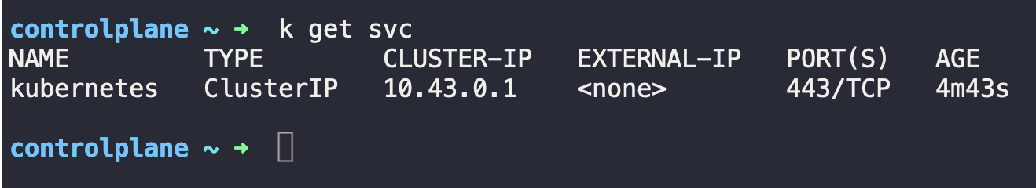

* Command to describe a service:

Syntax:   
 k describe svc <service_name>  
Example: k get svc Kubernetes  
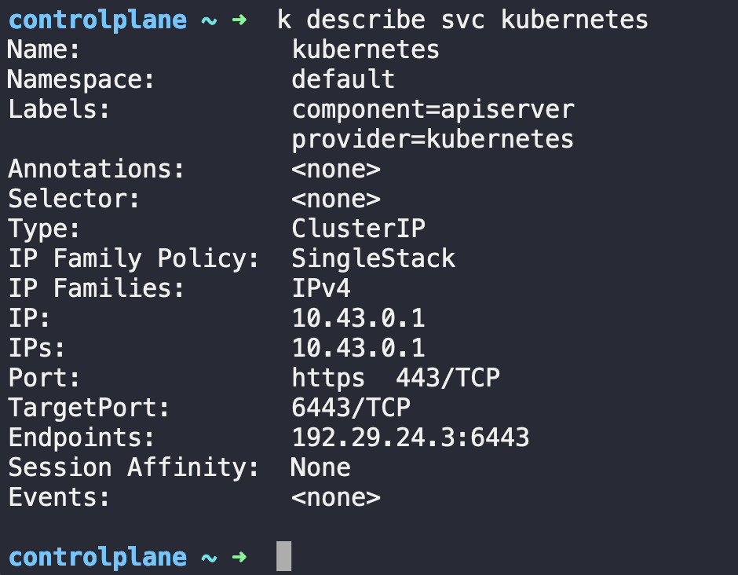

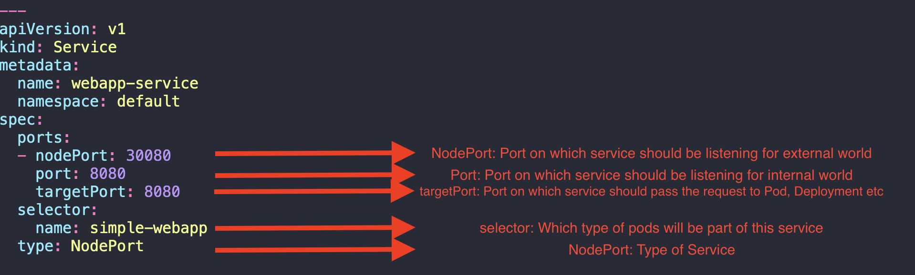

|  |
| --- |
| ---  apiVersion: v1  kind: Service  metadata:  name: webapp-service  namespace: default  spec:  ports:  - nodePort: 30080  port: 8080  targetPort: 8080  selector:  name: simple-webapp  type: NodePort |

## [Ingress]: Commands & Outputs

* Command to get ingress controllers in all namespaces:

Syntax:   
 k get ingress –all-namespaces  
 OR  
 k get ing -A  
Example: k get ing -A  


* Command to describe ingress controllers in particular namespace:

Syntax:   
 k describe ing -n <name_space   
Example: k describe ing -n app-space  
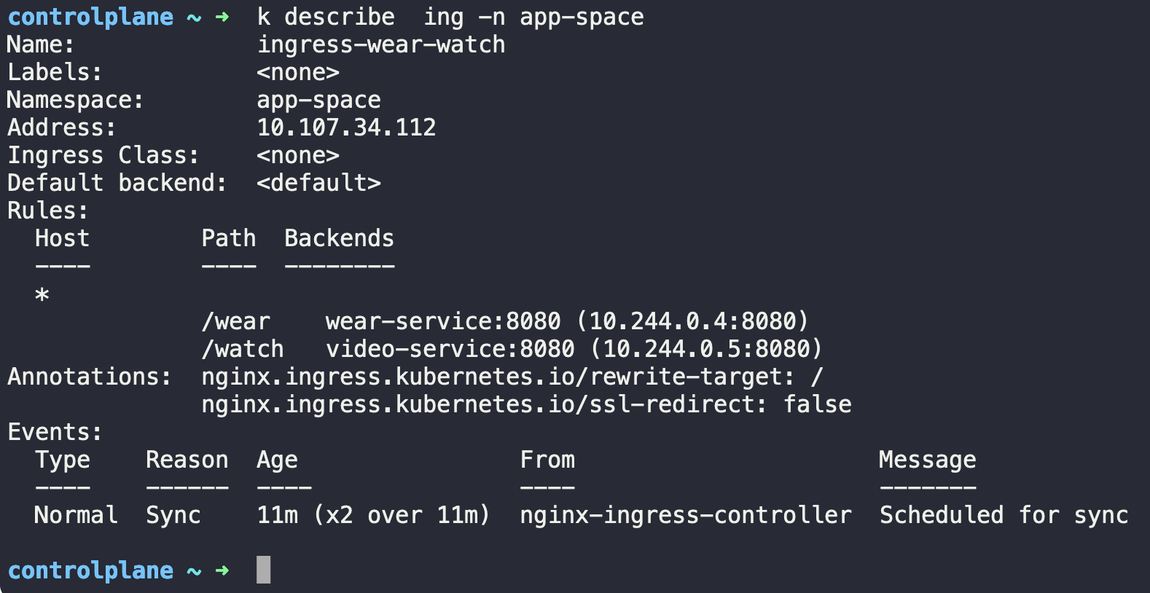

* Command to get deployment of ingress controller in a particular name space:

Syntax:   
 k get deploy <deployment_name> -n <namespace> -o yaml  
Example: kubectl get deploy ingress-nginx-controller -n ingress-nginx -o yaml

|  |
| --- |
| apiVersion: apps/v1  kind: Deployment  metadata:  annotations:  deployment.kubernetes.io/revision: "1"  creationTimestamp: "2024-09-22T07:28:23Z"  generation: 1  labels:  app.kubernetes.io/component: controller  app.kubernetes.io/instance: ingress-nginx  app.kubernetes.io/managed-by: Helm  app.kubernetes.io/name: ingress-nginx  app.kubernetes.io/part-of: ingress-nginx  app.kubernetes.io/version: 1.1.2  helm.sh/chart: ingress-nginx-4.0.18  name: ingress-nginx-controller  namespace: ingress-nginx  resourceVersion: "845"  uid: 01ac2565-81ca-4d64-bd71-db9debf55c81  spec:  progressDeadlineSeconds: 600  replicas: 1  revisionHistoryLimit: 10  selector:  matchLabels:  app.kubernetes.io/component: controller  app.kubernetes.io/instance: ingress-nginx  app.kubernetes.io/name: ingress-nginx  strategy:  rollingUpdate:  maxSurge: 25%  maxUnavailable: 25%  type: RollingUpdate  template:  metadata:  creationTimestamp: null  labels:  app.kubernetes.io/component: controller  app.kubernetes.io/instance: ingress-nginx  app.kubernetes.io/name: ingress-nginx  spec:  containers:  - args:  - /nginx-ingress-controller  - --publish-service=$(POD_NAMESPACE)/ingress-nginx-controller  - --election-id=ingress-controller-leader  - --watch-ingress-without-class=true  - --default-backend-service=app-space/default-backend-service  - --controller-class=k8s.io/ingress-nginx  - --ingress-class=nginx  - --configmap=$(POD_NAMESPACE)/ingress-nginx-controller  - --validating-webhook=:8443  - --validating-webhook-certificate=/usr/local/certificates/cert  - --validating-webhook-key=/usr/local/certificates/key  env:  - name: POD_NAME  valueFrom:  fieldRef:  apiVersion: v1  fieldPath: metadata.name  - name: POD_NAMESPACE  valueFrom:  fieldRef:  apiVersion: v1  fieldPath: metadata.namespace  - name: LD_PRELOAD  value: /usr/local/lib/libmimalloc.so  image: registry.k8s.io/ingress-nginx/controller:v1.1.2@sha256:28b11ce69e57843de44e3db6413e98d09de0f6688e33d4bd384002a44f78405c  imagePullPolicy: IfNotPresent  lifecycle:  preStop:  exec:  command:  - /wait-shutdown  livenessProbe:  failureThreshold: 5  httpGet:  path: /healthz  port: 10254  scheme: HTTP  initialDelaySeconds: 10  periodSeconds: 10  successThreshold: 1  timeoutSeconds: 1  name: controller  ports:  - containerPort: 80  name: http  protocol: TCP  - containerPort: 443  name: https  protocol: TCP  - containerPort: 8443  name: webhook  protocol: TCP  readinessProbe:  failureThreshold: 3  httpGet:  path: /healthz  port: 10254  scheme: HTTP  initialDelaySeconds: 10  periodSeconds: 10  successThreshold: 1  timeoutSeconds: 1  resources:  requests:  cpu: 100m  memory: 90Mi  securityContext:  allowPrivilegeEscalation: true  capabilities:  add:  - NET_BIND_SERVICE  drop:  - ALL  runAsUser: 101  terminationMessagePath: /dev/termination-log  terminationMessagePolicy: File  volumeMounts:  - mountPath: /usr/local/certificates/  name: webhook-cert  readOnly: true  dnsPolicy: ClusterFirst  nodeSelector:  kubernetes.io/os: linux  restartPolicy: Always  schedulerName: default-scheduler  securityContext: {}  serviceAccount: ingress-nginx  serviceAccountName: ingress-nginx  terminationGracePeriodSeconds: 300  volumes:  - name: webhook-cert  secret:  defaultMode: 420  secretName: ingress-nginx-admission  status:  availableReplicas: 1  conditions:  - lastTransitionTime: "2024-09-22T07:28:51Z"  lastUpdateTime: "2024-09-22T07:28:51Z"  message: Deployment has minimum availability.  reason: MinimumReplicasAvailable  status: "True"  type: Available  - lastTransitionTime: "2024-09-22T07:28:23Z"  lastUpdateTime: "2024-09-22T07:28:51Z"  message: ReplicaSet "ingress-nginx-controller-597d7b4fbd" has successfully progressed.  reason: NewReplicaSetAvailable  status: "True"  type: Progressing  observedGeneration: 1  readyReplicas: 1  replicas: 1  updatedReplicas: 1 |

* Command to delete ingress controllers in particular namespace:

Syntax:   
 k delete ing <ingress_name> -n <name_space   
Example: k delete ing ingress-wear-watch -n app-space --force

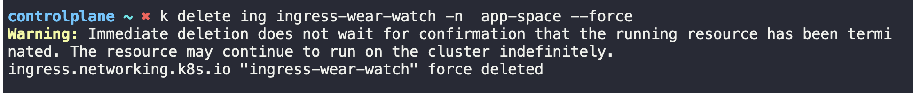

|  |
| --- |
| ---  apiVersion: networking.k8s.io/v1  kind: Ingress  metadata:  name: test-ingress  namespace: critical-space  annotations:  nginx.ingress.kubernetes.io/rewrite-target: /  nginx.ingress.kubernetes.io/ssl-redirect: "false"  spec:  rules:  - http:  paths:  - path: /pay  pathType: Prefix  backend:  service:  name: pay-service  port:  number: 8282 |

* Command to get roles and role bindings:

Syntax:   
 k get roles -A 🡪 Roles  
 k get rolebindings -A 🡪 RoleBindings  
Example: k get roles -A (To get all roles use -A)

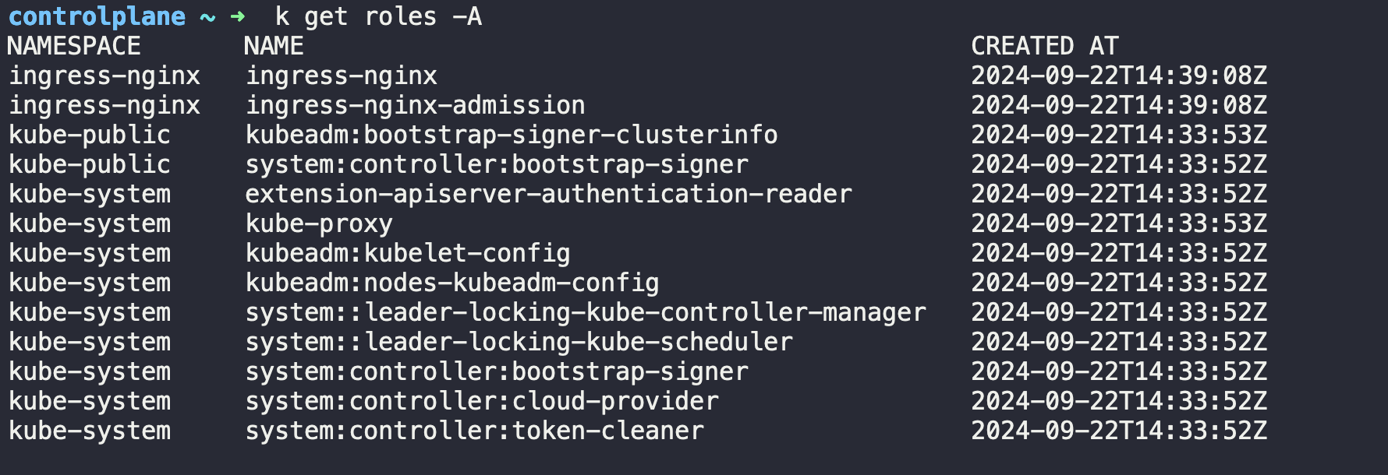

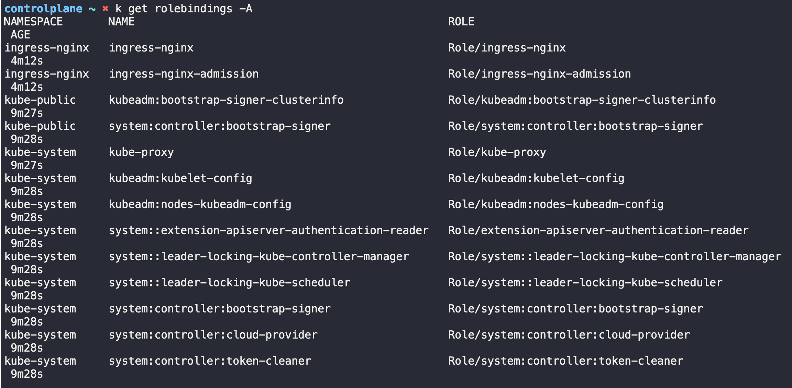

k describe role <role_name> -n <namespace>

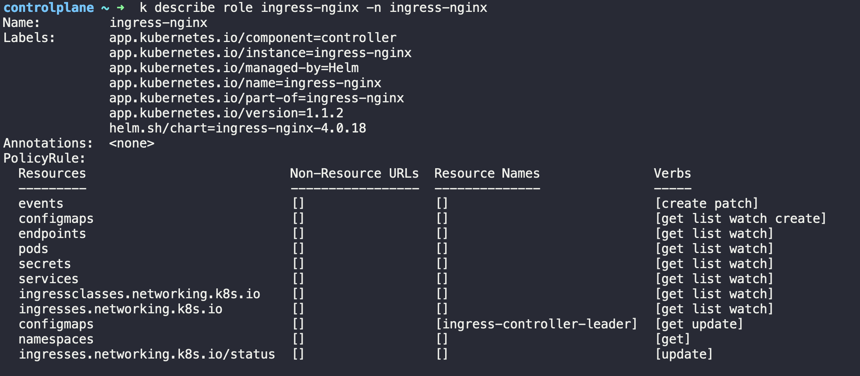

## [Imperative Commands]: Commands & Outputs

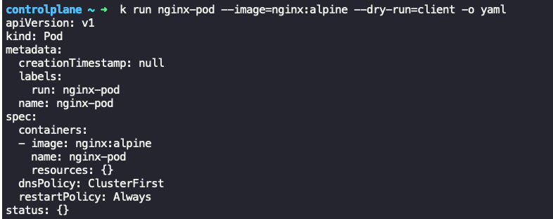



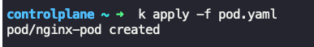

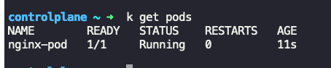

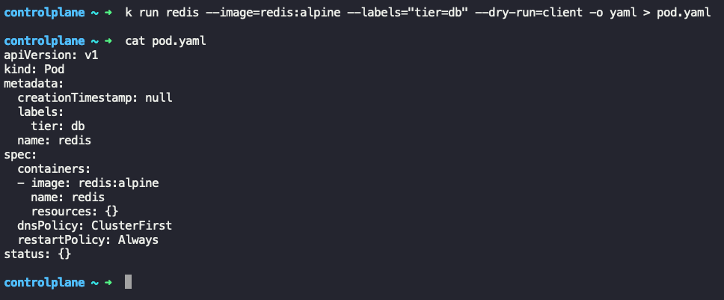

Expose a application(pod) named redis to port 6379 on service redis-service

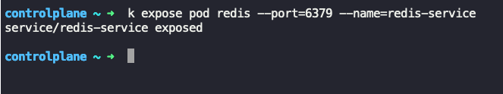







Create a deployment (redis-deploy), image(redis), replicas(2) and namespace(dev-ns)



Create a pod (httpd), image(httpd:alpine)  
--expose=True 🡪 Create a service of type ClusterIp and it requires –port option   
which is, port(80)

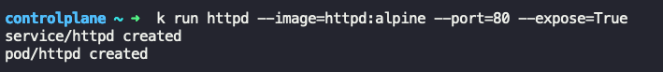

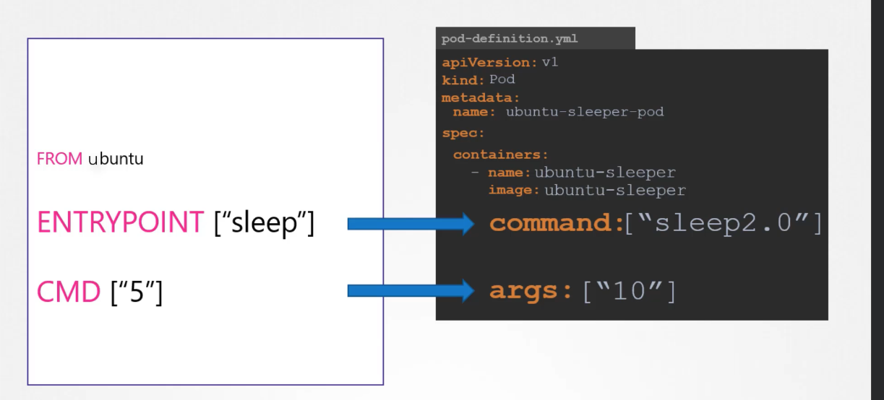

The **ENTRYPOINT** in the Dockerfile is overridden by the **command** in the pod definition file.

The **CMD** in the Dockerfile is overridden by the **args** in the pod definition file.

**Note**: It’s been noted that k edit command doesn’t work if you try to edit an exsiting command in above, it will complain and not allow to apply the modified changes.

Instead, edit the definition file, delete existing pod create the new pod using edited definition file  
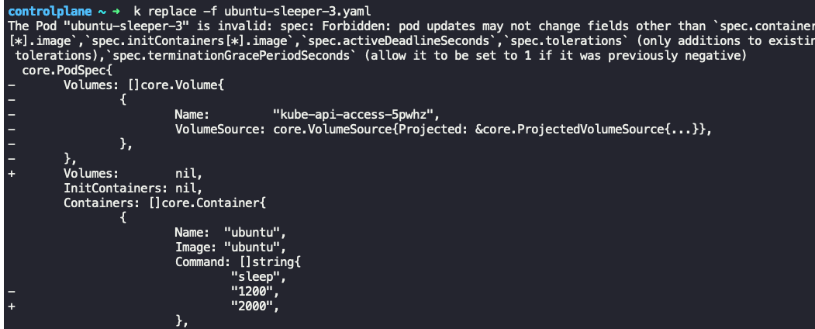

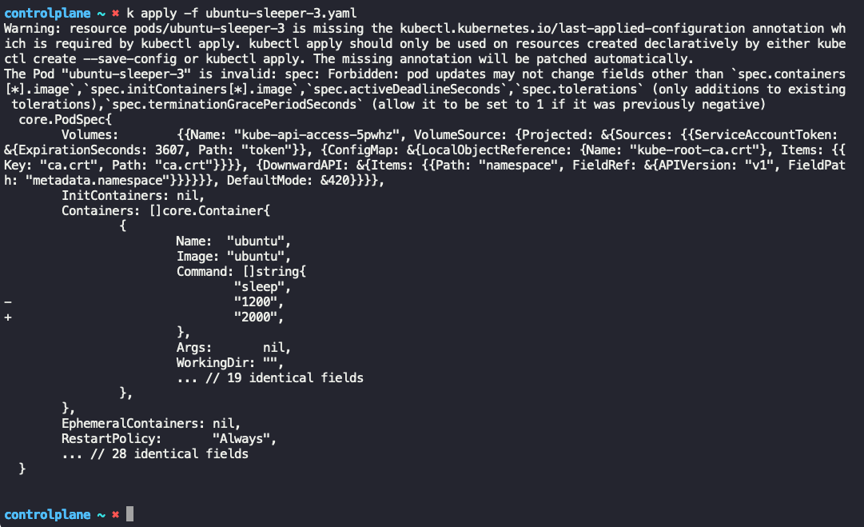

# Annexure II

|  |  |  |
| --- | --- | --- |
| **Kind** | **apiVersion** | **Description** |
| **Pod** | v1 | The smallest and simplest Kubernetes object. Represents a single instance of a running process. |
| **ReplicaSet** | apps/v1 | Ensures that a specified number of pod replicas are running at any given time. |
| **Deployment** | apps/v1 | Manages ReplicaSets to ensure that the correct number of pods are running. |
| **StatefulSet** | apps/v1 | Manages the deployment and scaling of a set of Pods, providing guarantees about ordering and uniqueness. |
| **DaemonSet** | apps/v1 | Ensures that all (or some) nodes run a copy of a Pod. |
| **Job** | batch/v1 | Creates one or more pods and ensures that a specified number of them successfully terminate. |
| **CronJob** | batch/v1 | Manages time-based Job scheduling. |
| **Service** | v1 | Exposes a set of Pods as a network service. |
| **Ingress** | networking.k8s.io/v1 | Manages external access to services, usually HTTP. |
| **ConfigMap** | v1 | Provides configuration data to pods. |
| **Secret** | v1 | Stores sensitive information such as passwords, OAuth tokens, and SSH keys. |
| **PersistentVolume** | v1 | Represents a piece of storage in the cluster that has been provisioned by an administrator. |
| **PersistentVolumeClaim** | v1 | A request for storage by a user that dynamically provisions storage resources. |
| **Namespace** | v1 | Provides a mechanism for isolating groups of resources within a single cluster. |
| **Node** | v1 | Represents a worker node in Kubernetes. |
| **ServiceAccount** | v1 | Associates a Kubernetes Pod with a specific set of permissions. |
| **Role** | rbac.authorization.k8s.io/v1 | Grants access to resources within a single namespace. |
| **RoleBinding** | rbac.authorization.k8s.io/v1 | Associates a Role with a set of users or groups. |
| **ClusterRole** | rbac.authorization.k8s.io/v1 | Grants access to resources cluster-wide. |
| **ClusterRoleBinding** | rbac.authorization.k8s.io/v1 | Associates a ClusterRole with a set of users or groups across the entire cluster. |
| **NetworkPolicy** | networking.k8s.io/v1 | Controls the traffic flow to/from Kubernetes Pods. |
| **ResourceQuota** | v1 | Limits the amount of resources that a namespace can use. |
| **LimitRange** | v1 | Specifies limits to the resource usage for containers within a namespace. |
| **HorizontalPodAutoscaler** | autoscaling/v1 | Automatically scales the number of pods based on observed CPU utilization or other application metrics. |
| **EndpointSlice** | discovery.k8s.io/v1 | A scalable API for discovering network endpoints. |

**Notes:**

* **v1 API Group**: This is the core API group and contains most of the fundamental Kubernetes objects like Pods, Services, ConfigMaps, etc.
* **apps/v1 API Group**: This API group manages higher-level abstractions like Deployments, StatefulSets, ReplicaSets, and DaemonSets.
* **batch/v1 API Group**: This API group is used for batch jobs, including Job and CronJob.
* **networking.k8s.io/v1**: This API group handles network-related resources, such as Ingress and NetworkPolicy.
* **rbac.authorization.k8s.io/v1**: This API group is used for Role-Based Access Control (RBAC) resources like Role, RoleBinding, ClusterRole, and ClusterRoleBinding.
* **autoscaling/v1**: This API group is used for auto-scaling resources like the HorizontalPodAutoscaler.

# Annexure III

Installing etcd-client CLI:

|  |
| --- |
| apt-get install etcd-client |